**Table of Contents**

Introduction3

Skip Patterns5

Survey Introduction20

Demographics 22

Family Structure 24

Word Association 26

Verb Generation 27

Word Association (Image) 30

Word Association (Slogan) 35

Brand Recognition 37

Tobacco Brand Recognition 47

25% Update 49

Single Target Implicit Association Task 50

Flicker Paradigm (Image One) 66

Disposable Income 73

Disposable Income Spent At Tobacco Retail Outlets 77

Store Visit Frequency 80

Tobacco Initiation – Part 1 203

Cigarette Use 204

Tobacco Initiation – Part 2 205

Tobacco Initiation – Part 3 208

Recent Tobacco Use – Part 1 210

Recent Tobacco Use – Part 2 212

Tobacco Quantity – Part 1 213

Modified Fagerstrom Tolerance Questionnaire (mFRQ) for Adolescents 214

Tobacco Quantity – Part 2 216

Access to Tobacco Products – Part 1 217

Tobacco Cessation 221

Tobacco Use Willingness222

Tobacco Initiation – Part 4 223

Access to Tobacco Products – Part 2 224

Perception of Peer Tobacco Use 225

Tobacco Brand Preference 227

Tobacco Brand Preference (Purchases) 229

Second-Hand Smoke Exposure 231

Health Professional Warnings 232

General Health Perceptions 233

Flicker Paradigm (Image Two) 234

Symmetry Span Task 241

Go/No-Go Task 251

65% Update 254

Short Form Smoking Consequences Questionnaire (S-SCQ) 255

Family and Peer Smoking 259

Injunctive Norms 262

Media Exposure 264

Prevention Program Exposure 269

75% Update 271

Drug Use Frequency Scale 272

Depression Anxiety Stress Scale (DASS-21) 278

Head Injury 282

Electronic Cigarette Commercials 283

Affective Response To Point-Of-Sale Ads and Warning Signs 290

Point-of-Sale Sensitivity 296

90% Update297

Perceived Stress PSS-10298

Shopper Type300

Extracurricular Activities306

Final Screen308

**Introduction**

All measures were administered to participants using a web-based survey programmed with Inquisit 4 Software. At the beginning of each survey, a whole number between 1 and 4 was assigned automatically in the field *Subject*. This number determined which version of the survey the participant received.

|  |  |  |
| --- | --- | --- |
| **Version** | **Initial Categories for Single Target Implicit Association Test** | **Initial Presentation of**  **Flicker Paradigm** |
| 1 | Unpleasant or Tobacco vs. Neutral | Flicker Paradigm (Image One) |
| 2 | Pleasant vs. Neutral or Tobacco | Flicker Paradigm (Image Two) |
| 3 | Pleasant or Tobacco vs. Neutral | Flicker Paradigm (Image One) |
| 4 | Unpleasant vs. Neutral or Tobacco | Flicker Paradigm (Image Two) |

The data from the survey was divided by Inquisit into 12 groups. A separate dataset was generated from each group. Four fields within each dataset permitted participant responses to be linked across groups.

The first field, *ID_Wave*, indicated which of three waves the participant completed.

The second field, *ID_School,* indicated which of 37 school locations the participant was from. This number was also used to trigger school-specific items, such as the stores near each school displayed in the Store Visit Frequency measure.

The third field, *ID_Participant*, was a unique value assigned to each student from a school that expressed interest in the study. Not all students that initially expressed interest completed the online survey.

The fourth field, *ID_Condition*, indicated which condition the student was randomly assigned to during the first wave of the study. A ‘9’ indicated that the participant was assigned to the first condition and completed the Symmetry Span Task in each of wave of the study. A ‘1’ indicated that the participant was assigned to the second condition and completed the Go/No-Go Task in each of wave of the study.

Collectively, these four fields were merged to create a *Survey ID* code that was unique for each survey completed by each participant. *ID_School* and *ID_Participant* remained constant for each individual participant across all three waves of the study.

*Variable Names*

All variables were labeled with a five-character prefix.

The first two characters denoted the wave. For example, *W1* indicated that the variable was from the first wave.

The next two characters denoted the measure the item was associated with. In the first wave these variables were labeled in sequence, i.e. the first measure was labeled *AA*, the second measure was labeled *AB*, and the final measure was labeled *BY*. These variable names were then retained in all waves regardless of their placement within the survey. Measures added to the second wave were assigned the character *C*, e.g. *CA*, *CB*, etc. Measures added to the third wave were assigned the character *D*, e.g. *DA*, *DB*, etc.

The last character in the five-character prefix was *Q*. It was followed by the question number. This number was sequential in the first wave and then remained constant in all subsequent waves. Thus, the variable *W1AAQ15* in the first wave was labeled *W3AAQ15* in the third wave even though it was the fifteenth question presented in the first wave and the third question presented in the second wave.

*Negative Values*

In the data generated from the online survey, negative values denote unique forms of data. The definition of each value is provided below:

* (Blank) = Participant chose not to answer the question or selected a response in a prior question that caused the question to be skipped.
* -7 = Participant selected ‘Don’t Know’, ‘Not Sure’, etc.
* -5 = Participant selected a fictional product brand or program.

***Skip Patterns***

During the survey, certain measures contained skip patterns. **Questions and responses that triggered a skip pattern in the survey are depicted below in red.** Questions that could be skipped as a result of a skip pattern are depicted below in blue.

***Store Visit Frequency***

[*Skip Pattern Question*]

**Are you currently a student at [Name of School Based on Entered ID]?**

Yes

**No**

[*Introduction*]

On the next screens, you will see pictures of stores near your school. For each picture, please indicate how often you visit the specific store at the address listed.

[*Repeated Screen*]

(picture)

(store name) at (address).

How often do you go to the store at THIS ADDRESS?

Never

Once a month

2-3 times a month

Once a week

2-3 times a week

Almost every day

***Tobacco Use***

**How old were you when you first tried…**

|  |  |  |  |  |  |  |  |  |  |  |  |  |  |
| --- | --- | --- | --- | --- | --- | --- | --- | --- | --- | --- | --- | --- | --- |
|  | **Never**  **tried** | Younger than 8 years old | 9 | 10 | 11 | 12 | 13 | 14 | 15 | 16 | 17 | 18 | 19 |
| ***Cigarettes***  ***(Marlboro, Camel, Newport, American Spirit, etc.)*** | **❑0** | ❑8 | ❑9 | ❑10 | ❑11 | ❑12 | ❑13 | ❑14 | ❑15 | ❑16 | ❑17 | ❑18 | ❑19 |
| ***Electronic Cigarettes, Vaporizers, or Vape Pens***  ***(Blu, NJOY, MarkTen, etc.)*** | **❑0** | ❑8 | ❑9 | ❑10 | ❑11 | ❑12 | ❑13 | ❑14 | ❑15 | ❑16 | ❑17 | ❑18 | ❑19 |
| ***Cigars, Cigarillos, or Little Cigars***  ***(Black and Milds, Swisher Sweets, Dutch Masters, etc.)*** | **❑0** | ❑8 | ❑9 | ❑10 | ❑11 | ❑12 | ❑13 | ❑14 | ❑15 | ❑16 | ❑17 | ❑18 | ❑19 |
| ***Chewing Tobacco, Snuff, or Dip***  ***(Copenhagen, Grizzly, Skoal, etc.)*** | **❑0** | ❑8 | ❑9 | ❑10 | ❑11 | ❑12 | ❑13 | ❑14 | ❑15 | ❑16 | ❑17 | ❑18 | ❑19 |

When was the last time you used…

|  |  |  |  |  |  |  |  |  |
| --- | --- | --- | --- | --- | --- | --- | --- | --- |
|  | Never  tried | 5 or more years ago | 1 to 4 years ago | 6 to 12  months ago | 1 to 5  months ago | 7 to 30  days ago | 1 to 6  days ago | Earlier  today |
| *Cigarettes* | ❑0 | ❑1 | ❑2 | ❑3 | ❑4 | ❑5 | ❑6 | ❑7 |
| *Electronic Cigarettes, Vaporizers, or Vape Pens* | ❑0 | ❑1 | ❑2 | ❑3 | ❑4 | ❑5 | ❑6 | ❑7 |
| *Cigars, Cigarillos, or Little Cigars* | ❑0 | ❑1 | ❑2 | ❑3 | ❑4 | ❑5 | ❑6 | ❑7 |
| *Chewing Tobacco, Snuff, or Dip* | ❑0 | ❑1 | ❑2 | ❑3 | ❑4 | ❑5 | ❑6 | ❑7 |
| *Pipe Tobacco* | ❑0 | ❑1 | ❑2 | ❑3 | ❑4 | ❑5 | ❑6 | ❑7 |
| *Hookah or Shisha* | ❑0 | ❑1 | ❑2 | ❑3 | ❑4 | ❑5 | ❑6 | ❑7 |

During the past 30 days, on how many days did you use each of the tobacco products below?

|  |  |  |  |  |  |  |  |
| --- | --- | --- | --- | --- | --- | --- | --- |
|  | 0  days | 1 or 2  days | 3 to 5  days | 6 to 9  days | 10 to 19  days | 20 to 29  days | All 30 days |
| *Cigarettes* | ❑0 | ❑1 | ❑2 | ❑3 | ❑4 | ❑5 | ❑6 |
| *Electronic Cigarettes, Vaporizers, or Vape Pens* | ❑0 | ❑1 | ❑2 | ❑3 | ❑4 | ❑5 | ❑6 |
| *Cigars, Cigarillos, or Little Cigars* | ❑0 | ❑1 | ❑2 | ❑3 | ❑4 | ❑5 | ❑6 |
| *Chewing Tobacco, Snuff, or Dip* | ❑0 | ❑1 | ❑2 | ❑3 | ❑4 | ❑5 | ❑6 |
| *Pipe Tobacco* | ❑0 | ❑1 | ❑2 | ❑3 | ❑4 | ❑5 | ❑6 |
| *Hookah or Shisha* | ❑0 | ❑1 | ❑2 | ❑3 | ❑4 | ❑5 | ❑6 |

On a typical day, which tobacco products do you use? (Check all that apply)

Cigarettes

Electronic Cigarettes, Vaporizers, or Vape Pens

Cigars, Cigarillos, or Little Cigars

Chewing Tobacco, Snuff, or Dip

Pipe Tobacco

Hookah or Shisha

None of the above

How many cigarettes a day do you smoke?

1-Over 26 cigarettes a day (2)

2-About 16-25 cigarettes a day (1)

3-About 1-15 cigarettes a day (0)

4-Less than 1 a day (0)

Do you inhale?

1-Always (2)

2-Quite often (1)

3-Seldom (1)

4-Never (0)

How soon after you wake up do you smoke your first cigarette?

1-Within the first 30 minutes (1)

2-More than 30 minutes after waking but before noon (0)

3-In the afternoon (0)

4-In the evening (0)

0-I currently don’t smoke cigarettes

Which cigarette would you hate to give up?

1-First cigarette in the morning (1)

2-Any other cigarette before noon (0)

3-Any other cigarette after noon (0)

4-Any other cigarette in the evening (0)

0-I currently don’t smoke cigarettes

Do you find it difficult to refrain from smoking in places where it is forbidden (church, library, movies etc.)?

1-Yes, very difficult (1)

2-Yes, somewhat difficult (1)

3-No, not usually difficult (0)

4-No, not at all difficult (0)

Do you smoke if you are so ill that you are in bed most of the day?

1-Yes, always (1)

2-Yes, quite often (1)

3-No, not usually (0)

4-No, never (0)

Do you smoke more during the first 2 hours than during the rest of the day?

1-Yes (1)

2-No (0)

On a typical day when you smoke, how many puffs do you take from each tobacco product?

|  |  |  |  |  |  |
| --- | --- | --- | --- | --- | --- |
|  | 0 | 1-10 puffs | 11-50 puffs | 51-200 puffs | 201+ puffs |
| ***Cigarettes*** | ❑0 | ❑1 | ❑2 | ❑3 | ❑4 |
| ***Electronic Cigarettes, Vaporizers, or Vape Pens*** | ❑0 | ❑1 | ❑2 | ❑3 | ❑4 |
| ***Cigars, Cigarillos, or Little Cigars*** | ❑0 | ❑1 | ❑2 | ❑3 | ❑4 |

On a typical day when you have chewing tobacco, snuff, or dip, how much do you use?

None

About 10% of a tin

About a quarter of a tin

About half of a tin

About three-quarters of a tin

A full tin

More than one tin

During the past 30 days, where did you get your own tobacco products? (Check all that apply)

I did not buy tobacco products during the past 30 days

A gas station

A convenience store

A grocery store

A drugstore or pharmacy

A vending machine

Over the Internet

Through the mail

A friend

A family member

None of the above

Other (please specify):

During the past 30 days, where did you get MOST of your tobacco products?

I did not buy tobacco products during the past 30 days

A gas station

A convenience store

A grocery store

A drugstore or pharmacy

A vending machine

Over the Internet

Through the mail

A friend

A family member

Other (please specify):

What is the CHEAPEST way to buy tobacco products?

At a gas station

At a convenience store

At a grocery store

At a drugstore or pharmacy

At a vending machine

Over the Internet

Through the mail

Other (please specify): ___________

What is the CHEAPEST tobacco product to buy?

Cigarettes

Electronic Cigarettes, Vaporizers, or Vape Pens

Cigars, Cigarillos, or Little Cigars

Chewing Tobacco, Snuff, or Dip

Pipe Tobacco

Hookah or Shisha

Other (please specify): ___________

Have you ever bought the following from a store near [Name of School Based on Entered ID]? (Check all that apply)

Cigarettes

Electronic Cigarettes, Vaporizers, or Vape Pens

Cigars, Cigarillos, or Little Cigars

Chewing Tobacco, Snuff, or Dip

Pipe Tobacco

Hookah or Shisha

None of the above

**School IDs:**

105 = Tracy High School

108 = Desert Winds High School

109 = R. Rex Parris High School

111 = North Park High School

112 = Somerset High School

113 = Chaparral High School

114 = Monterey High School

115 = Centinela Valley High School

116 = R. K. Lloyde High School

117 = Fairvalley High School

139 = Jack London High School

161 = Youth Opportunities High School

165 = Canyon Oaks High School

171 = Rose City High School

174 = Kurt T. Shery High School

181 = Santana High School

186 = Buena Park High School

195 = Valley Vista High School

197 = Back Bay High School

206 = Hillview High School

208 = Alvord High School

214 = Amistad High School

223 = Abraham Lincoln High School

224 = Mountain View High School

226 = Ortega High School

229 = Val Verde High School

232 = Central High School

244 = Mountain High School

246 = Middle College High School

250 = Oak View High School

254 = Mojave High School

261 = Abraxas High School

276 = Pacific High School

278 = Conejo Valley High School

280 = Community High School

282 = Phoenix High School

283 = Phoenix High School

During the past 30 days, did anyone ever refuse to sell you a tobacco product (cigarettes, cigars, electronic cigarettes, chewing tobacco, etc.) because of your age?

I did not try to buy a tobacco product in a store during the past 30 days

Yes, someone refused to sell me a tobacco product because of my age

No, no one refused to sell me a tobacco product because of my age

If you bought or tried to buy a tobacco product in a store during the past 30 days, were you ever asked to show proof of age?

I did not try to buy a tobacco product in a store during the past 30 days

Yes, I was asked to show proof of age

No, I was not asked to show proof of age

Have you ever thought about quitting or planning to quit using tobacco?

No

I thought about it but did not want to

I thought about it have not made up my mind

I plan to quit in the next 30 days

I plan to quit in the next 6 months

How many times during the past 12 months have you stopped using tobacco for one day or longer because you were trying to quit?

I have not tried to quit

1 time

2 times

3 to 5 times

6 to 9 times

10 or more times

When you last tried to quit tobacco, how long did you last?

Less than a day

1 to 7 days

More than 7 days but less than 30 days

30 days or more but less than 6 months

6 months or more but less than a year

1 year or more

***Media Exposure***

**During the past 30 days, about how often have you seen ads online FOR tobacco products?**

**None**

1-3 times in the past 30 days

1-3 times per week

Daily or almost daily

More than once a day

During the past 30 days, where did you see ads online FOR tobacco products? (Check all that apply)

Social Networks (Facebook, myspace, Instagram, etc.)

Email (Gmail, Yahoo mail, Hotmail, etc.)

Forums (Xual, Ultimate Teen Forums, All About Goldfish, etc.)

Search Engine (Google, Yahoo, Ask, etc.)

Online Shopping (Amazon, Ebay, Overstock, etc.)

Video Streaming (YouTube, Vimeo, DailyMotion, etc.)

Music Streaming (Pandora, Spotify, Grooveshark, etc.)

Download sites (Vertor, Take.FM, ThePirateBay, etc.)

Blogs (Blog.com, Wordpress, Blogger, etc.)

Wikis (Wikipedia, Wiktionary, ZineWiki, etc.)

Podcasts (Teen Talk, TBTL, NLCast, etc.)

***Electronic Cigarette Commercials***

**Have you ever seen a commercial for electronic cigarettes on television?**

Yes

**No**

**Have you ever seen a commercial for electronic cigarettes online (YouTube, Hulu, Netflix etc.)?**

Yes

**No**

Think of the last time you saw a commercial for electronic cigarettes either on TV or online.

Try to form a picture of this commercial in your mind.

What were you doing when you saw the electronic cigarette commercial?

Watching television

Watching a video online at a website like YouTube, Hulu, Netflix, etc.

Using a social network like Facebook, Instagram, etc.

Other (please specify): _____________

When did you last see this electronic cigarette commercial?

1-2 days ago

3-6 days ago

1-2 weeks ago

3-4 weeks ago

1-2 months ago

3-6 months ago

More than 6 months ago

What brand was being advertised in the electronic cigarette commercial?

Blu

Green Smart Living

MarkTen

NJOY

Xcite*

Square

Vuse

V2

I don’t know

Another brand (please specify):________________

For each numbered item below answer the following question.

How did the electronic cigarette commercial make you feel?

Very Unhappy Unhappy Neutral Happy Very Happy

Very Unpleasant Unpleasant Neutral Pleasant Very Pleasant

Very Bad Bad Neutral Good Very Good

Very Uncool Uncool Neutral Cool Very Cool

Were there people in the electronic cigarette commercial?

Yes

No

How old were the people in the electronic cigarette commercial? (Check all that apply)

Under 18

18 to 25

26 to 30

1. or older

There were no people in the advertisement

What was the gender of the people in the electronic cigarette commercial?

One male only

Two or more males (no females)

One female only

Two or more females (no males)

A mix of males and females

There were no people in the advertisement

What was the race/ethnicity of the people in the electronic cigarette commercial? (Check all that apply)

White

Hispanic

Black or African American

Asian

Native Hawaiian or Other Pacific Islander

American Indian or Alaska Native

There were no people in the advertisement

Other (please specify): __________________

When you see electronic cigarettes commercials on TV or online…

Do you think they are funny?

Yes, always

Yes, usually

No, usually not

No, never

Do you think they are sexy?

Yes, always

Yes, usually

No, usually not

No, never

Do you wish you were like the people in the commercials?

Yes, always

Yes, usually

No, usually not

No, never

When you see electronic cigarette commercials, how often do you pay attention to them?

Always

Most of the time

Some of the time

Never

Of all the commercials you see, how much do you like electronic cigarette commercials?

I like electronic cigarette commercials the most

I like electronic cigarette commercials a little more than the other commercials

I like electronic cigarette commercials a little less than the other commercials

I like electronic cigarette commercials the least

How often do you talk to other people about electronic cigarette commercials you saw on TV or online?

Very Often

Often

Sometimes

Never

Think back to the electronic cigarette commercials you have seen in the past month. What brand of electronic cigarette was advertised the most?

Blu

Green Smart Living

MarkTen

NJOY

Xcite*

Square

Vuse

V2

I don’t know

Another brand (please specify):________________

What is the name of the brand of your favorite electronic cigarette commercial?

Blu

Green Smart Living

MarkTen

NJOY

Xcite*

Square

Vuse

V2

I don’t know

Another brand (please specify):________________

About how often did you see an electronic cigarette commercial in the last six months?

Every day

2-6 times a week

Once a week

2-3 times a month

Once a month

Less than once a month

Never

In the past week, how many commercials have you seen for electronic cigarettes?

0

1

2

3

4

5

6 or more

***Extracurricular Activities***

**In the last 12 months, which of the following organized activities or groups have you participated in? (Check all that apply)**

Music, dance, theater or other performing arts (in or outside of school)

Athletic teams or organized sports (in or outside of school)

Boys or girls clubs (Boy Scouts, Girl Scouts, etc.)

Youth groups sponsored by a church, synagogue, mosque, or other religious institution

Another club or activity, in or outside of school, or volunteer work

**None of these clubs or activities**

How many hours a week did you participate in these activities? ___________

**Which of the following organized activities or groups are you currently participating in? (Check all that apply)**

Music, dance, theater or other performing arts (in or outside of school)

Athletic teams or organized sports (in or outside of school)

Boys or girls clubs (Boy Scouts, Girl Scouts, etc.)

Youth groups sponsored by a church, synagogue, mosque, or other religious institution

Another club or activity, in or outside of school, or volunteer work

**None of these clubs or activities**

How many hours a week do you participate in these activities? ___________

How many close friends participate in these activities with you?

None of them

A few of them

About half of them

Most of them

All of them

**Survey Introduction**

[*Introduction – First Screen*]

Thank you for participating in CHAMP.

The following survey asks about your thoughts, feelings, background, and health.

You will also be asked to perform some computer tasks.

Before you get started, make sure you are sitting comfortably in a quiet location and that you have plenty of time.

The survey may take up to two hours. It must be completed in one sitting.

Please select one of the options below and then click CONTINUE

[*Introduction – Second Screen*]

This survey includes audio. You may need to adjust the volume to hear it.

Please check the volume of your computer now by clicking the text below.

[*Introduction – Third Screen*]

During the survey, you will sometimes be asked to press the SPACE BAR to move to the next screen.

When the audio ends, press the SPACE BAR to continue

[*Introduction – Fourth Screen*]

From time to time, you will need to use the mouse to select an answer.

Let’s practice this.

Type in your date of birth.

Then use the mouse to point and click on one of the gender options below.

What is your date of birth?

_______________

Example: 11/09/1996

What is your gender?

Male

Female

[*Introduction – Fifth Screen*]

If you need any assistance or have any questions, don’t hesitate to call or text your Study Coordinator.

They are glad you are taking part in the study and will be happy to help you.

[*Introduction – Sixth Screen*]

Now let’s begin the survey.

Please enter the code that was emailed to you.

## Demographics

**Source:** Items 3-8 were adapted from:

Ensminger, M.E., Forrest, C.B., Riley, A.W., Kang, M., Green, B.F., Starfield, B., & Ryan, S.A. (2000). The validity of measures of socioeconomic status of adolescents. *Journal Of Adolescent Research, 15*(3), 392-419.

Hollingshead, A.B., Redlich, F.C. (1958). Social class and mental illness: A community study. New York, NY: Wiley.

**Designed For:** Adolescents

**Psychometrics:** Not provided

**Codebook:**

The following questions ask about your general background.

1. What is your date of birth? (MM/DD/YYYY) _____ W3AAQA1 W3DemDOBMM1 / _____ W3AAQB1 W3DemDOBDD1 /_____ W3AAQC1 W3DemDOBYYYY1
2. What is your gender? W3AAQ2 W3DemGender2

Male 1

Female 2

1. Is your father or male guardian currently... W3AAQ15 W3DemDadWork15

Working full-time 2

Working part-time 1

Not working 0

Don’t know -7

1. Is your mother or female guardian currently… W3AAQ16 W3DemMomWork16

Working full-time 2

Working part-time 1

Not working 0

Don’t know -7

1. Are you currently… W3AAQ20 W3DemSelfWork20

Working full-time 2

Working part-time 1

Not working 0

Don’t know -7

1. Does your family receive a welfare check? W3AAQ17 W3DemWelfare17

Yes 1

No 0

1. Does your family receive food stamps? W3AAQ18 W3DemFoodStamps18

Yes 1

No 0

1. Do you or any of your siblings receive free or reduced lunches at school? W3AAQ19 W3DemFreeLunch19

Yes 1

No 0

## Family Structure

**Source:** Items 1-3 adapted from Smith, C. & Denton, M.L. (2003). Methodological Design and Procedures for the National Survey of Youth and Religion (NSYR). <http://www.thearda.com/Archive/Files/Codebooks/NSYRW3_CB.asp>.

**Designed For:** Adolescents

**Psychometrics:** Not provided

**Codebook:**

1. Where do you live now? W3ABQ1 W3FamLivNow1

Your parent’s home 1

Another person’s home 2

Your own place 3

Group home 4

Other (please specify) 5 W3ABQ1other W3FamLivNowOther1

1. Do you live alone or with others? W3ABQ2 W3FamLivAlone2

Alone 1

With others 2

1. Who lives with you most of the time? (Check all that apply) W3ABQ3 W3FamLivMem3, 0 When Not Selected, 1 When Selected

Father W3ABQ3option1 W3FamLivMemDad3

Mother W3ABQ3option2 W3FamLivMemMom3

Stepfather W3ABQ3option3 W3FamLivMemStepDad3

Stepmother W3ABQ3option4 W3FamLivMemStepMom3

Foster Parent(s) W3ABQ3option5 W3FamLivFosterParent3

Brother(s) W3ABQ3option6 W3FamLivBro3

Sister(s) W3ABQ3option7 W3FamLivMemSis3

Grandfather(s) W3ABQ3option8 W3FamLivMemGranddad3

Grandmother(s) W3ABQ3option9 W3FamLivMemGrandma3

Other Relatives (Aunt, Uncle, Cousin) W3ABQ3option10 W3FamLivMemRel3

Wife/Husband W3ABQ3option11 W3FamLivMemSpouse3

Girlfriend/Boyfriend W3ABQ3option12 W3FamLivMemGirlBoyFriend3

Daughter(s) W3ABQ3option13 W3FamLivMemDaughter3

Son(s) W3ABQ3option14 W3FamLivMemSon3

Roommate(s)/Friend(s) W3ABQ3option15 W3FamLivMemRoommate3

Other People (please specify) W3ABQ3option16 W3FamLivMemOther3____________ W3ABQ3other W3FamLivOtherSpecify3

1. How many people under the age of 18 live with you most of the time? W3ABQ4 W3FamLiv18Under4

___________

1. How many people who are 18 or older live with you most of the time? W3ABQ5 W3FamLiv18andOver5

___________

**Word Association**

**Source:** Grenard, J.L., Ames, S.L., Thush, C., Sussman, S., Wiers, R., & Stacy, A.W. (2008). Working memory capacity moderates the predictive effects of drug-related associations on substance use. *Psychology of Addictive Behaviors, 22*(3): 426-432.

Rooke, S.E., Hine, D.W., & Thorsteinsson, E.B. (2008). Implicit cognition and substance use: A meta-analysis. *Addictive Behaviors, 33*, 1314-1328.

Stacy, A.W. (1997). Memory activation and expectancy as prospective predictors of alcohol and marijuana use. *Journal of Abnormal Psychology*, 106 (1), 61-73.

Stacy, A.W. (1995) Memory association and ambiguous cues in models of alcohol and marijuana use. *Experimental and Clinical Psychopharmacology*, 3 (2), 183-194.

Stacy, A.W., Ames, S.L. Sussman, S., Dent, C. (1996) Implicit cognition in adolescent drug use. *Psychology of Addictive Behaviors, 10* (3), 190-203.

Stacy, A.W., Galaif, E.R., Sussman, S., & Dent, C.W. (1996). Self-generated drug outcomes in high risk adolescents. *Psychology of Addictive Behaviors, 10*(1), 18-27.

Stacy, A.W, Leigh, B.C. & Weingardt, K., (1997). An individual-difference perspective applied to word association. *Personality and Social Psychology Bulletin*, 3, 229-237.

Sussman, S., Stacy, A.W., Ames, S.L., & Freedman, L.B. (1998). Self-reported high-risk locations of adolescent drug use. *Addictive Behaviors, 23*, 405-11.

Dosher, B., & Rosedale, G.S. (1997). Configural processing in memory retrieval: Multiple cues and ensemble representations.*Cognitive Psychology*, *33*(3), 209-265

**Designed For:** Adolescents

**Codebook:**

**Verb Generation**

**Task Instructions:**

[*Screen One*]

For the next set of questions, please type the very first behavior or action that comes to mind when you read a phrase on the screen. Behaviors, activities, or actions are 'things to do'. If you can’t think of a behavior or action, then type the first word that 'pops to mind'. If you still can't think of anything, type the word 'none'.

[*Screen Two*]

For example, suppose that the phrase was 'tasting something sweet'

Type the behavior or action that ‘pops to mind'.

When you see the words ‘tasting something sweet’: 'eating ice cream’

could be the first behavior that comes to mind.

[*Screen Three*]

Read the phrase below, and then type the first behavior or action that comes to mind.

tasting something sweet

First behavior or action

[*Text*]

[*Screen Four*]

Remember, if you can’t think of a behavior or action, then you can type the first word that 'pops to mind'. If you still can't think of anything, you can type the word 'none'.

[*Screen Five*]

Work quickly.

There is a time limit for each screen.

[*Header*]

Read the phrase below, and then type the first behavior or action that comes to mind

First behavior or action

[*Text*]

**Cues:** W3ACQ W3WAOBCue

1. feeling relaxed
2. feeling dreamy
3. forgetting problems
4. being sociable
5. went outside
6. laughing
7. feeling happy
8. **showing courage**
9. **being helpful**
10. being peaceful
11. at a party
12. having fun
13. **showing respect**
14. **making money**
15. feeling good
16. **inside a church, being quiet**
17. parking lot, looking cool
18. after school, walking home
19. outdoors, at school
20. going home, feeling stressed
21. **on the bus, being nice**
22. with friends, had a rough day
23. at home, feeling down
24. friday night, friends house, having fun
25. **weeknight, school library, pleasing family**
26. first thing in the morning
27. after a meal
28. in a convenience store
29. taking a break
30. at a gas station

**Coding Instructions:**

[*Self-Coding Introduction*]

Please help us understand what you were thinking about during this task. Each of the following screens will show one of your typed responses and a list of categories. Check all of the categories that are close to the meaning of your typed response.

[*Self-Coding Header*]

Please tell us what you mean by checking all of the categories that apply to your typed response.

**Coding Categories:** 1 When Selected

caffeine (energy drinks, soda, coffee drinks) W3ACQCaf_1_W3ACQ1 W3WAOBCaf1

food or snacks W3ACQSnack_1_W3ACQ1 W3WAOBSnack1

cigarettes or cigars W3ACQTobCigCigar_1_W3ACQ1 W3WAOBTobCigCigar1

smokeless tobacco (chew, snuff, dip) W3ACQTobChew_1_W3ACQ1 W3WAOBTobChew1

electronic cigarettes, vaporizers, or vape pens W3ACQTobECig_1_W3ACQ1 W3WAOBTobECig1

marijuana (weed, pot, grass, chronic) W3ACQPot_1_W3ACQ1 W3WAOBPot1

alcohol (beer, wine, wine coolers, liquor) W3ACQAlco_1_W3ACQ1 W3WAOBAlco1

speed (crystal, meth, ice, amp) W3ACQMeth_1_W3ACQ1 W3WAOBMeth1

other drugs W3ACQOthDrug_1_W3ACQ1 W3WAOBOthDrug1

exercise, workout, or sports W3ACQExer_1_W3ACQ1 W3WAOBExer1

school W3ACQSch_1_W3ACQ1 W3WAOBSch1

party W3ACQParty_1_W3ACQ1 W3WAOBParty1

sleeping W3ACQSleep_1_W3ACQ1 W3WAOBSleep1

none of the above W3ACQNone_1_W3ACQ1 W3WAOBNone1

**Word Association (Image)**

**Instructions:**

[*Screen One*]

For the next set of questions, please type the very first word that comes to mind when you see a picture on the screen. If you can't think of anything type the word 'none'.

[*Screen Two*]

For example, suppose that the picture was

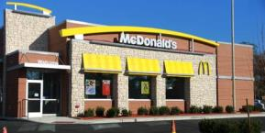

Type the first word that ‘pops to mind'.

‘Hamburger’ could be the first word that comes to mind.

[*Screen Three*]

Look at the picture below, and then type the first word that comes to mind

**

First word

[*Text*]

[*Screen Four*]

Remember, if you can't think of anything you can type the word 'none'.

[*Screen Five*]

Work quickly.

There is a time limit for each screen.

[*Header*]

Look at the picture below, and then type the first word that comes to mind

[*Cue*]

First word

[*Text*]

**Cues:** W3ADQ W3WAICue

(picture 2C_NoTobStore_WholeFoods)

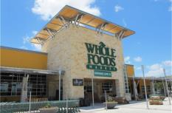

(picture 3C_NoTobStore_Target)

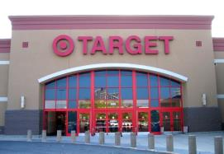

(picture 4T_TobStore_CircleK)

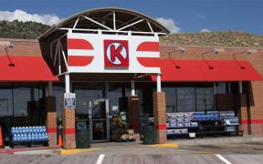

(picture 5T_TobStore_711)

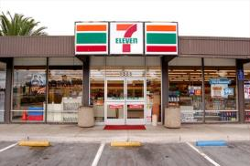

(picture 6C_NoTobStore_FreshEasy)

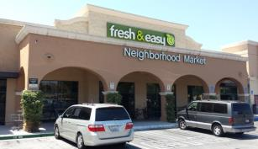

(picture 7T_TobStore_AMPM)

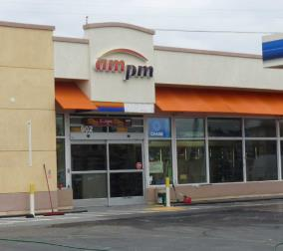

**Coding Instructions:**

[*Self-Coding Introduction*]

Please help us understand what you were thinking about during this task. Each of the following screens will show one of your typed responses and a list of categories. Check all of the categories that are close to the meaning of your typed response.

[*Self-Coding Header*]

Please tell us what you mean by checking all of the categories that apply to your typed response.

**Coding Categories:** 1 When Selected

caffeine (energy drinks, soda, coffee drinks) W3ADQCaf_1_W3ADQ1 W3WAIBCaf1

food or snacks W3ADQSnack_1_W3ADQ1 W3WAIBSnack1

cigarettes or cigars W3ADQTobCigCigar_1_W3ADQ1 W3WAIBTobCigCigar1

smokeless tobacco (chew, snuff, dip) W3ADQTobChew_1_W3ADQ1 W3WAIBTobChew1

electronic cigarettes, vaporizers, or vape pens W3ADQTobECig_1_W3ADQ1 W3WAIBTobECig1

marijuana (weed, pot, grass, chronic) W3ADQPot_1_W3ADQ1 W3WAIBPot1

alcohol (beer, wine, wine coolers, liquor) W3ADQAlco_1_W3ADQ1 W3WAIBAlco1

speed (crystal, meth, ice, amp) W3ADQMeth_1_W3ADQ1 W3WAIBMeth1

other drugs W3ADQOthDrug_1_W3ADQ1 W3WAIBOthDrug1

exercise, workout, or sports W3ADQExer_1_W3ADQ1 W3WAIBExer1

school W3ADQSch_1_W3ADQ1 W3WAIBSch1

party W3ADQParty_1_W3ADQ1 W3WAIBParty1

sleeping W3ADQSleep_1_W3ADQ1 W3WAIBSleep1

none of the above W3ADQNone_1_W3ADQ1 W3WAIBNone1

**Word Association (Slogan)**

**Instructions:**

[*Screen One*]

For the next set of questions, please type the very first PRODUCT or BRAND that comes to mind when you see a phrase on the screen. Products and brands are ‘things you can buy at a store’. If you can’t think of a product or brand, then type the first word that 'pops to mind'. If you still can't think of anything, type the word 'none'.

[*Screen Two*]

For example, suppose that the phrase was 'Do The Dew'

Type the PRODUCT or BRAND that ‘pops to mind'.

When you see the words

Do The Dew: ‘Soda’ or ‘Mountain Dew’ could be the first PRODUCT or BRAND that comes to mind.

[*Screen Three*]

Read the phrase below, and then type the first PRODUCT or BRAND that comes to mind

Do The Dew

First PRODUCT or BRAND

[*Text*]

[*Screen Four*]

Remember, if you can’t think of a product or brand, then you can type the first word that 'pops to mind'. If you still can't think of anything, you can type the word 'none'.

[*Screen Five*]

Work quickly.

There is a time limit for each screen.

[*Header*]

Read the phrase below, and then type the first PRODUCT or BRAND that comes to mind

[*Cue*]

First PRODUCT or BRAND

[*Text*]

**Cues (Slogans):** W3AEQ W3WAPCue

1. Here we go.
2. Come to where the flavor is.
3. Be Bold. Get Black.
4. Enjoy ice cold.
5. Grab and go.
6. Bold Flavor. Distinct Edge.

**Coding Instructions:**

[*Self-Coding Introduction*]

Please help us understand what you were thinking about during this task. Each of the following screens will show one of your typed responses and a list of categories. Check all of the categories that are close to the meaning of your typed response.

[*Self-Coding Header*]

Please tell us what you mean by checking all of the categories that apply to your typed response.

**Coding Categories:** 1 When Selected

food or snacks (sandwiches, chips, candy, ice cream) W3AEQSnack_1_W3AEQ1 W3WAPSnack1

drinks (energy drinks, soda, coffee drinks) W3AEQDrink_1_W3AEQ1 W3WAPDrink1

alcohol (beer, wine, wine coolers, liquor) W3AEQAlco_1_W3AEQ1 W3WAPAlco1

tobacco (cigarettes, cigars, cigarillos) W3AEQCigCigar_1_W3AEQ1 W3WAPCigCigar1

smokeless tobacco (chew, snuff, dip) W3AEQChew_1_W3AEQ1 W3WAPChew1

electronic cigarettes, vaporizers, or vape pens W3AEQEcig_1_W3AEQ1 W3WAPEcig1

clothes W3AEQClothes_1_W3AEQ1 W3WAPClothes1

electronic devices (cell phone, MP3 player, tablet) W3AEQEdev_1_W3AEQ1 W3WAPEdev1

none of the above W3AEQNone_1_W3AEQ1 W3WAPNone1

**Brand Recognition**

**Source:** Hanewinkel, R., Isensee, B, Sargent, J.D., & Morgenstern, M. (2011). Cigarette advertising and teen smoking initiation. *Pediatrics, 127*, e271-278.

Similar measures were also utilized in Dauphinee, A.L., Doxey, J.R., Schleicher, N.C., Fortmann, S.P., & Henriksen, L. (2013). Racial differences in cigarette brand recognition and impact on youth smoking. *BMC Public Health, 13*, 170-177.

**Designed For:** Adolescents

**Psychometrics**: Chronbach’s alpha = 0.74

**Cigarette Advertisements Found At Tobacco**

**Retail Outlets with Brand Name Removed**

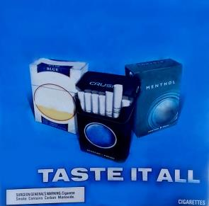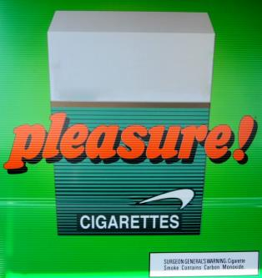

**Other Advertisements Found At Tobacco Retail**

**Outlets with Brand Name Removed**

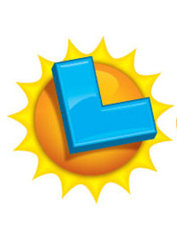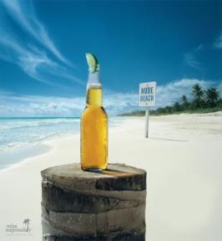



**Other Advertisements Found At Other Stores**

**with Brand Name Removed**

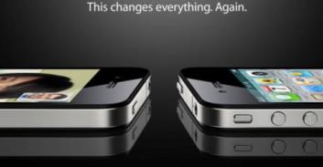

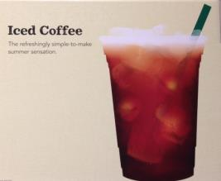

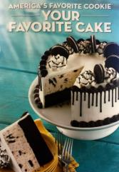

**Order:**







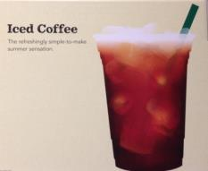

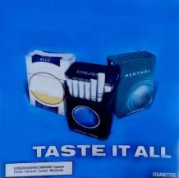

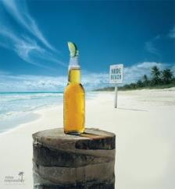

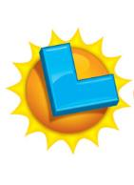

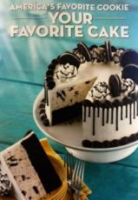

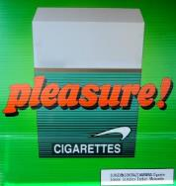

**Codebook:**

(picture 1C_NoTobStore_Apple.jpg)

1. How many times have you seen this advertisement? W3AFQ1 W3BrandRecogNoTobStoreAppleSeen1

Never 0

1-4 times 1

5-10 times 2

More than 10 times 3

1. What brand is being advertised? ____________________ W3AFQ2 W3BrandRecogNoTobStoreAppleName2

(picture 2C_TobStore_Good_Humor.jpg)

1. How many times have you seen this advertisement? W3AFQ3 W3BrandRecog1TobStoreNoTobGoodHumorSeen3

Never 0

1-4 times 1

5-10 times 2

More than 10 times 3

1. What brand is being advertised? ____________________ W3AFQ4 W3BrandRecogTobStoreNoTobGoodHumorName4

(picture 3T_TobStore_Marlboro.jpg)

1. How many times have you seen this advertisement? W3AFQ5 W3BrandRecogTobStoreTobMarlboroSeen5

Never 0

1-4 times 1

5-10 times 2

More than 10 times 3

1. What brand is being advertised? ____________________ W3AFQ6 W3BrandRecogTobStoreTobMarlboroName6

(picture 4C_NoTobStore_Starbucks.jpg)

1. How many times have you seen this advertisement? W3AFQ7 W3BrandRecogNoTobStoreStarbucksSeen7

Never 0

1-4 times 1

5-10 times 2

More than 10 times 3

1. What brand is being advertised? ____________________ W3AFQ8 W3BrandRecogNoTobStoreStarbucksName8

(picture 5T_TobStore_Camel.jpg)

1. How many times have you seen this advertisement? W3AFQ9 W3BrandRecogTobStoreTobCamelSeen9

Never 0

1-4 times 1

5-10 times 2

More than 10 times 3

1. What brand is being advertised? ____________________ W3AFQ10 W3BrandRecogTobStoreTobCamelName10

(picture 6C_TobStore_Corona.jpg)

1. How many times have you seen this advertisement? W3AFQ11 W3BrandRecogTobStoreNoTobCoronaSeen11

Never 0

1-4 times 1

5-10 times 2

More than 10 times 3

1. What brand is being advertised? ____________________ W3AFQ12 W3BrandRecogTobStoreNoTobCoronaName12

(picture 7C_TobStore_CalLotto.jpg)

1. How many times have you seen this advertisement? W3AFQ13 W3BrandRecogTobStoreNoTobCalLottoSeen13

Never 0

1-4 times 1

5-10 times 2

More than 10 times 3

1. What brand is being advertised? ____________________ W3AFQ14 W3BrandRecogTobStoreNoTobCalLottoName14

(picture 8C_NoTobStore_BaskinRobbins.jpg)

1. How many times have you seen this advertisement? W3AFQ15 W3BrandRecogNoTobStoreBaskinRobbinsSeen15

Never 0

1-4 times 1

5-10 times 2

More than 10 times 3

1. What brand is being advertised? ____________________ W3AFQ16 W3BrandRecogNoTobStoreBaskinRobbinsName16

(picture 9T_TobStore_Newport.jpg)

1. How many times have you seen this advertisement? W3AFQ17 W3BrandRecogTobStoreTobNewportSeen17

Never 0

1-4 times 1

5-10 times 2

More than 10 times 3

1. What brand is being advertised? ____________________ W3AFQ18 W3BrandRecogTobStoreTobNewportName18

**Tobacco Brand Recognition**

**Source:** Adapted from:

Centers for Disease Control and Prevention (CDC). (2014a). 2012 National youth tobacco survey (NYTS). Retrieved from: <http://www.cdc.gov/TOBACCO/data_statistics/surveys/NYTS/index.htm>

Centers for Disease Control and Prevention (CDC). (2014b). 2011 Youth tobacco survey (YTS). Retrieved from: <http://www.cdc.gov/tobacco/data_statistics/surveys/yts/index.htm>

**Designed For:** Adolescents

**Psychometrics**: Not provided

**Codebook**:

1. Which of the following cigarette brands have you heard of? (Check all that apply) W3AGQ1, W3TobBrandRecogCig1, 0 When Not Selected, 1 When Selected

American Spirit W3AGQ1option1 W3TobBrandRecogCigSpirit1

Camel W3AGQ1option2 W3TobBrandRecogCigCamel1

GPC, Basic, or Doral W3AGQ1option3 W3TobBrandRecogCigGPC1

Kool W3AGQ1option4 W3TobBrandRecogCigKool1

Lucky Strike W3AGQ1option5 W3TobBrandRecogCigLucky1

Marlboro W3AGQ1option6 W3TobBrandRecogCigMarlboro1

Newport W3AGQ1option7 W3TobBrandRecogCigNewport1

Parliament W3AGQ1option8 W3TobBrandRecogCigParliament1

Summit W3AGQ1option9 W3TobBrandRecogCigFake1

Virginia Slims W3AGQ1option10 W3TobBrandRecogCigVirginia1

None of the above W3AGQ1option11 W3TobBrandRecogCigNone1

1. Which of the following electronic cigarette, vaporizer, or vape pen brands have you heard of? (Check all that apply) W3AGQ2, W3TobBrandRecogECig2, 0 When Not Selected, 1 When Selected

Blu W3AGQ2option1 W3TobBrandRecogECigBlu2

Green Smart Living W3AGQ2option2 W3TobBrandRecogECigGreen2

MarkTen W3AGQ2option3 W3TobBrandRecogECigMarkTen2

NJOY W3AGQ2option4 W3TobBrandRecogECigNJOY2

Xcite W3AGQ2option5 W3TobBrandRecogECigFake2

Square W3AGQ2option6 W3TobBrandRecogECigSquare2

Vuse W3AGQ2option7 W3TobBrandRecogECigVuse2

V2 W3AGQ2option8 W3TobBrandRecogECigVTwo2

None of the above W3AGQ2option9 W3TobBrandRecogECigNone2

1. Which of the following cigar, cigarillo, or little cigar brands have you heard of? (Check all that apply) W3AGQ3, W3TobBrandRecogCigar3, 0 When Not Selected, 1 When Selected

Al Capone W3AGQ3option1 W3TobBrandRecogCigarCapone3

Backwoods W3AGQ3option2 W3TobBrandRecogCigarBackwoods3

Black and Mild W3AGQ3option3 W3TobBrandRecogCigarBlackMild3

Colonials W3AGQ3option4 W3TobBrandRecogCigarFake3

Dutch Masters W3AGQ3option5 W3TobBrandRecogCigarDutch3

Phillies W3AGQ3option6 W3TobBrandRecogCigarPhillies3

Prime Time W3AGQ3option7 W3TobBrandRecogCigarPrime3

Royal Comfort W3AGQ3option8 W3TobBrandRecogCigarRoyal3

Splitarillos W3AGQ3option9 W3TobBrandRecogCigarSplit3

Swisher Sweets W3AGQ3option10 W3TobBrandRecogCigarSwisher3

White Owl W3AGQ3option11 W3TobBrandRecogCigarOwl3

None of the above W3AGQ3option12 W3TobBrandRecogCigarNone3

1. Which of the following chewing tobacco, snuff, or dip brands have you heard of? (Check all that apply) W3AGQ4, W3TobBrandRecogChew4, 0 When Not Selected, 1 When Selected

Beechnut W3AGQ4option1 W3TobBrandRecogChewBeechnut4

Back Country W3AGQ4option2 W3TobBrandRecogChewFake4

Copenhagen W3AGQ4option3 W3TobBrandRecogChewCopen4

Grizzly W3AGQ4option4 W3TobBrandRecogChewGrizzly4

Kodiak W3AGQ4option5 W3TobBrandRecogChewKodiak4

Levi Garrett W3AGQ4option6 W3TobBrandRecogChewLevi4

Longhorn W3AGQ4option7 W3TobBrandRecogChewLonghorn4

Red Man W3AGQ4option8 W3TobBrandRecogChewRedman4

Skoal W3AGQ4option9 W3TobBrandRecogChewSkoal4

None of the above W3AGQ4option10 W3TobBrandRecogChewNone4

**25% Update**

[*A 25% Progress Bar Will Be Shown Here*]

Your Progress

Well done! You are making excellent progress.

Now we will ask you to complete a series of computer tasks. These can be challenging. Do the best that you can.

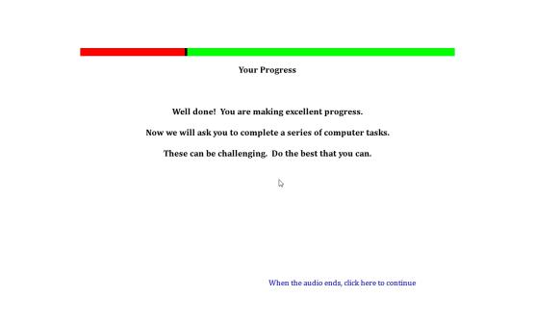

**Single Target Implicit Association Task**

**Source:** Bluemke, M., Friese, M. (2008). Reliability and validity of the single-target IAT (ST-IAT): Assessing automatic affect towards multiple attitude objects. *European Journal of Social Psychology, 38*, 977-997.

Greenwald, A.G., McGhee, D.E., & Schwartz, J.K. (1998). Measuring individual differences in implicit cognition: The implicit association test. *Journal Of Personality And Social Psychology*,*74*(6), 1464-1480.

Greenwald, A.G., Nosek, B.A., & Banaji, M.R. (2003). Understanding and using the Implicit Association Test: I. An improved scoring algorithm. *Journal Of Personality And Social Psychology*, *85*(2), 197-216

Karpinski, A., & Steinman, R.B. (2006). The single category implicit association test as a measure of implicit social cognition. *Journal of Personality and Social Psychology, 91*(1):16-32.

Conrey, F.R., Sherman, J.W., Gawronski, B., Hugenberg, K. & Groom, C.J. (2005). Separating multiple processes in implicit social cognition: The quad model of implicit task performance. *Journal of Personality and Social Psychology, 89*(4): 469-87.

Sherman, J. W., Gawronski, B., Gonsalkorale, K., Hugenberg, K., Allen, T. J., & Groom, C. J. (2008). The self-regulation of automatic associations and behavioral impulses. *Psychology Review, 115*(2): 314-35.

**Designed For:** Adolescents

**Psychometrics:** Internal consistency (.72)**,** Test-retest stability (Kendall’s W = .75)

#### Description: The Single Target Implicit Association Test assesses associations among three categories. The first trial utilizes the categories ‘Pleasant’, ‘Neutral’, and ‘Tobacco’. The second trial utilizes the categories ‘Unpleasant’, ‘Neutral’, and ‘Tobacco’.

**Items:**

W3AHQ

**Source for Tobacco Words:**

Huijding, J., de Jong, P.J., Wiers, R.W., & Verkooijen, K. (2005). Implicit and explicit attitudes toward smoking in a smoking and nonsmoking setting. *Addictive Behaviors, 30*, 949-961 was used as the source for the following words:

Tobacco

Smoking

Cigarettes

Nicotine

Smokers

Lighter

Butt

Ames, S.L., Grenard, J.L., Stacy, A.W., Xiao, L., He, Q., Wong, S.W., Xue, G., Wiers, R.W., Bechara, A. Functional imaging of implicit marijuana associations during performance on an Implicit Association Test (IAT). *Behavioural Brain Research, 256*, 494-502 was used as the source for the following words:

Ashes

Smokes

Cigs

**Source for Neutral Words:**

Houben, K., & Wiers, R.W. (2009). Beer makes the heart grow fonder: Single-target implicit attitudes toward beer but not alcohol are related to drinking behaviour in regular beer drinkers. *Netherlands Journal of Psychology, 65*, 10-21 was used as the source for the following words:

Truck

Machine

Window

Factory

Scissors

Letter

Paper

Square

Circle

Page

Magnet

The following word was also added:

Line

**Source for Pleasant Words:** Waters, A.J., Carter, B.L., Robinson, J.D., Wetter, D.W., Lam, C.Y., & Cinciripini, P.M. (2007). Implicit attitudes to smoking are associated with craving and dependence. *Drug and Alcohol Dependence, 91*, 178-186 was used as the source for the following words:

Calm

Cool

Friendly

Nice

Peaceful

Pleasant

Positive

Relaxing

Restful

Soothing

**Source for Unpleasant Words:** Waters, A.J., Carter, B.L., Robinson, J.D., Wetter, D.W., Lam, C.Y., & Cinciripini, P.M. (2007). Implicit attitudes to smoking are associated with craving and dependence. *Drug and Alcohol Dependence, 91*, 178-186 was used as the source for the following words:

Dirty

Foul

Harmful

Nasty

Negative

Smelly

Ugly

Unhealthy

Unpleasant

Ames, S.L., Grenard, J.L., Thush, C., Sussman, S., Wiers, R.W., & Stacy, A.W. (2007). Comparison of indirect assessments of association as predictors of marijuana use among at-risk adolescents. *Experimental and Clinical Psychopharmacology, 15*, 204-218 was used as the source for the following words:

Sad

**Rank, Hits, and Reading Level for Words:**

|  |  |  |  |
| --- | --- | --- | --- |
| **Word** | **Rank out of 86,800 Words (wordcount.org)** | **Hits (Google)** | **Reading Level (www.spellingcity.com)** |
| **Tobacco** | | | |
| Tobacco | 5335 | 44700000 | 4th |
| Smoking | 3224 | 128000000 | 5th |
| Cigarettes | 5830 | 26600000 | 4th (cigarette) |
| Nicotine | 20904 | 8120000 | 4th |
| Smokers | 10890 | 14000000 | 4th (smoke) |
| Lighter | 6539 | 46900000 | 2nd |
| Butt | 12108 | 111000000 | Not Listed |
| Ashes | 10825 | 20900000 | 4th |
| Smokes | 23915 | 9050000 | 4th (smoke) |
| Cigs | 52497 | 3380000 | Not Listed |
| **Pleasant** | | | |
| Calm | 3205 | 82500000 | 4th |
| Cool | 2520 | 650000000 | 2nd |
| Friendly | 2465 | 396000000 | 3rd |
| Nice | 743 | 680000000 | 1st |
| Peaceful | 4947 | 47400000 | 3rd |
| Pleasant | 3427 | 88500000 | 4th |
| Positive | 1220 | 340000000 | 4th |
| Relaxing | 9088 | 54100000 | 4th (relax) |
| Restful | 25994 | 7920000 | 3rd |
| Soothing | 12833 | 17300000 | 6th |
| **Unpleasant** | | | |
| Dirty | 3364 | 190000000 | 4th |
| Foul | 6875 | 23500000 | 3rd |
| Harmful | 8076 | 33600000 | 3rd |
| Nasty | 4673 | 84800000 | 3rd |
| Negative | 2132 | 171000000 | 4th |
| Smelly | 16396 | 6540000 | 3rd (smell) |
| Ugly | 5716 | 78100000 | 1st |
| Unhealthy | 16048 | 12300000 | 3rd |
| Unpleasant | 5902 | 11900000 | 4th |
| Sad | 2847 | 2750000000 | 1st |
| **Neutral** | | | |
| Truck | 6325 | 225000000 | 1st |
| Machine | 1145 | 415000000 | 4th |
| Window | 960 | 1590000000 | 4th |
| Factory | 2195 | 278000000 | 4th |
| Scissors | 12220 | 22900000 | 5th |
| Letter | 722 | 225000000 | 2nd |
| Magnet | 14955 | 14500000 | 4th |
| Line | 408 | 243000000 | 2nd |
| Circle | 2761 | 212000000 | 2nd |
| Page | 931 | 4500000000 | 1st |

#### Counterbalancing:

|  |  |  |  |  |  |  |  |
| --- | --- | --- | --- | --- | --- | --- | --- |
| **Version One** | | | | | | | |
|  | **# of Trials** | **Practice/Real** | **Categories on Left** | **Categories on Right** | **Unpleasant Words** | **Neutral Words** | **Tobacco Words** |
| **Block 1** | 20 | Practice (Red X) | Unpleasant | Neutral | 10 | 10 | 0 |
| **Block 2** | 20 | Practice (No Red X) | Unpleasant | Neutral | 10 | 10 | 0 |
| **Block 3** | 30 | Real | Unpleasant+Tobacco | Neutral | 10 | 10 | 10 |
| **Block 4** | 30 | Real | Unpleasant+Tobacco | Neutral | 10 | 10 | 10 |
| **Block 5** | 30 | Real | Unpleasant | Neutral+Tobacco | 10 | 10 | 10 |
| **Block 6** | 30 | Real | Unpleasant | Neutral+Tobacco | 10 | 10 | 10 |
| **Total** | 160 |  |  |  | 60 | 60 | 40 |
|  | **# of Trials** | **Practice/Real** | **Categories on Left** | **Categories on Right** | **Pleasant Words** | **Neutral Words** | **Tobacco Words** |
| **Block 1** | 20 | Practice (Red X) | Pleasant | Neutral | 10 | 10 | 0 |
| **Block 2** | 20 | Practice (No Red X) | Pleasant | Neutral | 10 | 10 | 0 |
| **Block 3** | 30 | Real | Pleasant+Tobacco | Neutral | 10 | 10 | 10 |
| **Block 4** | 30 | Real | Pleasant+Tobacco | Neutral | 10 | 10 | 10 |
| **Block 5** | 30 | Real | Pleasant | Neutral+Tobacco | 10 | 10 | 10 |
| **Block 6** | 30 | Real | Pleasant | Neutral+Tobacco | 10 | 10 | 10 |
| **Total** | 160 |  |  |  | 60 | 60 | 40 |

|  |  |  |  |  |  |  |  |
| --- | --- | --- | --- | --- | --- | --- | --- |
| **Version Two** | | | | | | | |
|  | **# of Trials** | **Practice/Real** | **Categories on Left** | **Categories on Right** | **Pleasant Words** | **Neutral Words** | **Tobacco Words** |
| **Block 1** | 20 | Practice (Red X) | Pleasant | Neutral | 10 | 10 | 0 |
| **Block 2** | 20 | Practice (No Red X) | Pleasant | Neutral | 10 | 10 | 0 |
| **Block 3** | 30 | Real | Pleasant+Tobacco | Neutral | 10 | 10 | 10 |
| **Block 4** | 30 | Real | Pleasant+Tobacco | Neutral | 10 | 10 | 10 |
| **Block 5** | 30 | Real | Pleasant | Neutral+Tobacco | 10 | 10 | 10 |
| **Block 6** | 30 | Real | Pleasant | Neutral+Tobacco | 10 | 10 | 10 |
| **Total** | 160 |  |  |  | 60 | 60 | 40 |
|  | **# of Trials** | **Practice/Real** | **Categories on Left** | **Categories on Right** | **Unpleasant Words** | **Neutral Words** | **Tobacco Words** |
| **Block 1** | 20 | Practice (Red X) | Unpleasant | Neutral | 10 | 10 | 0 |
| **Block 2** | 20 | Practice (No Red X) | Unpleasant | Neutral | 10 | 10 | 0 |
| **Block 3** | 30 | Real | Unpleasant+Tobacco | Neutral | 10 | 10 | 10 |
| **Block 4** | 30 | Real | Unpleasant+Tobacco | Neutral | 10 | 10 | 10 |
| **Block 5** | 30 | Real | Unpleasant | Neutral+Tobacco | 10 | 10 | 10 |
| **Block 6** | 30 | Real | Unpleasant | Neutral+Tobacco | 10 | 10 | 10 |
| **Total** | 160 |  |  |  | 60 | 60 | 40 |

|  |  |  |  |  |  |  |  |
| --- | --- | --- | --- | --- | --- | --- | --- |
|  |  |  |  |  |  |  |  |
| **Version Three** | | | | | | | |
|  | **# of Trials** | **Practice/Real** | **Categories on Left** | **Categories on Right** | **Pleasant Words** | **Neutral Words** | **Tobacco Words** |
| **Block 1** | 20 | Practice (Red X) | Neutral | Pleasant | 10 | 10 | 0 |
| **Block 2** | 20 | Practice (No Red X) | Neutral | Pleasant | 10 | 10 | 0 |
| **Block 3** | 20 | Real | Neutral | Pleasant+Tobacco | 10 | 10 | 10 |
| **Block 4** | 40 | Real | Neutral | Pleasant+Tobacco | 10 | 10 | 10 |
| **Block 5** | 20 | Real | Neutral+Tobacco | Pleasant | 10 | 10 | 10 |
| **Block 6** | 40 | Real | Neutral+Tobacco | Pleasant | 10 | 10 | 10 |
| **Total** | 160 |  |  |  | 60 | 60 | 40 |
|  | **# of Trials** | **Practice/Real** | **Categories on Left** | **Categories on Right** | **Unpleasant Words** | **Neutral Words** | **Tobacco Words** |
| **Block 1** | 20 | Practice (Red X) | Neutral | Unpleasant | 10 | 10 | 0 |
| **Block 2** | 20 | Practice (No Red X) | Neutral | Unpleasant | 10 | 10 | 0 |
| **Block 3** | 20 | Real | Neutral | Unpleasant+Tobacco | 10 | 10 | 10 |
| **Block 4** | 40 | Real | Neutral | Unpleasant+Tobacco | 10 | 10 | 10 |
| **Block 5** | 20 | Real | Neutral+Tobacco | Unpleasant | 10 | 10 | 10 |
| **Block 6** | 40 | Real | Neutral+Tobacco | Unpleasant | 10 | 10 | 10 |
| **Total** | 160 |  |  |  | 60 | 60 | 40 |
|  |  |  |  |  |  |  |  |
| **Version Four** | | | | | | | |
|  | **# of Trials** | **Practice/Real** | **Categories on Left** | **Categories on Right** | **Unpleasant Words** | **Neutral Words** | **Tobacco Words** |
| **Block 1** | 20 | Practice (Red X) | Neutral | Unpleasant | 10 | 10 | 0 |
| **Block 2** | 20 | Practice (No Red X) | Neutral | Unpleasant | 10 | 10 | 0 |
| **Block 3** | 20 | Real | Neutral | Unpleasant+Tobacco | 10 | 10 | 10 |
| **Block 4** | 40 | Real | Neutral | Unpleasant+Tobacco | 10 | 10 | 10 |
| **Block 5** | 20 | Real | Neutral+Tobacco | Unpleasant | 10 | 10 | 10 |
| **Block 6** | 40 | Real | Neutral+Tobacco | Unpleasant | 10 | 10 | 10 |
| **Total** | 160 |  |  |  | 60 | 60 | 40 |
|  | **# of Trials** | **Practice/Real** | **Categories on Left** | **Categories on Right** | **Pleasant Words** | **Neutral Words** | **Tobacco Words** |
| **Block 1** | 20 | Practice (Red X) | Neutral | Pleasant | 10 | 10 | 0 |
| **Block 2** | 20 | Practice (No Red X) | Neutral | Pleasant | 10 | 10 | 0 |
| **Block 3** | 30 | Real | Neutral | Pleasant+Tobacco | 10 | 10 | 10 |
| **Block 4** | 30 | Real | Neutral | Pleasant+Tobacco | 10 | 10 | 10 |
| **Block 5** | 30 | Real | Neutral+Tobacco | Pleasant | 10 | 10 | 10 |
| **Block 6** | 30 | Real | Neutral+Tobacco | Pleasant | 10 | 10 | 10 |
| **Total** | 160 |  |  |  | 60 | 60 | 40 |

#### Instructions:

#### *First Set*

#### *Transition*

For the next task, you will be sorting words that appear in the middle of the computer screen into categories which appear on the upper left and right of the screen.

#### *Screen One*

Put your middle or index fingers on the ‘E’ and ‘I’ keys of your keyboard.

Words representing the categories at the top will appear one-by-one in the middle of the screen.

When the item belongs to a category on the left, PRESS THE ‘E’ KEY.

When the item belongs to a category on the right, PRESS THE ‘I’ KEY.

Items fit best in one of the categories.

During the practice trials we will provide feedback in the form of a red X when you make a mistake. We will not provide this feedback during the actual task trials.

This is a timed sorting task. GO AS FAST AS YOU CAN while making as few mistakes as possible.

This task will take about 5 minutes to complete.

#### *Screen Two*

There will not be any feedback (NO RED X) for the rest of this task.

Continue to keep your middle or index fingers on the ‘E’ and ‘I’ keys of your keyboard. Continue to work quickly.

#### *Screen Three*

See above, a new category now appears together with one of the previous categories you saw.

Remember, each item fits best in one group.

For example:

If the categories pleasant and tobacco appear on separate sides above – pleasant words would go in the pleasant category, not the tobacco category.

Use the ‘E’ and ‘I’ keys to categorize items into groups.

#### *Screen Four*

Sort the same items again.

Remember to go as fast as you can while making as few mistakes as possible.

Use the ‘E’ and ‘I’ keys to categorize items into the groups.

#### *Screen Five*

See above, the three categories now appear together in a new configuration.

Remember, each item fits best in one group.

Use the ‘E’ and ‘I’ keys to categorize items into groups.

#### *Screen Six*

Sort the same items again.

Remember to go as fast as you can while making as few mistakes as possible.

Use the ‘E’ and ‘I’ keys to categorize items into the groups.

#### *Second Set*

#### *Transition*

Now you will do the same task again but with different categories.

GO AS FAST AS YOU CAN while making as few mistakes as possible.

#### *Screen One*

See above, the categories have changed.

Use the ‘E’ and ‘I’ keys to categorize items into the groups.

Remember to go as fast as you can while making as few mistakes as possible.

During the practice trials we will provide feedback in the form of a red X when you make a mistake. We will not provide this feedback during the actual task trials.

This task will take about 5 minutes to complete.

#### *Screen Two*

There will not be any feedback (NO RED X) for the rest of this task.

Continue to keep your middle or index fingers on the ‘E’ and ‘I’ keys of your keyboard. Continue to work quickly.

#### *Screen Three*

See above, a new category now appears together with one of the previous categories you saw.

Remember, each item fits best in one group.

For example:

If the categories unpleasant and tobacco appear on separate sides above – unpleasant words would go in the unpleasant category, not the tobacco category.

Use the ‘E’ and ‘I’ keys to categorize items into groups.

#### *Screen Four*

Sort the same items again.

Remember to go as fast as you can while making as few mistakes as possible.

Use the ‘E’ and ‘I’ keys to categorize items into the groups.

#### *Screen Five*

See above, the three categories now appear together in a new configuration.

Remember, each item fits best in one group.

Use the ‘E’ and ‘I’ keys to categorize items into groups.

#### *Screen Six*

Sort the same items again.

Remember to go as fast as you can while making as few mistakes as possible.

Use the ‘E’ and ‘I’ keys to categorize items into the groups.

#### Example:

tobacco

*pleasant*

*neutral*

cigarette

#### Stimuli:

**Tobacco Words**

1. Tobacco
2. Smoking
3. Cigarettes
4. Nicotine
5. Smokers
6. Lighter
7. Butt
8. Ashes
9. Smokes
10. Cigs

**Pleasant Words**

1. Calm
2. Cool
3. Friendly
4. Nice
5. Peaceful
6. Pleasant
7. Positive
8. Relaxing
9. Restful
10. Soothing

**Unpleasant Words**

1. Dirty
2. Foul
3. Harmful
4. Nasty
5. Negative
6. Smelly
7. Ugly
8. Unhealthy
9. Unpleasant
10. Sad

**Neutral Words**

1. Truck
2. Machine
3. Window
4. Factory
5. Scissors
6. Letter
7. Magnet
8. Line
9. Circle
10. Page

#### Example Screens:

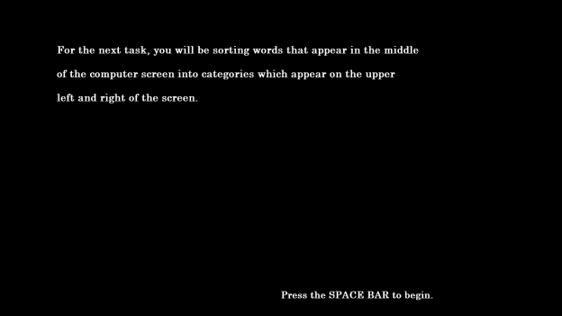

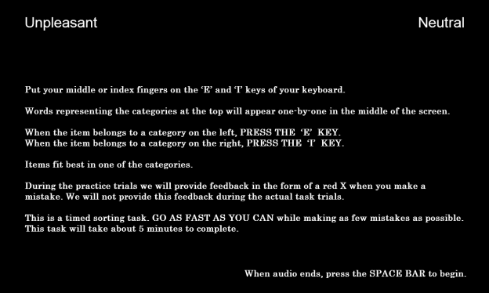

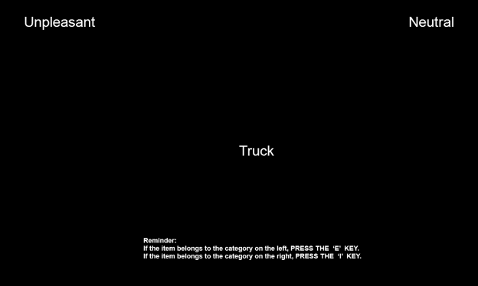

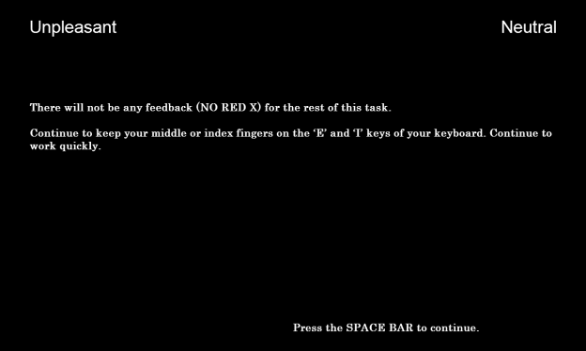

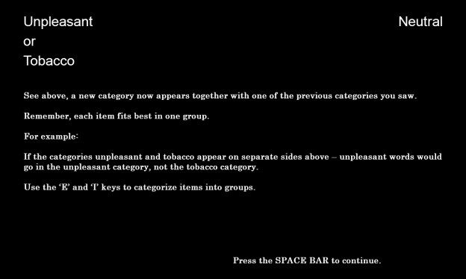

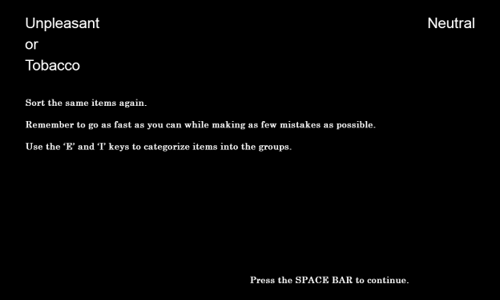

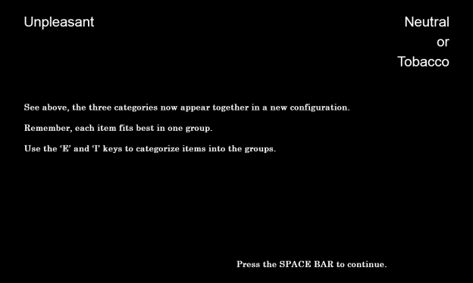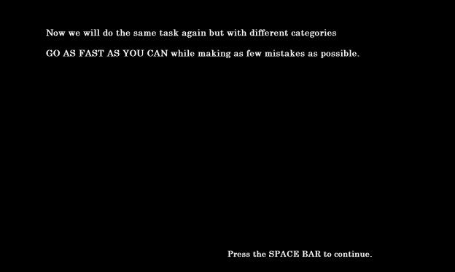

**Flicker Paradigm (Image One)**

**Primary Source:**

Rensink, R.A. (1997). To see or not to see: The need for attention to perceive changes in scenes. *Psychological Science, 8*, 368-373.

**Additional Sources:**

Beck, M.R., & Levin, D.T. (2003). The role of representational volatility in recognizing pre- and postchange objects. *Perception & Psychophysics, 65*, 458-468.

Hollingworth, A., & Henderson, J.M. (2002). Accurate visual memory for previously attended objects in natural scenes. *Journal of Experimental Psychology: Human Perception and Performance, 28*, 113-136.

Hollingworth, A., Williams, C.C., & Henderson, J.M. (2001). To see and remember: Visually specific information is retained in memory from previously attended objects in natural scenes. *Psychonomic Bulletin & Review, 8*, 761-768.

Simons, D. J. & Rensink, R. A. (2005). Change blindness: past, present, and future. *TRENDS in Cognitive Sciences, 9*(1), 16-20.

**Sources for Attentional Bias:**

Chanon, V.W., Sours, C.R., & Boettiger, C.A. (2010). Attentional bias toward cigarette cues in active smokers. *Psychopharmacology, 212*, 309-320.

Hobson, J., Bruce, G., & Butler, S.H. (2012). A flicker change blindness task employing eye tracking reveals an association with levels of craving not consumption. *Journal of Psychopharmacology, 27*, 93-97.

Schoenmakers, T.M., & Wiers, R.W. (2010). Craving and attentional bias respond differently to alcohol priming: A field study in the pub. *European Addiction Research, 16*, 9-16.

Jones, B.T., Bruce, G., Livingstone, S., & Reed, E. (2006). Alcohol-related attentional bias in problem drinkers with the flicker change blindness paradigm. *Psychology of Addictive Behaviors, 20*, 171-177.

Jones, B.C., Jones, B.T., Blundell, L., & Bruce, G. (2002). Social users of alcohol and cannabis who detect substance-related changes in a change blindness paradigm report higher levels of use than those detecting substance-neutral changes. *Psychopharmacology, 165*, 93-96.

Tibboel, H., De Houwer, J., & Field, M. (2009). Reduced attentional blink for alcohol-related stimuli in heavy social drinkers. *Journal of Psychopharmacology, 0*, 1-8.

**Sources for Presenting Only One Image:**

Jones, B.T., Bruce, G., Livingstone, S., & Reed, E. (2006). Alcohol-related attentional bias in problem drinkers with the flicker change blindness paradigm. *Psychology of Addictive Behaviors, 20*, 171-177.

Jones, B.C., Jones, B.T., Blundell, L., & Bruce, G. (2002). Social users of alcohol and cannabis who detect substance-related changes in a change blindness paradigm report higher levels of use than those detecting substance-neutral changes. *Psychopharmacology, 165*, 93-96.

**Designed For:** Adults

**Instructions:**

This task will ask you to detect changes in different pictures.

Press the SPACE BAR to continue.

In a moment, you will be shown a very fast flickering picture. The same picture is shown all the time. But half the time there is one change in the picture. The change can be the addition or removal of something in the picture or the replacement of something.

Press the SPACE BAR to continue.

Press the SPACE BAR as soon as you notice the change. You will then be asked to describe the change.

If you didn't notice any change, the picture will stop flickering after one minute.

Press the SPACE BAR to begin.

**Codebook:**

[*Flickering Images*]

Original

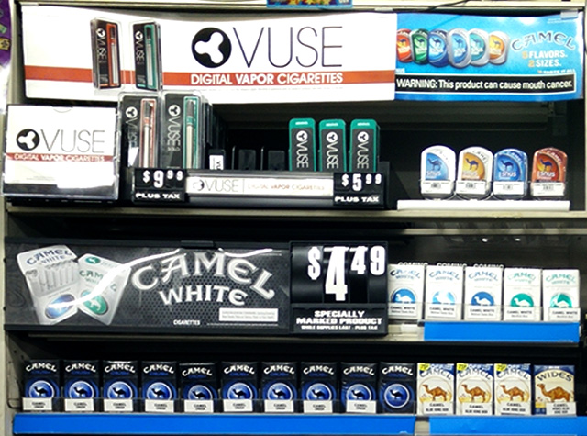

Modified

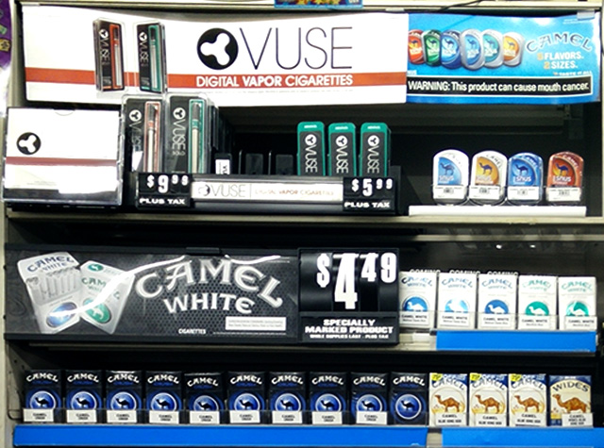

[*Page 1*]

Please describe what changed in the textbox below. Be as specific as you can.

If you didn’t notice any chance, type ‘No change.’

[*Text Box*]

W3AL1Q_textboxresponse1 W3FlickerChange1

[*Page 2*]

How difficult was it to detect the change? W3AI1Q2 W3FlickerDifficulty2

Very Easy 1 Somewhat Easy 2 Somewhat Difficult 3 Very Difficult 4

[*Page 3*]

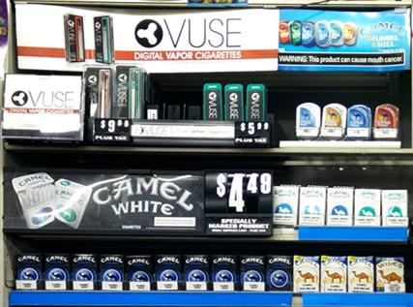

How often do you visit stores that have displays that look like the one above? W3AI1Q3 W3FlickerStoreVisit3

Never 0

Once a month or less 1

2-3 times a month 2

Once a week 3

2-3 times a week 4

Almost every day or every day 5

[*Page 4*]



How often have you seen this advertisement at a store? W3AI1Q4 W3FlickerAdvertisementSeen4

Never 0

Once a month or less 1

2-3 times a month 2

Once a week 3

2-3 times a week 4

Almost every day or every day 5

**Additional Information:**

* There will be no practice images.
* There will be one manipulated image.
* There will be no clues or suggested fixation points.
* Each image will be displayed for 240 milliseconds followed by a black screen for 80 milliseconds. This will continue for 60 seconds.
* The original image will be displayed twice followed by the manipulated image

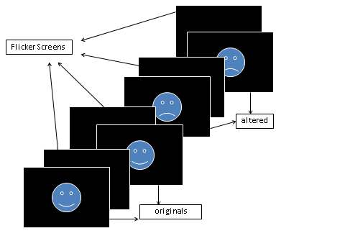

**Data Provided:**

* Date
* Time
* Count_cycles - counts the number of cycles started until a response occurs
* Responsepoint - determines the stimulus in the response cycle (the cycle that participant made a positive response) that was presented when participant made response: "StimA1", "flicker_AA", "StimA2", "flicker_AB", "StimB1", "flicker_BB", "StimB2", "flicker_BA" or "N/A" (if no response was given)
* Alternations - Determines the number of alternations between original and altered pictures until response occurs. Each switch between originals and altered pictures as well as each switch between altered pictures and original pictures is counted as an alternation. For each completed cycle, participants go through 2 alternations. If the response occurs AFTER the change from original to altered pic in the last cycle, one more alternation is added to the count.
* Cycle_rt - stores the combined trial latencies across the entire cycle until response occurs
* Textboxresponse - stores the open-ended response
* Textboxresponse_rt - stores the time it took participant to work on the openended response until pressing the button

**Disposable Income**

**Source:** Items 1-3 adapted from West, P., Sweeting, H., Young, R., & Robins, M. (2006). A material paradox: Socioeconomic status, young people's disposable income and consumer culture. *Journal Of Youth Studies, 9*(4), 437-462.

Items 4-8 adapted from Darling, H., Reeder, A.I., McGee, R., & Williams, S. (2006). Brief report: Disposable income, and spending on fast food, alcohol, cigarettes, and gambling by New Zealand secondary school students. *Journal Of Adolescence, 29*(5), 837-843.

Response options adapted from Johnston, L.D., O’Malley, P.M., Bachman, J.G., & Schulenberg, J.E. (2014) 2011 Monitoring the future survey (MTF). Retrieved from <http://www.monitoringthefuture.org/>. Ann Arbor: Institute for Social Research, The University of Michigan.

**Designed For:** Adolescents

**Psychometrics:** Not provided

**Codebook:**

In an average week, how much money do you receive from…

1. Your Family W3AJQ1 W3DisIncFamily1

$0 0

$1-5 1

$6-10 2

$11-20 3

$21-35 4

$36-50 5

$51-75 6

$76-125 7

$126-175 8

$176+ 9

1. A Job W3AJQ2 W3DisIncJob2

$0 0

$1-5 1

$6-10 2

$11-20 3

$21-35 4

$36-50 5

$51-75 6

$76-125 7

$126-175 8

$176+ 9

1. Other Sources W3AJQ3 W3DisIncOther3

$0 0

$1-5 1

$6-10 2

$11-20 3

$21-35 4

$36-50 5

$51-75 6

$76-125 7

$126-175 8

$176+ 9

In an average week, how much money do you spend on…

1. Snack Foods W3AKQ1 W3DisSpendSnack1

$0 0

$1-5 1

$6-10 2

$11-20 3

$21-35 4

$36-50 5

$51-75 6

$76-125 7

$126-175 8

$176+ 9

1. Soda or Energy Drinks W3AKQ2 W3DisSpendSoda2

$0 0

$1-5 1

$6-10 2

$11-20 3

$21-35 4

$36-50 5

$51-75 6

$76-125 7

$126-175 8

$176+ 9

1. Alcohol W3AKQ3 W3DisSpendAlcohol3

$0 0

$1-5 1

$6-10 2

$11-20 3

$21-35 4

$36-50 5

$51-75 6

$76-125 7

$126-175 8

$176+ 9

1. Tobacco Products W3AKQ4 W3DisSpendTobacco4

$0 0

$1-5 1

$6-10 2

$11-20 3

$21-35 4

$36-50 5

$51-75 6

$76-125 7

$126-175 8

$176+ 9

1. Other W3AKQ5 W3DisSpendOther5

$0 0

$1-5 1

$6-10 2

$11-20 3

$21-35 4

$36-50 5

$51-75 6

$76-125 7

$126-175 8

$176+ 9

**Disposable Income Spent At Tobacco Retail Outlets**

**Source:** Store categories adapted from

* Feighery, E.C., Henriksen, L., Wang, Y., Schleicher, N.C., & Fortmann, S.P. (2006). An evaluation of four measures of adolescents' exposure to cigarette marketing in stores. *Nicotine & Tobacco Research, 8*(6), 751-759.
* Feighery, E.C, Ribisl, K.M., Schleicher, N., Lee, R., & Halvorson, S. (2001). Cigarette advertising and promotional strategies in retail outlets: Results of a statewide survey in California. *Tobacco Control, 10*, 184-188.
* Feighery, E.C, Ribisl, K.M., Schleicher, N., & Clark, P.I. (2004). Retailer participation in cigarette company incentive programs is related to increased levels of cigarette advertising and cheaper cigarette prices in stores. *Preventive Medicine, 38*, 876-884.
* Henriksen, L., Feighery, E.C., Schleicher, N.C., Haladjian, H.H., & Fortmann, S.P. (2004). Reaching youth at the point of sale: cigarette marketing is more prevalent in stores where adolescents shop frequently. *Tobacco Control, 13*, 315–318.
* Henriksen, L., Feighery, E.C., Wang, Y., Fortmann, S.P. Association of retail tobacco marketing with adolescent smoking. (2004). *American Journal of Public Health, 94*(12), 2081-2083.
* Schleicher, N., Johnson, T.O., Dauphinee, A.L., Henriksen, L. (2011). Tobacco Marketing in California’s Retail Environment (2008-2011), Final report for the California Tobacco Advertising Survey.

Response options adapted from Johnston, L.D., O’Malley, P.M., Bachman, J.G., & Schulenberg, J.E. (2014) 2011 Monitoring the future survey (MTF). Retrieved from <http://www.monitoringthefuture.org/>. Ann Arbor: Institute for Social Research, The University of Michigan.

**Designed For:** Adolescents

**Psychometrics:** Not provided

**Items:**

In an average week, how much money do you spend at…

1. Supermarkets W3DAQ1 W3StoreSpendSuperMark1

$0 0

$1-5 1

$6-10 2

$11-20 3

$21-35 4

$36-50 5

$51-75 6

$76-125 7

$126-175 8

$176+ 9

1. Small Grocery Stores W3DAQ2 W3StoreSpendSmallMark2

$0 0

$1-5 1

$6-10 2

$11-20 3

$21-35 4

$36-50 5

$51-75 6

$76-125 7

$126-175 8

$176+ 9

1. Convenience Stores W3DAQ3 W3StoreSpendConvenience3

$0 0

$1-5 1

$6-10 2

$11-20 3

$21-35 4

$36-50 5

$51-75 6

$76-125 7

$126-175 8

$176+ 9

1. Gas Stations W3DAQ4 W3StoreSpendGas4

$0 0

$1-5 1

$6-10 2

$11-20 3

$21-35 4

$36-50 5

$51-75 6

$76-125 7

$126-175 8

$176+ 9

1. Drug Stores W3DAQ5 W3StoreSpendDrug5

$0 0

$1-5 1

$6-10 2

$11-20 3

$21-35 4

$36-50 5

$51-75 6

$76-125 7

$126-175 8

$176+ 9

1. Liquor Stores W3DAQ6 W3StoreSpendLiquor6

$0 0

$1-5 1

$6-10 2

$11-20 3

$21-35 4

$36-50 5

$51-75 6

$76-125 7

$126-175 8

$176+ 9

1. Tobacco Stores W3DAQ7 W3StoreSpendTobacco7

$0 0

$1-5 1

$6-10 2

$11-20 3

$21-35 4

$36-50 5

$51-75 6

$76-125 7

$126-175 8

$176+ 9

**Store Visit Frequency**

**Source:** Feighery, E.C., Henriksen, L., Wang, Y., Schleicher, N.C., & Fortmann, S.P. (2006). An evaluation of four measures of adolescents' exposure to cigarette marketing in stores. *Nicotine & Tobacco Research, 8*(6), 751-759.

Feighery, E.C, Ribisl, K.M., Schleicher, N., Lee, R., & Halvorson, S. (2001). Cigarette advertising and promotional strategies in retail outlets: Results of a statewide survey in California. *Tobacco Control, 10*, 184-188.

Feighery, E.C, Ribisl, K.M., Schleicher, N., & Clark, P.I. (2004). Retailer participation in cigarette company incentive programs is related to increased levels of cigarette advertising and cheaper cigarette prices in stores. *Preventive Medicine, 38*, 876-884.

Henriksen, L., Feighery, E.C., Schleicher, N.C., Haladjian, H.H., & Fortmann, S.P. (2004). Reaching youth at the point of sale: cigarette marketing is more prevalent in stores where adolescents shop frequently. *Tobacco Control, 13*, 315–318.

Henriksen, L., Feighery, E.C., Wang, Y., Fortmann, S.P. Association of retail tobacco marketing with adolescent smoking. (2004). *American Journal of Public Health, 94*(12), 2081-2083.

Schleicher, N., Johnson, T.O., Dauphinee, A.L., Henriksen, L. (2011). Tobacco Marketing in California’s Retail Environment (2008-2011), Final report for the California Tobacco Advertising Survey.

**Designed For:** Adolescents

**Psychometrics**: Not reported

**Codebook:**

[*Screen One*]

1. How often do you go to large supermarkets? W3ALQ1 W3StoreVisitSuperMark1

Never 0

Once a month 1

2-3 times a month 2

Once a week 3

2-3 times a week 4

Almost every day 5

1. How often do you go to small grocery stores? W3ALQ2 W3StoreVisitSmallMark2

Never 0

Once a month 1

2-3 times a month 2

Once a week 3

2-3 times a week 4

Almost every day 5

1. How often do you go to convenience stores? W3ALQ3 W3StoreVisitConvenience3

Never 0

Once a month 1

2-3 times a month 2

Once a week 3

2-3 times a week 4

Almost every day 5

1. How often do you go to gas stations? W3ALQ4 W3StoreVisitGas4

Never 0

Once a month 1

2-3 times a month 2

Once a week 3

2-3 times a week 4

Almost every day 5

[*Screen Two*]

1. How often do you go to drug stores? W3ALQ5 W3StoreVisitDrug5

Never 0

Once a month 1

2-3 times a month 2

Once a week 3

2-3 times a week 4

Almost every day 5

1. How often do you go to liquor stores? W3ALQ6 W3StoreVisitLiquor6

Never 0

Once a month 1

2-3 times a month 2

Once a week 3

2-3 times a week 4

Almost every day 5

1. How often do you go to tobacco stores? W3ALQ7 W3StoreVisitTobacco7

Never 0

Once a month 1

2-3 times a month 2

Once a week 3

2-3 times a week 4

Almost every day 5

**School Tailored Items:**

[*Skip Pattern Question*]

1. Are you currently a student at [Name of School Based on Entered ID]? W3ALQ9 W3StoreVisitAttendSchool9

Yes 1

No 0

**School IDs:**

105 = Tracy High School

108 = Desert Winds High School

109 = R. Rex Parris High School

111 = North Park High School

112 = Somerset High School

113 = Chaparral High School

114 = Monterey High School

115 = Centinela Valley High School

116 = R. K. Lloyde High School

117 = Fairvalley High School

139 = Jack London High School

161 = Youth Opportunities High School

165 = Canyon Oaks High School

171 = Rose City High School

174 = Kurt T. Shery High School

181 = Santana High School

186 = Buena Park High School

195 = Valley Vista High School

197 = Back Bay High School

206 = Hillview High School

208 = Alvord High School

214 = Amistad High School

223 = Abraham Lincoln High School

224 = Mountain View High School

226 = Ortega High School

229 = Val Verde High School

232 = Central High School

244 = Mountain High School

246 = Middle College High School

250 = Oak View High School

254 = Mojave High School

261 = Abraxas High School

276 = Pacific High School

278 = Conejo Valley High School

280 = Community High School

282 = Phoenix High School

283 = Phoenix High School

(If Yes…)

**Abraham Lincoln (ID: 223)**

(picture 223-56778.jpg)

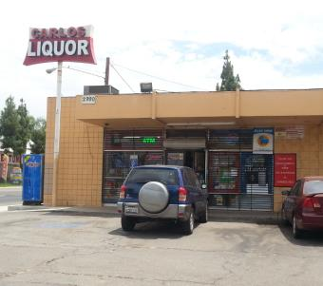

CARLOS LIQUOR at 2990 14TH STREET, RIVERSIDE, CA

How often do you go to the store at THIS ADDRESS?

Never 0

Once a month 1

2-3 times a month 2

Once a week 3

2-3 times a week 4

Almost every day 5

(picture 223-56786.jpg)

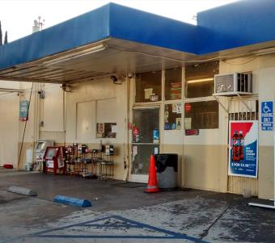

ARCO at 2720 14TH STREET, RIVERSIDE, CA

How often do you go to the store at THIS ADDRESS?

Never 0

Once a month 1

2-3 times a month 2

Once a week 3

2-3 times a week 4

Almost every day 5

(picture 223-56806.jpg)

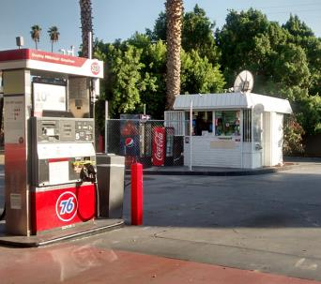

76 at 2658 UNIVERSITY AVENUE, RIVERSIDE, CA

How often do you go to the store at THIS ADDRESS?

Never 0

Once a month 1

2-3 times a month 2

Once a week 3

2-3 times a week 4

Almost every day 5

(picture 223-67635.jpg)

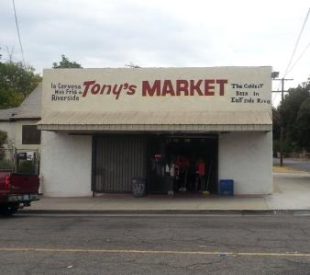

TONY'S MARKET at 4098 PARK AVENUE, RIVERSIDE, CA

How often do you go to the store at THIS ADDRESS?

Never 0

Once a month 1

2-3 times a month 2

Once a week 3

2-3 times a week 4

Almost every day 5

(picture 223-70332.jpg)

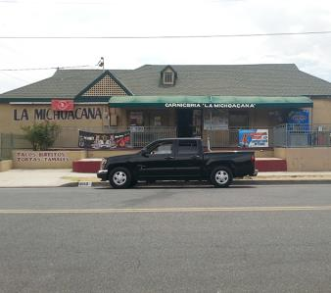

LA MICHOACANA MARKET at 4110 VICTORIA AVENUE, RIVERSIDE, CA

How often do you go to the store at THIS ADDRESS?

Never 0

Once a month 1

2-3 times a month 2

Once a week 3

2-3 times a week 4

Almost every day 5

(picture fake.jpg)

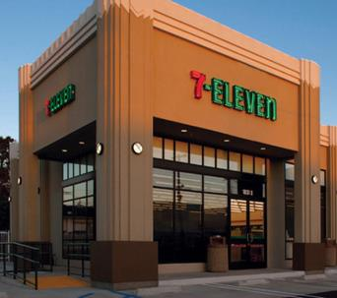

7-ELEVEN at 4495 HOWARD AVENUE, RIVERSIDE, CA

How often do you go to the store at THIS ADDRESS?

Never 0

Once a month 1

2-3 times a month 2

Once a week 3

2-3 times a week 4

Almost every day 5

(If Yes…)

**Abraxas (ID: 261)**

(picture 261-56472.jpg)

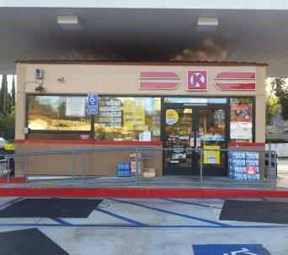

CIRCLE K at 14713 POMERADO ROAD, POWAY, CA

How often do you go to the store at THIS ADDRESS?

Never 0

Once a month 1

2-3 times a month 2

Once a week 3

2-3 times a week 4

Almost every day 5

(picture fake.jpg)

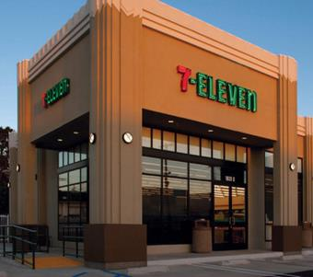

7-ELEVEN at 14551 POMERADO ROAD, POWAY, CA

How often do you go to the store at THIS ADDRESS?

Never 0

Once a month 1

2-3 times a month 2

Once a week 3

2-3 times a week 4

Almost every day 5

(If Yes…)

**Alvord (ID: 208)**

(picture 208-70116.jpg)

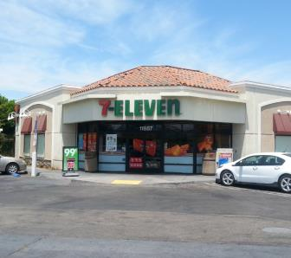

7-ELEVEN at 11887 MAGNOLIA AVENUE, RIVERSIDE, CA

How often do you go to the store at THIS ADDRESS?

Never 0

Once a month 1

2-3 times a month 2

Once a week 3

2-3 times a week 4

Almost every day 5

(picture fake.jpg)

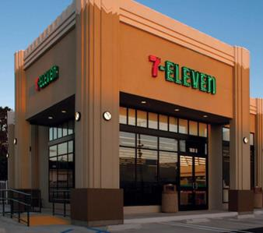

7-ELEVEN at 11860 MAGNOLIA AVENUE, RIVERSIDE, CA

How often do you go to the store at THIS ADDRESS?

Never 0

Once a month 1

2-3 times a month 2

Once a week 3

2-3 times a week 4

Almost every day 5

(If Yes…)

**Amistad (ID: 214)**

(picture fake.jpg)



7-ELEVEN at 44320 JACKSON STREET, INDIO, CA

How often do you go to the store at THIS ADDRESS?

Never 0

Once a month 1

2-3 times a month 2

Once a week 3

2-3 times a week 4

Almost every day 5

(If Yes…)

**Back Bay (ID: 197)**

(picture fake.jpg)

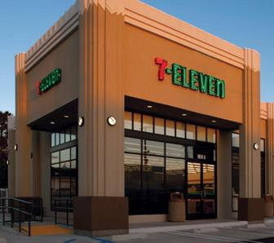

7-ELEVEN at 2651 IRVINE AVENUE, COSTA MESA, CA

How often do you go to the store at THIS ADDRESS?

Never 0

Once a month 1

2-3 times a month 2

Once a week 3

2-3 times a week 4

Almost every day 5

(If Yes…)

**Buena Park (ID: 186)**

(picture 186-58872.jpg)

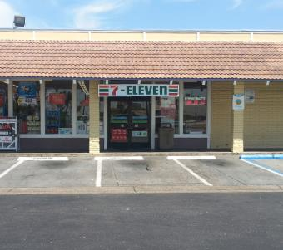

7-ELEVEN at 8725 ORANGETHORPE AVENUE, BUENA PARK, CA

How often do you go to the store at THIS ADDRESS?

Never 0

Once a month 1

2-3 times a month 2

Once a week 3

2-3 times a week 4

Almost every day 5

(picture 186-58873.jpg)

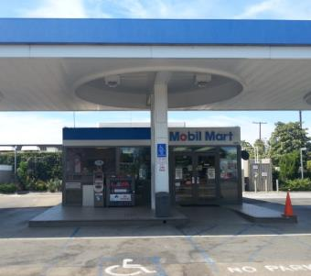

MOBIL at 8991 ORANGETHORPE AVENUE, BUENA PARK, CA

How often do you go to the store at THIS ADDRESS?

Never 0

Once a month 1

2-3 times a month 2

Once a week 3

2-3 times a week 4

Almost every day 5

(picture fake.jpg)



7-ELEVEN at 2627 WEST ORANGETHORPE AVENUE, FULLERTON, CA

How often do you go to the store at THIS ADDRESS?

Never 0

Once a month 1

2-3 times a month 2

Once a week 3

2-3 times a week 4

Almost every day 5

(If Yes…)

**Canyon Oaks (ID: 165)**

(picture 165-59571.jpg)

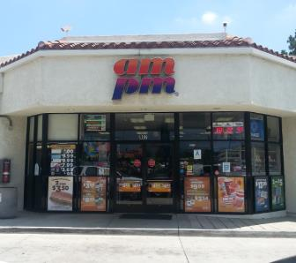

AM/PM at 902 HUNTINGTON DRIVE, DUARTE, CA

How often do you go to the store at THIS ADDRESS?

Never 0

Once a month 1

2-3 times a month 2

Once a week 3

2-3 times a week 4

Almost every day 5

(picture 165-59575.jpg)

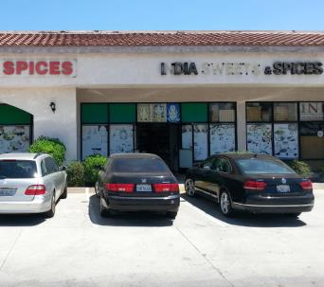

INDIA SWEETS & SPICES at 1208 HUNTINGTON DRIVE, DUARTE, CA

How often do you go to the store at THIS ADDRESS?

Never 0

Once a month 1

2-3 times a month 2

Once a week 3

2-3 times a week 4

Almost every day 5

(picture 165-62797.jpg)

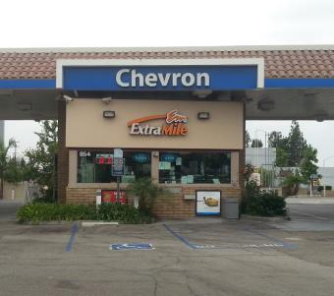

CHEVRON at 854 EAST HUNTINGTON DRIVE, MONROVIA, CA

How often do you go to the store at THIS ADDRESS?

Never 0

Once a month 1

2-3 times a month 2

Once a week 3

2-3 times a week 4

Almost every day 5

(picture 165-62798.jpg)

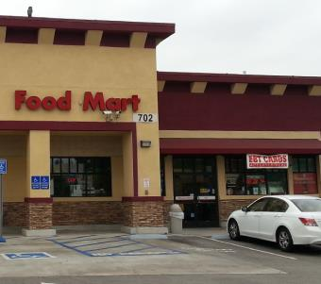

SHELL at 702 EAST HUNTINGTON DRIVE, MONROVIA, CA

How often do you go to the store at THIS ADDRESS?

Never 0

Once a month 1

2-3 times a month 2

Once a week 3

2-3 times a week 4

Almost every day 5

(picture 165-68622.jpg)

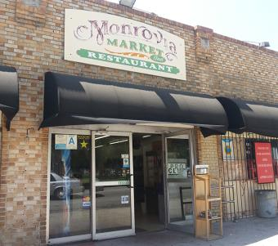

MONROVIA MARKET AND RESTAURANT at 525 SOUTH SHAMROCK AVENUE, MONROVIA, CA

How often do you go to the store at THIS ADDRESS?

Never 0

Once a month 1

2-3 times a month 2

Once a week 3

2-3 times a week 4

Almost every day 5

(picture fake.jpg)



7-ELEVEN at 831 EAST HUNTINGTON DRIVE, MONROVA, CA

How often do you go to the store at THIS ADDRESS?

Never 0

Once a month 1

2-3 times a month 2

Once a week 3

2-3 times a week 4

Almost every day 5

(If Yes…)

**Centinela Valley (ID: 115)**

(picture 115-60856.jpg)

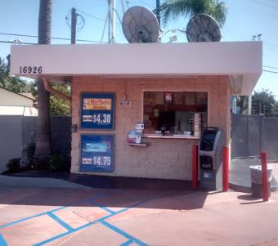

76 at 16926 HAWTHORNE BOULEVARD, LAWNDALE, CA

How often do you go to the store at THIS ADDRESS?

Never 0

Once a month 1

2-3 times a month 2

Once a week 3

2-3 times a week 4

Almost every day 5

(picture 115-60872.jpg)

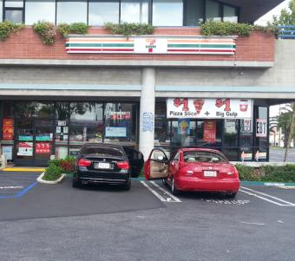

7-ELEVEN at 4401 REDONDO BEACH BOULEVARD, LAWNDALE, CA

How often do you go to the store at THIS ADDRESS?

Never 0

Once a month 1

2-3 times a month 2

Once a week 3

2-3 times a week 4

Almost every day 5

(picture fake.jpg)



7-ELEVEN at 4641 ARTESIA BOULEVARD, LAWNDALE, CA

How often do you go to the store at THIS ADDRESS?

Never 0

Once a month 1

2-3 times a month 2

Once a week 3

2-3 times a week 4

Almost every day 5

(If Yes…)

**Central (ID: 232)**

(picture 232-68687.jpg)

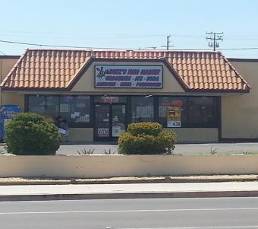

BUZZ'S MINI MARKET at 100 EAST MAIN STREET, BARSTOW, CA

How often do you go to the store at THIS ADDRESS?

Never 0

Once a month 1

2-3 times a month 2

Once a week 3

2-3 times a week 4

Almost every day 5

(picture 232-70528.jpg)

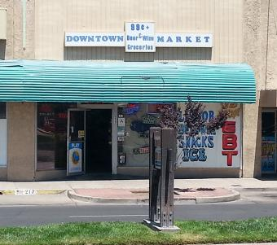

DOWNTOWN MARKET at 219 EAST MAIN STREET, BARSTOW, CA

How often do you go to the store at THIS ADDRESS?

Never 0

Once a month 1

2-3 times a month 2

Once a week 3

2-3 times a week 4

Almost every day 5

(picture 232-70809.jpg)

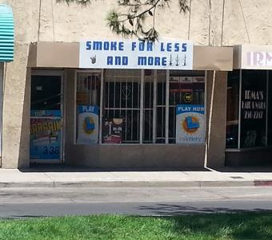

SMOKE FOR LESS AND MORE at 217 EAST MAIN STREET, BARSTOW, CA

How often do you go to the store at THIS ADDRESS?

Never 0

Once a month 1

2-3 times a month 2

Once a week 3

2-3 times a week 4

Almost every day 5

(picture fake.jpg)



7-ELEVEN at 524 EAST MAIN STREET, BARSTOW, CA

How often do you go to the store at THIS ADDRESS?

Never 0

Once a month 1

2-3 times a month 2

Once a week 3

2-3 times a week 4

Almost every day 5

(If Yes…)

**Chaparral (ID: 113)**

(picture 113-63814.jpg)

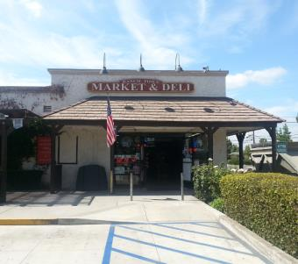

RANCH TOWN MARKET & DELI at 1112 NORTH SAN DIMAS AVENUE, SAN DIMAS, CA

How often do you go to the store at THIS ADDRESS?

Never 0

Once a month 1

2-3 times a month 2

Once a week 3

2-3 times a week 4

Almost every day 5

(picture fake.jpg)



7-ELEVEN at 409 WEST ALLEN AVENUE, SAN DIMAS, CA

How often do you go to the store at THIS ADDRESS?

Never 0

Once a month 1

2-3 times a month 2

Once a week 3

2-3 times a week 4

Almost every day 5

(If Yes…)

**Community (ID: 280)**

(picture fake.jpg)



7-ELEVEN at 6144 CONDOR DRIVE, MOORPARK, CA

How often do you go to the store at THIS ADDRESS?

Never 0

Once a month 1

2-3 times a month 2

Once a week 3

2-3 times a week 4

Almost every day 5

(If Yes…)

**Conejo Valley (ID: 278)**

(picture 278-52693.jpg)

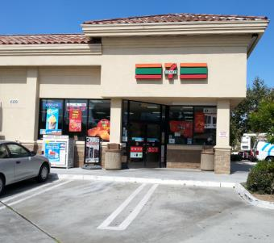

7-ELEVEN at 609 RANCHO CONEJO BOULEVARD, THOUSAND OAKS, CA

How often do you go to the store at THIS ADDRESS?

Never 0

Once a month 1

2-3 times a month 2

Once a week 3

2-3 times a week 4

Almost every day 5

(picture 278-52695.jpg)

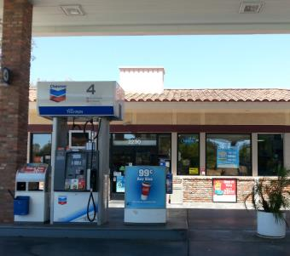

CHEVRON at 2290 BORCHARD ROAD, NEWBURY PARK, CA

How often do you go to the store at THIS ADDRESS?

Never 0

Once a month 1

2-3 times a month 2

Once a week 3

2-3 times a week 4

Almost every day 5

(picture 278-52697.jpg)

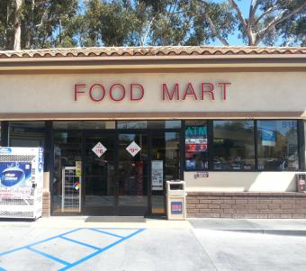

FOOD MART at 518 RANCHO CONEJO BOULEVARD, NEWBURY PARK, CA

How often do you go to the store at THIS ADDRESS?

Never 0

Once a month 1

2-3 times a month 2

Once a week 3

2-3 times a week 4

Almost every day 5

(picture 278-52700.jpg)

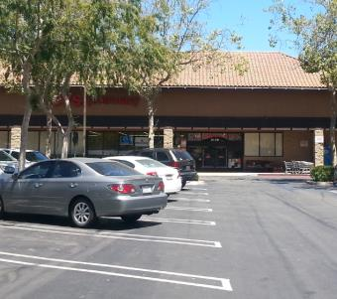

CVS at 2120 NEWBURY ROAD, NEWBURY PARK, CA

How often do you go to the store at THIS ADDRESS?

Never 0

Once a month 1

2-3 times a month 2

Once a week 3

2-3 times a week 4

Almost every day 5

(picture 278-52703.jpg)

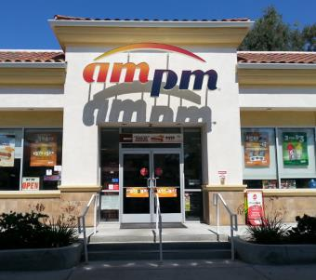

AM/PM at 2305 BORCHARD ROAD, NEWBURY PARK, CA

How often do you go to the store at THIS ADDRESS?

Never 0

Once a month 1

2-3 times a month 2

Once a week 3

2-3 times a week 4

Almost every day 5

(picture fake.jpg)



7-ELEVEN at 1620 NEWBURY ROAD, NEWBURY PARK, CA

How often do you go to the store at THIS ADDRESS?

Never 0

Once a month 1

2-3 times a month 2

Once a week 3

2-3 times a week 4

Almost every day 5

(If Yes…)

**Desert Winds (ID: 108)**

(picture 108-54276.jpg)

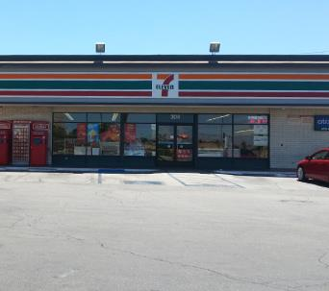

7-ELEVEN at 304 EAST AVENUE I, LANCASTER, CA

How often do you go to the store at THIS ADDRESS?

Never 0

Once a month 1

2-3 times a month 2

Once a week 3

2-3 times a week 4

Almost every day 5

(picture 108-65625.jpg)

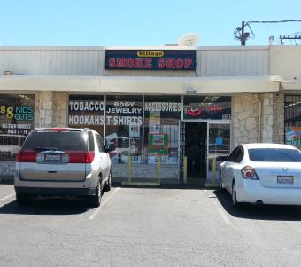

SMOKE SHOP at 326 EAST AVENUE I, LANCASTER, CA

How often do you go to the store at THIS ADDRESS?

Never 0

Once a month 1

2-3 times a month 2

Once a week 3

2-3 times a week 4

Almost every day 5

(picture 108-68457.jpg)

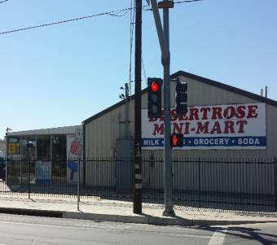

DESERT ROSE MINI MART at 106 WEST AVENUE I, LANCASTER, CA

How often do you go to the store at THIS ADDRESS?

Never 0

Once a month 1

2-3 times a month 2

Once a week 3

2-3 times a week 4

Almost every day 5

(picture 108-69149.jpg)

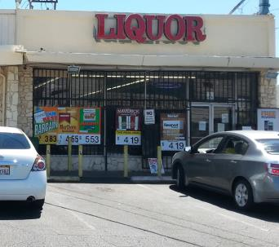

VILLAGE LIQUOR at 332 EAST AVENUE I, LANCASTER, CA

How often do you go to the store at THIS ADDRESS?

Never 0

Once a month 1

2-3 times a month 2

Once a week 3

2-3 times a week 4

Almost every day 5

(picture fake.jpg)



7-ELEVEN at 105 WEST AVENUE I, LANCASTER, CA

How often do you go to the store at THIS ADDRESS?

Never 0

Once a month 1

2-3 times a month 2

Once a week 3

2-3 times a week 4

Almost every day 5

(If Yes…)

**Fairvalley (ID: 117)**

(picture 117-53969.jpg)

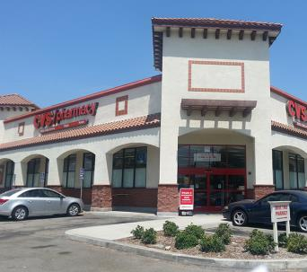

CVS at 915 EAST ARROW HIGHWAY, AZUSA, CA

How often do you go to the store at THIS ADDRESS?

Never 0

Once a month 1

2-3 times a month 2

Once a week 3

2-3 times a week 4

Almost every day 5

(picture 117-59375.jpg)

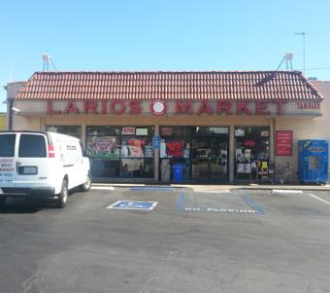

LARIOS MARKET at 19004 EAST ARROW HIGHWAY, COVINA, CA

How often do you go to the store at THIS ADDRESS?

Never 0

Once a month 1

2-3 times a month 2

Once a week 3

2-3 times a week 4

Almost every day 5

(picture 117-59383.jpg)

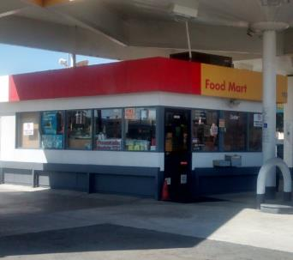

SHELL at 110 WEST ARROW HIGHWAY, COVINA, CA

How often do you go to the store at THIS ADDRESS?

Never 0

Once a month 1

2-3 times a month 2

Once a week 3

2-3 times a week 4

Almost every day 5

(picture fake.jpg)



7-ELEVEN at 1385 NORTH CITRUS AVENUE, COVINA, CA

How often do you go to the store at THIS ADDRESS?

Never 0

Once a month 1

2-3 times a month 2

Once a week 3

2-3 times a week 4

Almost every day 5

(If Yes…)

**Hillview (ID: 206)**

(picture 206-68332.jpg)

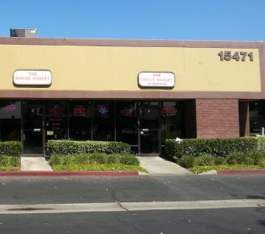

THE BREAD BASKET at 15471 RED HILL AVENUE, TUSTIN, CA

How often do you go to the store at THIS ADDRESS?

Never 0

Once a month 1

2-3 times a month 2

Once a week 3

2-3 times a week 4

Almost every day 5

(picture fake.jpg)



7-ELEVEN at 15052 RED HILL AVENUE, TUSTIN, CA

How often do you go to the store at THIS ADDRESS?

Never 0

Once a month 1

2-3 times a month 2

Once a week 3

2-3 times a week 4

Almost every day 5

(If Yes…)

**Jack London (ID: 139)**

(picture fake.jpg)



7-ELEVEN at 12500 OXNARD STREET, VAN NUYS, CA

How often do you go to the store at THIS ADDRESS?

Never 0

Once a month 1

2-3 times a month 2

Once a week 3

2-3 times a week 4

Almost every day 5

(If Yes…)

**Middle College (ID: 246)**

(picture 246-55040.jpg)

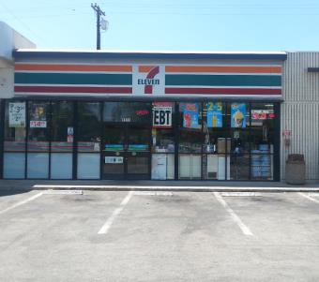

7-ELEVEN at 1511 NORTH MOUNT VERNON AVENUE, COLTON, CA

How often do you go to the store at THIS ADDRESS?

Never 0

Once a month 1

2-3 times a month 2

Once a week 3

2-3 times a week 4

Almost every day 5

(picture 246-56972.jpg)

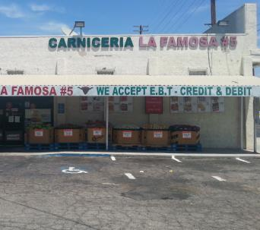

LA FAMOSA MARKET at 390 SOUTH MOUNT VERNON AVENUE, SAN BERNARDINO, CA

How often do you go to the store at THIS ADDRESS?

Never 0

Once a month 1

2-3 times a month 2

Once a week 3

2-3 times a week 4

Almost every day 5

(picture 246-67442.jpg)

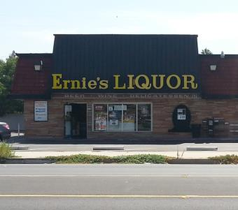

ERNIE'S LIQUOR at 539 SOUTH MOUNT VERNON AVENUE, SAN BERNARDINO, CA

How often do you go to the store at THIS ADDRESS?

Never 0

Once a month 1

2-3 times a month 2

Once a week 3

2-3 times a week 4

Almost every day 5

(picture 246-69891.jpg)

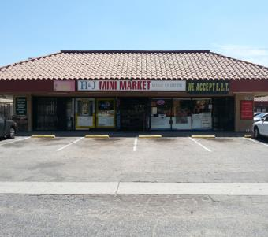

H&J MINI MARKET at 509 SOUTH MOUNT VERNON AVENUE, SAN BERNARDINO, CA

How often do you go to the store at THIS ADDRESS?

Never 0

Once a month 1

2-3 times a month 2

Once a week 3

2-3 times a week 4

Almost every day 5

(picture 246-70973.jpg)

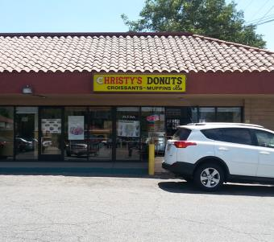

CHRISTY'S DONUTS at 1292 WEST MILL STREET, SAN BERNARDINO, CA

How often do you go to the store at THIS ADDRESS?

Never 0

Once a month 1

2-3 times a month 2

Once a week 3

2-3 times a week 4

Almost every day 5

(picture fake.jpg)



7-ELEVEN at 1791 NORTH MOUNT VERNON AVENUE, COLTON, CA

How often do you go to the store at THIS ADDRESS?

Never 0

Once a month 1

2-3 times a month 2

Once a week 3

2-3 times a week 4

Almost every day 5

(If Yes…)

**Mojave (ID: 254)**

(picture fake.jpg)



7-ELEVEN at 10924 HESPERIA ROAD, HESPERIA, CA

How often do you go to the store at THIS ADDRESS?

Never 0

Once a month 1

2-3 times a month 2

Once a week 3

2-3 times a week 4

Almost every day 5

(If Yes…)

**Monterey (ID: 114)**

(picture 114-58945.jpg)

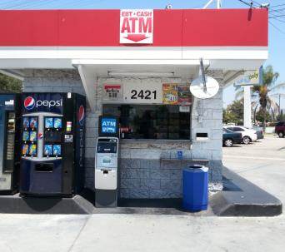

76 at 2421 WEST VICTORY BOULEVARD, BURBANK, CA

How often do you go to the store at THIS ADDRESS?

Never 0

Once a month 1

2-3 times a month 2

Once a week 3

2-3 times a week 4

Almost every day 5

(picture fake.jpg)



7-ELEVEN at 2457 WEST VICTORY BOULEVARD, BURBANK, CA

How often do you go to the store at THIS ADDRESS?

Never 0

Once a month 1

2-3 times a month 2

Once a week 3

2-3 times a week 4

Almost every day 5

(If Yes…)

**Mountain (ID: 244)**

(picture fake.jpg)



7-ELEVEN at 24835 LAKE DRIVE, CRESTLINE, CA

How often do you go to the store at THIS ADDRESS?

Never 0

Once a month 1

2-3 times a month 2

Once a week 3

2-3 times a week 4

Almost every day 5

(If Yes…)

**Mountain View (ID: 224)**

(picture 224-57859.jpg)

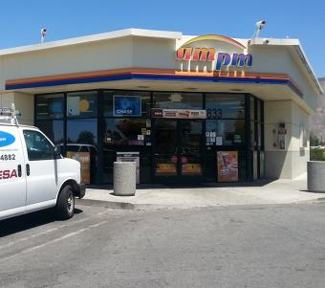

AM/PM at 833 NORTH RAMONA BOULEVARD, SAN JACINTO, CA

How often do you go to the store at THIS ADDRESS?

Never 0

Once a month 1

2-3 times a month 2

Once a week 3

2-3 times a week 4

Almost every day 5

(picture 224-57860.jpg)

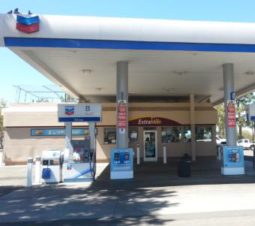

CHEVRON at 720 WEST RAMONA EXPRESSWAY, SAN JACINTO, CA

How often do you go to the store at THIS ADDRESS?

Never 0

Once a month 1

2-3 times a month 2

Once a week 3

2-3 times a week 4

Almost every day 5

(picture 224-57868.jpg)

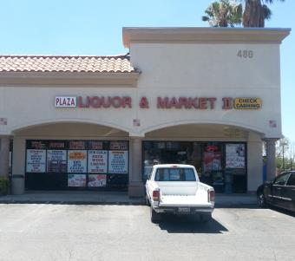

PLAZA LIQUOR & MARKET II at 480 NORTH STATE STREET, SAN JACINTO, CA

How often do you go to the store at THIS ADDRESS?

Never 0

Once a month 1

2-3 times a month 2

Once a week 3

2-3 times a week 4

Almost every day 5

(picture 224-65367.jpg)

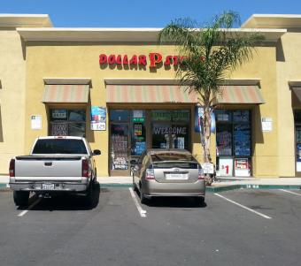

DOLLAR STORE at 651 NORTH STATE STREET, SAN JACINTO, CA

How often do you go to the store at THIS ADDRESS?

Never 0

Once a month 1

2-3 times a month 2

Once a week 3

2-3 times a week 4

Almost every day 5

(picture 224-66693.jpg)

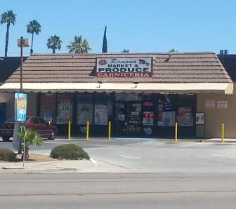

RAMONA MARKET AND PRODUCE at 794 NORTH RAMONA BOULEVARD, SAN JACINTO, CA

How often do you go to the store at THIS ADDRESS?

Never 0

Once a month 1

2-3 times a month 2

Once a week 3

2-3 times a week 4

Almost every day 5

(picture fake.jpg)



7-ELEVEN at 464 NORTH STATE STREET, SAN JACINTO, CA

How often do you go to the store at THIS ADDRESS?

Never 0

Once a month 1

2-3 times a month 2

Once a week 3

2-3 times a week 4

Almost every day 5

(If Yes…)

**North Park (ID: 111)**

(picture 111-58637.jpg)

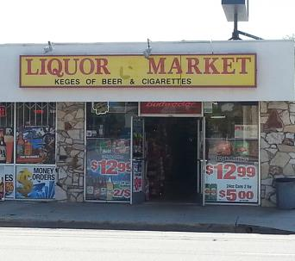

LIQUOR MARKET at 4503 MAINE AVENUE, BALDWIN PARK, CA

How often do you go to the store at THIS ADDRESS?

Never 0

Once a month 1

2-3 times a month 2

Once a week 3

2-3 times a week 4

Almost every day 5

(picture 111-58651.jpg)

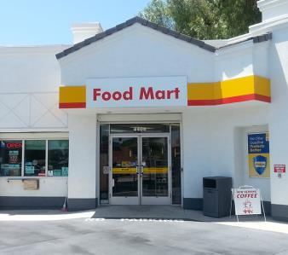

SHELL at 4405 MAINE AVENUE, BALDWIN PARK, CA

How often do you go to the store at THIS ADDRESS?

Never 0

Once a month 1

2-3 times a month 2

Once a week 3

2-3 times a week 4

Almost every day 5

(picture 111-58653.jpg)

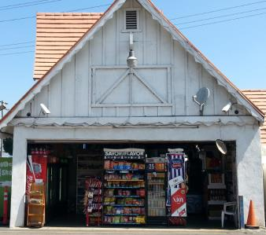

ROCKVIEW DAIRY at 4390 MAINE AVENUE, BALDWIN PARK, CA

How often do you go to the store at THIS ADDRESS?

Never 0

Once a month 1

2-3 times a month 2

Once a week 3

2-3 times a week 4

Almost every day 5

(picture 111-58681.jpg)

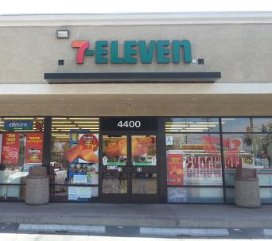

7-ELEVEN at 4400 MAINE AVENUE, BALDWIN PARK, CA

How often do you go to the store at THIS ADDRESS?

Never 0

Once a month 1

2-3 times a month 2

Once a week 3

2-3 times a week 4

Almost every day 5

(picture 111-58682.jpg)

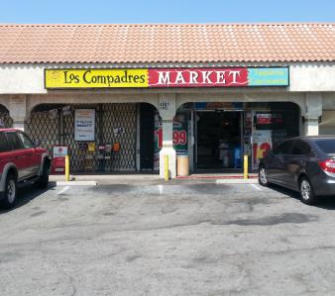

LOS COMPADRES MARKET at 4801 MAINE AVENUE, BALDWIN PARK, CA

How often do you go to the store at THIS ADDRESS?

Never 0

Once a month 1

2-3 times a month 2

Once a week 3

2-3 times a week 4

Almost every day 5

(picture 111-68637.jpg)

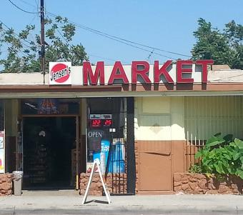

JENSEN'S MARKET at 4724 MAINE AVENUE, BALDWIN PARK, CA

How often do you go to the store at THIS ADDRESS?

Never 0

Once a month 1

2-3 times a month 2

Once a week 3

2-3 times a week 4

Almost every day 5

(picture fake.jpg)



7-ELEVEN at 14394 CLARK STREET, BALDWIN PARK, CA

How often do you go to the store at THIS ADDRESS?

Never 0

Once a month 1

2-3 times a month 2

Once a week 3

2-3 times a week 4

Almost every day 5

(If Yes…)

**Oak View (ID: 250)**

(picture fake.jpg)



7-ELEVEN at 12137 5TH STREET YUCAIPA, CA

How often do you go to the store at THIS ADDRESS?

Never 0

Once a month 1

2-3 times a month 2

Once a week 3

2-3 times a week 4

Almost every day 5

(If Yes…)

**Ortega (ID: 226)**

(picture fake.jpg)



7-ELEVEN at 31295 CHANEY STREET, LAKE ELSINORE, CA

How often do you go to the store at THIS ADDRESS?

Never 0

Once a month 1

2-3 times a month 2

Once a week 3

2-3 times a week 4

Almost every day 5

(If Yes…)

**Pacific (ID: 276)**

(picture 276-53784.jpg)

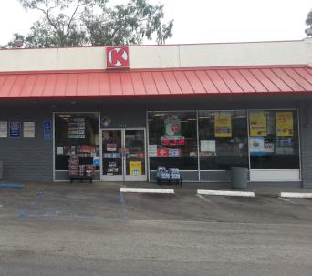

CIRCLE K at 3506 EAST MAIN STREET, VENTURA, CA

How often do you go to the store at THIS ADDRESS?

Never 0

Once a month 1

2-3 times a month 2

Once a week 3

2-3 times a week 4

Almost every day 5

(picture 276-53811.jpg)

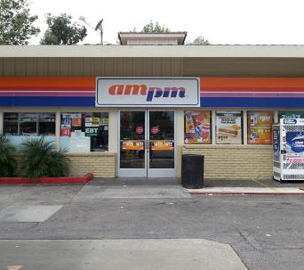

AM/PM at 605 SOUTH MILLS ROAD, VENTURA, CA

How often do you go to the store at THIS ADDRESS?

Never 0

Once a month 1

2-3 times a month 2

Once a week 3

2-3 times a week 4

Almost every day 5

(picture 276-66640.jpg)

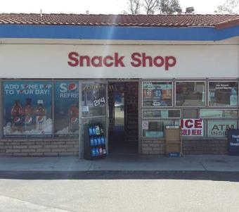

MOBIL at 3500 EAST MAIN STREET, VENTURA, CA

How often do you go to the store at THIS ADDRESS?

Never 0

Once a month 1

2-3 times a month 2

Once a week 3

2-3 times a week 4

Almost every day 5

(picture fake.jpg)



7-ELEVEN at 3748 TELEGRAPH ROAD, VENTURA, CA

How often do you go to the store at THIS ADDRESS?

Never 0

Once a month 1

2-3 times a month 2

Once a week 3

2-3 times a week 4

Almost every day 5

(If Yes…)

**Phoenix (North) (ID: 283)**

(picture fake.jpg)



7-ELEVEN at 220 WEST AVENUE H6, LANCASTER, CA

How often do you go to the store at THIS ADDRESS?

Never 0

Once a month 1

2-3 times a month 2

Once a week 3

2-3 times a week 4

Almost every day 5

(If Yes…)

**Phoenix (South) (ID: 282)**

(picture fake.jpg)



7-ELEVEN at 38815 20TH STREET EAST, PALMDALE, CA

How often do you go to the store at THIS ADDRESS?

Never 0

Once a month 1

2-3 times a month 2

Once a week 3

2-3 times a week 4

Almost every day 5

(If Yes…)

**R. K. Lloyde (ID: 116)**

(picture 116-60858.jpg)

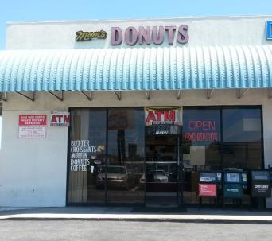

MOM'S DONUTS at 15102 INGLEWOOD AVENUE, LAWNDALE, CA

How often do you go to the store at THIS ADDRESS?

Never 0

Once a month 1

2-3 times a month 2

Once a week 3

2-3 times a week 4

Almost every day 5

(picture 116-63733.jpg)

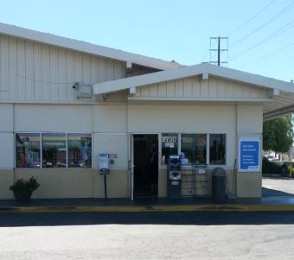

ARCO at 2730 MARINE AVENUE, REDONDO BEACH, CA

How often do you go to the store at THIS ADDRESS?

Never 0

Once a month 1

2-3 times a month 2

Once a week 3

2-3 times a week 4

Almost every day 5

(picture 116-67948.jpg)

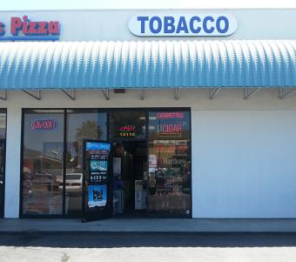

INTERNATIONAL TOBACCO at 15116 INGLEWOOD AVENUE, LAWNDALE, CA

How often do you go to the store at THIS ADDRESS?

Never 0

Once a month 1

2-3 times a month 2

Once a week 3

2-3 times a week 4

Almost every day 5

(picture fake.jpg)



7-ELEVEN at 3859 INGLEWOOD AVENUE, REDONDO BEACH, CA

How often do you go to the store at THIS ADDRESS?

Never 0

Once a month 1

2-3 times a month 2

Once a week 3

2-3 times a week 4

Almost every day 5

(If Yes…)

**Rex Parris (ID: 109)**

(picture fake.jpg)



7-ELEVEN at 38712 6TH STREET E, PALMDALE, CA

How often do you go to the store at THIS ADDRESS?

Never 0

Once a month 1

2-3 times a month 2

Once a week 3

2-3 times a week 4

Almost every day 5

(If Yes…)

**Rose City (ID: 171)**

(picture 171-63364.jpg)

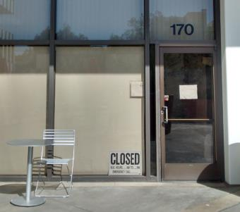

PLAZA CAFE at 251 SOUTH LAKE AVENUE, PASADENA, CA

How often do you go to the store at THIS ADDRESS?

Never 0

Once a month 1

2-3 times a month 2

Once a week 3

2-3 times a week 4

Almost every day 5

(picture 171-63365.jpg)

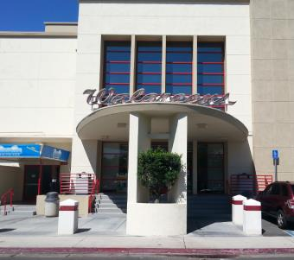

WALGREENS at 310 SOUTH LAKE AVENUE, PASADENA, CA

How often do you go to the store at THIS ADDRESS?

Never 0

Once a month 1

2-3 times a month 2

Once a week 3

2-3 times a week 4

Almost every day 5

(picture 171-63367.jpg)

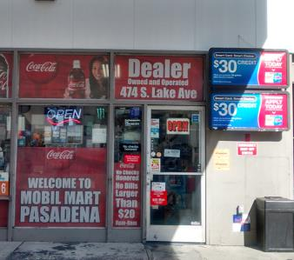

MOBIL at 474 SOUTH LAKE AVENUE, PASADENA, CA

How often do you go to the store at THIS ADDRESS?

Never 0

Once a month 1

2-3 times a month 2

Once a week 3

2-3 times a week 4

Almost every day 5

(picture 171-65547.jpg)

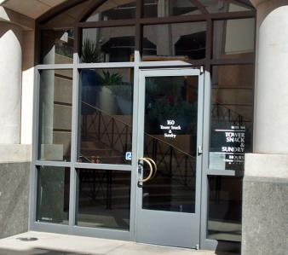

TOWER SNACK & SUNDRY at 55 SOUTH LAKE AVENUE, PASADENA, CA

How often do you go to the store at THIS ADDRESS?

Never 0

Once a month 1

2-3 times a month 2

Once a week 3

2-3 times a week 4

Almost every day 5

(picture 171-67504.jpg)

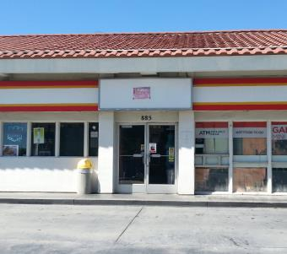

GARY'S MINI MART at 885 EAST CALIFORNIA BOULEVARD, PASADENA, CA

How often do you go to the store at THIS ADDRESS?

Never 0

Once a month 1

2-3 times a month 2

Once a week 3

2-3 times a week 4

Almost every day 5

(picture fake.jpg)

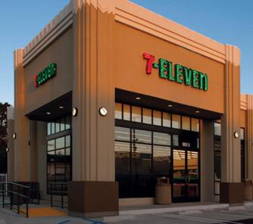

7-ELEVEN at 805 EAST COLORADO BOULEVARD, CA

How often do you go to the store at THIS ADDRESS?

Never 0

Once a month 1

2-3 times a month 2

Once a week 3

2-3 times a week 4

Almost every day 5

(If Yes…)

**Santana (ID: 181)**

(picture fake.jpg)



7-ELEVEN at 627 LA SEDA ROAD, LA PUENTE, CA

How often do you go to the store at THIS ADDRESS?

Never 0

Once a month 1

2-3 times a month 2

Once a week 3

2-3 times a week 4

Almost every day 5

(If Yes…)

**Sherry (ID: 174)**

(picture fake.jpg)



7-ELEVEN at 22511 CRENSHAW BOULEVARD, TORRANCE, CA

How often do you go to the store at THIS ADDRESS?

Never 0

Once a month 1

2-3 times a month 2

Once a week 3

2-3 times a week 4

Almost every day 5

(If Yes…)

**Somerset (ID: 112)**

(picture 112-58780.jpg)

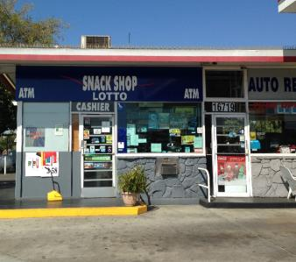

76 at 16719 LAKEWOOD BOULEVARD, BELLFLOWER, CA

How often do you go to the store at THIS ADDRESS?

Never 0

Once a month 1

2-3 times a month 2

Once a week 3

2-3 times a week 4

Almost every day 5

(picture 112-65767.jpg)

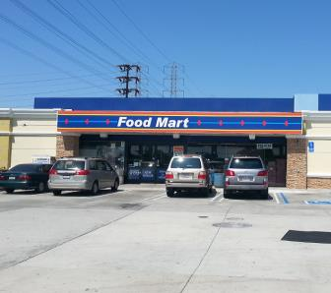

ARCO at 17020 LAKEWOOD BOULEVARD, BELLFLOWER, CA

How often do you go to the store at THIS ADDRESS?

Never 0

Once a month 1

2-3 times a month 2

Once a week 3

2-3 times a week 4

Almost every day 5

(picture 112-70582.jpg)

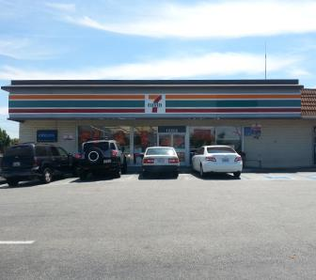

7-ELEVEN at 16852 LAKEWOOD BOULEVARD, BELLFLOWER, CA

How often do you go to the store at THIS ADDRESS?

Never 0

Once a month 1

2-3 times a month 2

Once a week 3

2-3 times a week 4

Almost every day 5

(picture fake.jpg)



7-ELEVEN at 16917 LAKEWOOD BOULEVARD, BELLFLOWER, CA

How often do you go to the store at THIS ADDRESS?

Never 0

Once a month 1

2-3 times a month 2

Once a week 3

2-3 times a week 4

Almost every day 5

(If Yes…)

**Tracy (ID: 105)**

(picture 105-59005.jpg)

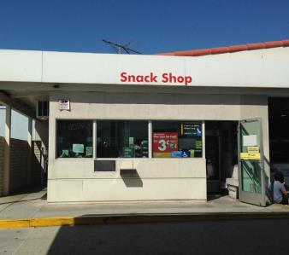

SHELL at 16821 NORWALK BOULEVARD, CERRITOS, CA

How often do you go to the store at THIS ADDRESS?

Never 0

Once a month 1

2-3 times a month 2

Once a week 3

2-3 times a week 4

Almost every day 5

(picture 105-59012.jpg)

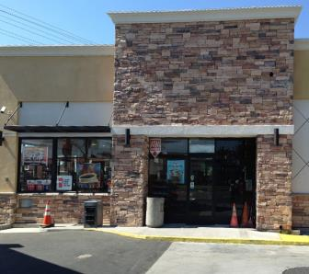

ARCO at 12157 ARTESIA BOULEVARD, CERRITOS, CA

How often do you go to the store at THIS ADDRESS?

Never 0

Once a month 1

2-3 times a month 2

Once a week 3

2-3 times a week 4

Almost every day 5

(picture 105-59021.jpg)

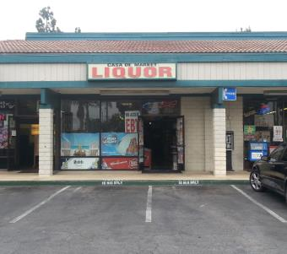

CASA DE MARKET at 16432 NORWALK BOULEVARD, CERRITOS, CA

How often do you go to the store at THIS ADDRESS?

Never 0

Once a month 1

2-3 times a month 2

Once a week 3

2-3 times a week 4

Almost every day 5

(picture 105-68957.jpg)

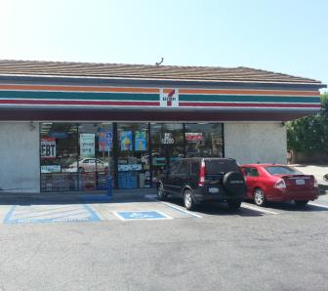

7-ELEVEN at 12200 ARTESIA BOULEVARD, ARTESIA, CA

How often do you go to the store at THIS ADDRESS?

Never 0

Once a month 1

2-3 times a month 2

Once a week 3

2-3 times a week 4

Almost every day 5

(picture fake.jpg)



7-ELEVEN at 17198 NORWALK BOULEVARD, CERRITOS, CA

How often do you go to the store at THIS ADDRESS?

Never 0

Once a month 1

2-3 times a month 2

Once a week 3

2-3 times a week 4

Almost every day 5

(If Yes…)

**Val Verde (ID: 229)**

(picture fake.jpg)



7-ELEVEN at 3601 BRENNAN AVENUE, PERRIS, CA

How often do you go to the store at THIS ADDRESS?

Never 0

Once a month 1

2-3 times a month 2

Once a week 3

2-3 times a week 4

Almost every day 5

(If Yes…)

**Valley Vista (ID: 195)**

(picture 195-59665.jpg)

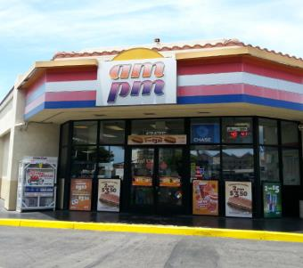

AM/PM at 17475 BROOKHURST STREET, FOUNTAIN VALLEY, CA

How often do you go to the store at THIS ADDRESS?

Never 0

Once a month 1

2-3 times a month 2

Once a week 3

2-3 times a week 4

Almost every day 5

(picture 195-59666.jpg)



ARCO at 17520 BROOKHURST STREET, FOUNTAIN VALLEY, CA

How often do you go to the store at THIS ADDRESS?

Never 0

Once a month 1

2-3 times a month 2

Once a week 3

2-3 times a week 4

Almost every day 5

(picture fake.jpg)



7-ELEVEN at 10000 SLATER AVENUE, FOUNTAIN VALLEY, CA

How often do you go to the store at THIS ADDRESS?

Never 0

Once a month 1

2-3 times a month 2

Once a week 3

2-3 times a week 4

Almost every day 5

(If Yes…)

**Youth Opportunities (ID: 161)**

(picture 161-62403.jpg)

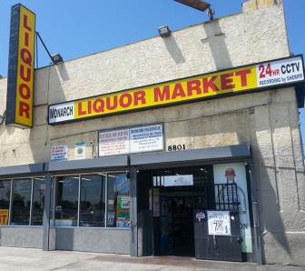

LIQUOR MARKET at 8801 SOUTH VERMONT AVENUE, LOS ANGELES, CA

How often do you go to the store at THIS ADDRESS?

Never 0

Once a month 1

2-3 times a month 2

Once a week 3

2-3 times a week 4

Almost every day 5

(picture 161-62407.jpg)

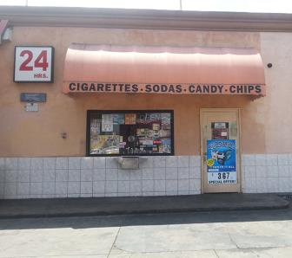

ARCO at 800 WEST MANCHESTER AVENUE, LOS ANGELES, CA

How often do you go to the store at THIS ADDRESS?

Never 0

Once a month 1

2-3 times a month 2

Once a week 3

2-3 times a week 4

Almost every day 5

(picture 161-67145.jpg)

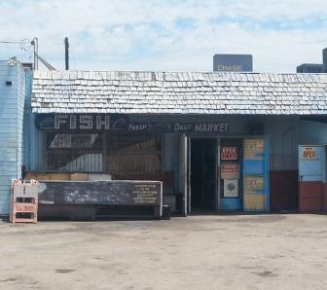

MANCHESTER FISH at 1059 WEST MANCHESTER AVENUE, LOS ANGELES, CA

How often do you go to the store at THIS ADDRESS?

Never 0

Once a month 1

2-3 times a month 2

Once a week 3

2-3 times a week 4

Almost every day 5

(picture 161-67603.jpg)

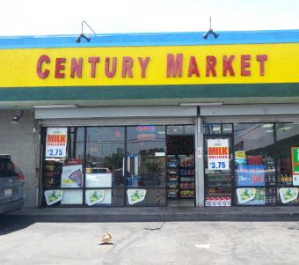

CENTURY MARKET at 8453 SOUTH FIGUEROA STREET, LOS ANGELES, CA

How often do you go to the store at THIS ADDRESS?

Never 0

Once a month 1

2-3 times a month 2

Once a week 3

2-3 times a week 4

Almost every day 5

(picture 161-67613.jpg)

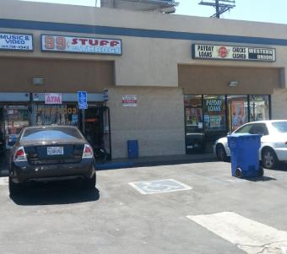

99 CENT STUFF & THANGS at 8608 SOUTH VERMONT AVENUE, LOS ANGELES, CA

How often do you go to the store at THIS ADDRESS?

Never 0

Once a month 1

2-3 times a month 2

Once a week 3

2-3 times a week 4

Almost every day 5

(picture 161-67932.jpg)

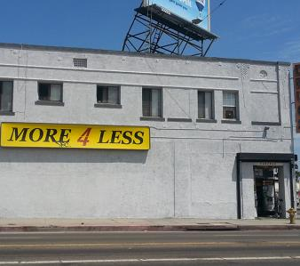

MORE 4 LESS at 1011 WEST MANCHESTER AVENUE, LOS ANGELES, CA

How often do you go to the store at THIS ADDRESS?

Never 0

Once a month 1

2-3 times a month 2

Once a week 3

2-3 times a week 4

Almost every day 5

(picture 161-68042.jpg)

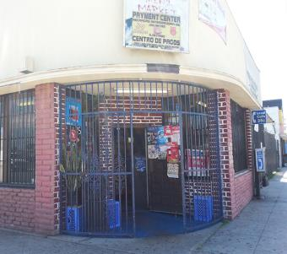

ANGELS MINI-MARKET at 8500 SOUTH HOOVER STREET, LOS ANGELES, CA

How often do you go to the store at THIS ADDRESS?

Never 0

Once a month 1

2-3 times a month 2

Once a week 3

2-3 times a week 4

Almost every day 5

(picture 161-68422.jpg)

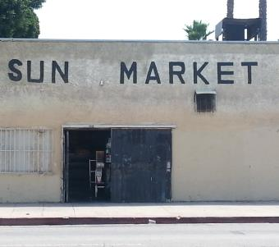

SUN MARKET at 8107 SOUTH HOOVER STREET, LOS ANGELES, CA

How often do you go to the store at THIS ADDRESS?

Never 0

Once a month 1

2-3 times a month 2

Once a week 3

2-3 times a week 4

Almost every day 5

(picture 161-69978.jpg)

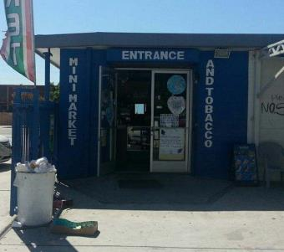

LUCKY MINI MARKET & TOBACCO at 1111 WEST MANCHESTER AVENUE, LOS ANGELES, CA

How often do you go to the store at THIS ADDRESS?

Never 0

Once a month 1

2-3 times a month 2

Once a week 3

2-3 times a week 4

Almost every day 5

(picture 161-70307.jpg)

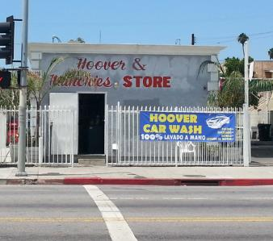

HOOVER & MUNCHIES STORE at 803 WEST 83RD STREET, LOS ANGELES, CA

How often do you go to the store at THIS ADDRESS?

Never 0

Once a month 1

2-3 times a month 2

Once a week 3

2-3 times a week 4

Almost every day 5

(picture 161-70361.jpg)

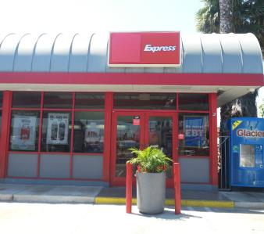

76 at 400 WEST MANCHESTER AVENUE, LOS ANGELES, CA

How often do you go to the store at THIS ADDRESS?

Never 0

Once a month 1

2-3 times a month 2

Once a week 3

2-3 times a week 4

Almost every day 5

(picture 161-70615.jpg)

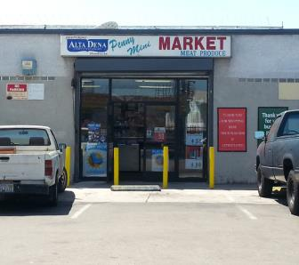

PENNY MINI MARKET at 1001-1023 WEST 89TH STREET, LOS ANGELES, CA

How often do you go to the store at THIS ADDRESS?

Never 0

Once a month 1

2-3 times a month 2

Once a week 3

2-3 times a week 4

Almost every day 5

(picture 161-72452.jpg)

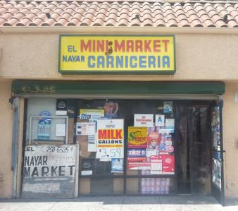

EL NAYAR MINI MARKET at 8301 SOUTH VERMONT AVENUE, LOS ANGELES, CA

How often do you go to the store at THIS ADDRESS?

Never 0

Once a month 1

2-3 times a month 2

Once a week 3

2-3 times a week 4

Almost every day 5

(picture fake.jpg)



7-ELEVEN at 8310 SOUTH VERMONT AVENUE, LOS ANGELES, CA

How often do you go to the store at THIS ADDRESS?

Never 0

Once a month 1

2-3 times a month 2

Once a week 3

2-3 times a week 4

Almost every day 5

**Tobacco Initiation - Part 1**

**Source:** Adapted from Centers for Disease Control and Prevention (CDC). (2014a). 2012 National youth tobacco survey (NYTS). Retrieved from: <http://www.cdc.gov/TOBACCO/data_statistics/surveys/NYTS/index.htm>

**Designed For:** Adolescents

**Psychometrics**: Not reported

**Codebook**:

1. Which of the following tobacco products have you ever tried, even just one time? (Check all that apply) W3AMQ1, W3TobEverUse1, 0 When Not Selected, 1 When Selected

Cigarettes (Marlboro, Camel, Newport, American Spirit, etc.) W3AMQ1option1 W3TobEverUseCig1

Electronic Cigarettes (Blu, NJOY, MarkTen, etc.) W3AMQ1option2 W3TobEverUseECig1

Cigars, Cigarillos, or Little Cigars (Black and Mild, Swisher Sweets, Dutch Masters, etc.)

W3AMQ1option3 W3TobEverUseCigar1

Chewing Tobacco, Snuff, or Dip (Copenhagen, Grizzly, Skoal, etc.) W3AMQ1option4 W3TobEverUseChew1

Tobacco smoked out of a traditional pipe (Captain Black, Lane Limited, etc.)

W3AMQ1option5 W3TobEverUsePipe1

Hookah or Shisha (Starbuzz, Fantasia, Fumari, etc.) W3AMQ1option6 W3TobEverUseHookah1

I have never tried any of these tobacco products W3AMQ1option7 W3TobEverUseNever1

**Cigarette Use**

**Source:** Adapted from:

Centers for Disease Control and Prevention (CDC). (2014a). 2012 National youth tobacco survey (NYTS). Retrieved from: <http://www.cdc.gov/TOBACCO/data_statistics/surveys/NYTS/index.htm>

Centers for Disease Control and Prevention (CDC). (2014b). 2011 Youth tobacco survey (YTS). Retrieved from: <http://www.cdc.gov/tobacco/data_statistics/surveys/yts/index.htm>

Methods for classifying the various smoker types are depicted in IARC Working Group on Methods for Evaluating Tobacco Control Policies. (2008). Methods for evaluating tobacco control policies. International Agency for Research on Cancer.

Additional classification information is also provided in Mayhew, K.P., Flay, B.R., Mott J.A. (2000). Stages in the development of adolescent smoking. *Drug and Alcohol Dependence, 1* (59), S61-81.

**Designed For:** Adolescents

**Psychometrics**: Not reported

**Codebook**:

1. About how many cigarettes have you smoked in your entire life? W3ANQ1 W3CigUseLife1

None 0

1 or more puffs but never a whole cigarette 1

1 cigarette 2

2 to 5 cigarettes 3

6 to 15 cigarettes 4

16 to 25 cigarettes (about 1 pack) 5

26 to 99 cigarettes (more than 1 pack, but less than 5 packs) 6

100 or more cigarettes (5 or more packs) 7

1. Have you ever smoked cigarettes daily, that is, at least one cigarette every day for 30 days? W3ANQ2 W3CigUseDaily2

Yes 1

No 0

1. During the past 30 days, how many cigarettes did you smoke per day? W3ANQ3 W3CigUsePastMonth3

I did not smoke cigarettes during the past 30 days 0

Less than 1 cigarette per day 1

1 cigarette per day 2

2 to 5 cigarettes per day 3

6 to 10 cigarettes per day 4

11 to 20 cigarettes per day 5

More than 20 cigarettes per day 6

**Tobacco Initiation - Part 2**

**Source:** Adapted from Centers for Disease Control and Prevention (CDC). (2014a). 2012 National youth tobacco survey (NYTS). Retrieved from: <http://www.cdc.gov/TOBACCO/data_statistics/surveys/NYTS/index.htm>

**Designed For:** Adolescents

**Psychometrics**: Not reported

**Codebook**:

1. How old were you when you first smoked a cigarette? W3AOQ1 W3TobFirstUseCig1

Never tried 0

8 years old or younger 8

9 years old 9

10 years old 10

11 years old 11

12 years old 12

13 years old 13

14 years old 14

15 years old 15

16 years old 16

17 years old 17

18 years old 18

19 years old or older 19

1. How old were you when you first smoked a WHOLE cigarette? W3AOQ2 W3TobFirstUseWholeCig2

Never tried 0

8 years old or younger 8

9 years old 9

10 years old 10

11 years old 11

12 years old 12

13 years old 13

14 years old 14

15 years old 15

16 years old 16

17 years old 17

18 years old 18

19 years old or older 19

1. How old were you when you first smoked an electronic cigarette, vaporizer, or vape pen? W3AOQ3 W3TobFirstUseECig3

Never tried 0

8 years old or younger 8

9 years old 9

10 years old 10

11 years old 11

12 years old 12

13 years old 13

14 years old 14

15 years old 15

16 years old 16

17 years old 17

18 years old 18

19 years old or older 19

1. How old were you when you smoked a cigar, cigarillo, or little cigar? W3AOQ4 W3TobFirstUseCigar4

Never tried 0

8 years old or younger 8

9 years old 9

10 years old 10

11 years old 11

12 years old 12

13 years old 13

14 years old 14

15 years old 15

16 years old 16

17 years old 17

18 years old 18

19 years old or older 19

1. How old were you when you first had chewing tobacco, snuff, or dip? W3AOQ5 W3TobFirstUseChew5

Never tried 0

8 years old or younger 8

9 years old 9

10 years old 10

11 years old 11

12 years old 12

13 years old 13

14 years old 14

15 years old 15

16 years old 16

17 years old 17

18 years old 18

19 years old or older 19

**Tobacco Initiation - Part 3**

**Source:** Adapted from Centers for Disease Control and Prevention (CDC). (2014a). 2012 National youth tobacco survey (NYTS). Retrieved from: <http://www.cdc.gov/TOBACCO/data_statistics/surveys/NYTS/index.htm>

**Designed For:** Adolescents

**Psychometrics**: Not reported

**Codebook**:

1. What was the first brand of cigarettes you tried? W3APQ1 W3TobFirstBrandCig1

Never tried cigarettes 0

American Spirit 1

Camel 2

GPC, Basic, or Doral 3

Kool 4

Lucky Strike 5

Marlboro 6

Newport 7

Parliament 8

Summit -5

Virginia Slims 9

I don’t know -7

Another brand (please specify): 10 _________ W3APQ1other W3TobFirstBrandCigOther1

1. What was the first brand of electronic cigarettes, vaporizers, or vape pens you tried? W3APQ2 W3TobFirstBrandECig2

Never tried electronic cigarettes, vaporizers, or vape pens 0

Blu 1

Green Smart Living 2

MarkTen 3

NJOY 4

Xcite* -5

Square 5

Vuse 6

V2 7

I don’t know -7

Another brand (please specify): 8 ___________ W3APQ2other W3TobFirstBrandECigOther2

1. What was the first brand of cigars, cigarillos, or little cigars you tried? W3APQ3 W3TobFirstBrandCigar3

Never tried cigars, cigarillos, or little cigars 0

Al Capone 1

Backwoods 2

Black and Mild 3

Colonials -5

Dutch Masters 4

Phillies 5

Prime Time 6

Royal Comfort 7

Splitarillos 8

Swisher Sweets 9

White Owl 10

I don’t know -7

Another brand (please specify): 11 ___________ W3APQ3other W3TobFirstBrandCigarOther3

1. What was the first brand of chewing tobacco, snuff, or dip you tried? W3APQ4 W3TobFirstBrandChew4

Never tried chewing tobacco, snuff, or dip 0

Beechnut 1

Back Country -5

Copenhagen 2

Grizzly 3

Kodiak 4

Levi Garrett 5

Longhorn 6

Red Man 7

Skoal 8

I don’t know -7

Another brand (please specify): 9 ___________ W3APQ4other W3TobFirstBrandChewOther4

**Recent Tobacco Use - Part 1**

**Source:** Adapted from Centers for Disease Control and Prevention (CDC). (2014a). 2012 National youth tobacco survey (NYTS). Retrieved from: <http://www.cdc.gov/TOBACCO/data_statistics/surveys/NYTS/index.htm>

Methods for classifying the various smoker types are depicted in IARC Working Group on Methods for Evaluating Tobacco Control Policies. (2008). Methods for evaluating tobacco control policies. International Agency for Research on Cancer.

Additional classification information is also provided in Mayhew, K.P., Flay, B.R., Mott J.A. (2000). Stages in the development of adolescent smoking. *Drug and Alcohol Dependence, 1* (59), S61-81.

**Designed For:** Adolescents

**Psychometrics**: Not reported

**Codebook**:

When was the last time you used…

1. Cigarettes W3AQQ1 W3TobLastUseCig1

Never tried 0

Earlier today 7

1 to 6 days ago 6

7 to 30 days ago 5

1 to 5 months ago 4

6 to 11 months ago 3

1 to 4 years ago 2

5 or more years ago 1

1. Electronic Cigarettes, Vaporizers, or Vape Pens W3AQQ2 W3TobLastUseEcig2

Never tried 0

Earlier today 7

1 to 6 days ago 6

7 to 30 days ago 5

1 to 5 months ago 4

6 to 11 months ago 3

1 to 4 years ago 2

5 or more years ago 1

1. Cigars, Cigarillos, or Little Cigars W3AQQ3 W3TobLastUseCigar3

Never tried 0

Earlier today 7

1 to 6 days ago 6

7 to 30 days ago 5

1 to 5 months ago 4

6 to 11 months ago 3

1 to 4 years ago 2

5 or more years ago 1

1. Chewing Tobacco, Snuff, or Dip W3AQQ4 W3TobLastUseChew4

Never tried 0

Earlier today 7

1 to 6 days ago 6

7 to 30 days ago 5

1 to 5 months ago 4

6 to 11 months ago 3

1 to 4 years ago 2

5 or more years ago 1

1. Pipe Tobacco W3AQQ5 W3TobLastUsePipe5

Never tried 0

Earlier today 7

1 to 6 days ago 6

7 to 30 days ago 5

1 to 5 months ago 4

6 to 11 months ago 3

1 to 4 years ago 2

5 or more years ago 1

1. Hookah or Shisha W3AQQ6 W3TobLastUseHookah6

Never tried 0

Earlier today 7

1 to 6 days ago 6

7 to 30 days ago 5

1 to 5 months ago 4

6 to 11 months ago 3

1 to 4 years ago 2

5 or more years ago 1

**Recent Tobacco Use - Part 2**

**Source:** Adapted from Centers for Disease Control and Prevention (CDC). (2014a). 2012 National youth tobacco survey (NYTS). Retrieved from: <http://www.cdc.gov/TOBACCO/data_statistics/surveys/NYTS/index.htm>

Methods for classifying the various smoker types are depicted in IARC Working Group on Methods for Evaluating Tobacco Control Policies. (2008). Methods for evaluating tobacco control policies. International Agency for Research on Cancer.

Additional classification information is also provided in Mayhew, K.P., Flay, B.R., Mott J.A. (2000). Stages in the development of adolescent smoking. *Drug and Alcohol Dependence, 1* (59), S61-81.

**Designed For:** Adolescents

**Psychometrics**: Not reported

**Codebook**:

During the past 30 days, on how many days did you use each of the tobacco products below?

|  |  |  |  |  |  |  |  |
| --- | --- | --- | --- | --- | --- | --- | --- |
|  | 0  days | 1 or 2  days | 3 to 5  days | 6 to 9  days | 10 to 19  days | 20 to 29  days | All 30 days |
| ***Cigarettes***  W3ARQ1 W3Tob30DayUseCig1 | ❑0 | ❑1 | ❑2 | ❑3 | ❑4 | ❑5 | ❑6 |
| ***Electronic Cigarettes, Vaporizers, or Vape Pens***  W3ARQ2 W3Tob30DayUseEcig2 | ❑0 | ❑1 | ❑2 | ❑3 | ❑4 | ❑5 | ❑6 |
| ***Cigars, Cigarillos, or Little Cigars***  W3ARQ3 W3Tob30DayUseCigar3 | ❑0 | ❑1 | ❑2 | ❑3 | ❑4 | ❑5 | ❑6 |
| ***Chewing Tobacco, Snuff, or Dip***  W3ARQ4 W3Tob30DayUseChew4 | ❑0 | ❑1 | ❑2 | ❑3 | ❑4 | ❑5 | ❑6 |
| ***Pipe Tobacco***  W3ARQ5 W3Tob30DayUsePipe5 | ❑0 | ❑1 | ❑2 | ❑3 | ❑4 | ❑5 | ❑6 |
| ***Hookah or Shisha***  W3ARQ6 W3Tob30DayUseHookah6 | ❑0 | ❑1 | ❑2 | ❑3 | ❑4 | ❑5 | ❑6 |

**Tobacco Quantity - Part 1**

**Source:** Adapted from Centers for Disease Control and Prevention (CDC). (2014a). 2012 National youth tobacco survey (NYTS). Retrieved from: <http://www.cdc.gov/TOBACCO/data_statistics/surveys/NYTS/index.htm>

**Designed For:** Adolescents

**Psychometrics**: Not reported

**Codebook**:

1. On a typical day, which tobacco products do you use? (Check all that apply) W3ASQ1, W3TobConcurrentUse1, 0 When Not Selected, 1 When Selected

Cigarettes W3ASQ1option1 W3TobConcurrentUseCig1

Electronic Cigarettes, Vaporizers, or Vape Pens W3ASQ1option2 W3TobConcurrentUseEcig1

Cigars, Cigarillos, or Little Cigars W3ASQ1option3 W3TobConcurrentUseCigar1

Chewing Tobacco, Snuff, or Dip W3ASQ1option4 W3TobConcurrentUseChew1

Pipe Tobacco W3ASQ1option5 W3TobConcurrentUsePipe1

Hookah or Shisha W3ASQ1option6 W3TobConcurrentUseHookah1

None of the above W3ASQ1option7 W3TobConcurrentUseNone1

**Modified Fagerstrom Tolerance Questionnaire (mFTQ) for Adolescents**

**Source:** Prokhorov, A.V., Pallonen, U.E., Fava, J.L., Ding, L., & Niaura, R. (1996). Measuring nicotine dependence among high-risk adolescent smokers. *Addictive Behaviors*, *21*(1), 117-127.

Prokhorov, A.V., De Moor, C., Pallonen, U.E., Suchanek Hudmon, K., Koehly, L., & Hu, S. (2000). Validation of the modified Fagerström Tolerance Questionnaire with salivary cotinine among adolescents. *Addictive Behaviors, 25*(3), 429-433.

**Designed For:** Adolescents

**Psychometrics**: Not reported

**Codebook**:

1. How many cigarettes a day do you smoke? W3ATQ1 W3FagerCigs1

Over 26 cigarettes a day 4

About 16-25 cigarettes a day 3

About 1-15 cigarettes a day 2

Less than 1 a day 1

1. Do you inhale? W3ATQ2 W3FagerInhale2

Always 4

Quite often 3

Seldom 2

Never 1

1. How soon after you wake up do you smoke your first cigarette? W3ATQ3 W3FagerWakeUp3

Within the first 30 minutes 4

More than 30 minutes after waking but before noon 3

In the afternoon 2

In the evening 1

I currently don’t smoke cigarettes 0

1. Which cigarette would you hate to give up? W3ATQ4 W3FagerHateToGiveUp4

First cigarette in the morning 4

Any other cigarette before noon 3

Any other cigarette after noon 2

Any other cigarette in the evening 1

I currently don’t smoke cigarettes 0

1. Do you find it difficult to refrain from smoking in places where it is forbidden (church, library, movies etc.)? W3ATQ5 W3FagerRefrainSmoking5

Yes, very difficult 4

Yes, somewhat difficult 3

No, not usually difficult 2

No, not at all difficult 1

1. Do you smoke if you are so ill that you are in bed most of the day? W3ATQ6 W3FagerSmokeIll6

Yes, always 4

Yes, quite often 3

No, not usually 2

No, never 1

1. Do you smoke more during the first 2 hours than during the rest of the day? W3ATQ7 W3FagerFirst2Hours7

Yes 1

No 0

**Tobacco Quantity - Part 2**

**Source:** Adapted from Centers for Disease Control and Prevention (CDC). (2014a). 2012 National youth tobacco survey (NYTS). Retrieved from: <http://www.cdc.gov/TOBACCO/data_statistics/surveys/NYTS/index.htm>

**Designed For:** Adolescents

**Psychometrics**: Not reported

**Codebook**:

On a typical day when you smoke, how many puffs do you take from each tobacco product?

|  |  |  |  |  |  |
| --- | --- | --- | --- | --- | --- |
|  | 0 | 1-10 puffs | 11-50 puffs | 51-200 puffs | 201+ puffs |
| ***Cigarettes***  W3AUQ1 W3TobQuantCig1 | ❑0 | ❑1 | ❑2 | ❑3 | ❑4 |
| ***Electronic Cigarettes, Vaporizers, or Vape Pens***  W3AUQ2 W3TobQuantEcig2 | ❑0 | ❑1 | ❑2 | ❑3 | ❑4 |
| ***Cigars, Cigarillos, or Little Cigars***  W3AUQ3 W3TobQuantCigar3 | ❑0 | ❑1 | ❑2 | ❑3 | ❑4 |

On a typical day when you have chewing tobacco, snuff, or dip, how much do you use? W3AUQ4 W3TobQuantChew4

None 0

About 10% of a tin 1

About a quarter of a tin 2

About half of a tin 3

About three-quarters of a tin 4

A full tin 5

More than one tin 6

**Access to Tobacco Products - Part 1**

**Source:** Adapted from:

Centers for Disease Control and Prevention (CDC). (2014a). 2012 National youth tobacco survey (NYTS). Retrieved from: <http://www.cdc.gov/TOBACCO/data_statistics/surveys/NYTS/index.htm>

Centers for Disease Control and Prevention (CDC). (2014b). 2011 Youth tobacco survey (YTS). Retrieved from: http://www.cdc.gov/tobacco/data_statistics/surveys/yts/index.htm

**Designed For:** Adolescents

**Psychometrics**: Not reported

**Codebook**:

1. During the past 30 days, where did you get your own tobacco products? (Check all that apply) W3AVQ1, W3TobAccessLocation1, 0 When Not Selected, 1 When Selected

I did not buy tobacco products during the past 30 days W3AVQ1option1 W3TobAccessLocationNoBuy1

A gas station W3AVQ1option2 W3TobAccessLocationGas1

A convenience store W3AVQ1option3 W3TobAccessLocationConvenience1

A grocery store W3AVQ1option4 W3TobAccessLocationGrocery1

A drugstore or pharmacy W3AVQ1option5 W3TobAccessDrug1

A vending machine W3AVQ1option6 W3TobAccessVending1

Over the Internet W3AVQ1option7 W3TobAccessInternet1

Through the mail W3AVQ1option8 W3TobAccessMail1

A friend W3AVQ1option9 W3TobAccessFriend1

A family member W3AVQ1option10 W3TobAccessFamily1

None of the above W3AVQ1option11 W3TobAccessNone1

Other (please specify) W3AVQ1option12 W3TobAccessOther1 ____________ W3AVQ1other W3TobAccessOtherSpecify1

1. During the past 30 days, where did you get MOST of your tobacco products? W3AVQ4, W3TobAccessLocationMost1

I did not buy tobacco products during the past 30 days 0

A gas station 1

A convenience store 2

A grocery store 3

A drugstore or pharmacy 4

A vending machine 5

Over the Internet 6

Through the mail 7

A friend 8

A family member 9

Other (please specify): 10 ___________ W3AVQ4other

1. What is the CHEAPEST way to buy tobacco products? W3AVQ5, W3TobAccessLocationCheap1

At a gas station 1

At a convenience store 2

At a grocery store 3

At a drugstore or pharmacy 4

At a vending machine 5

Over the Internet 6

Through the mail 7

Other (please specify): 8 ___________ W3AVQ5other

1. What is the CHEAPEST tobacco product to buy? W3AVQ6, W3TobAccessTypeCheap1

Cigarettes 1

Electronic Cigarettes, Vaporizers, or Vape Pens 2

Cigars, Cigarillos, or Little Cigars 3

Chewing Tobacco, Snuff, or Dip 4

Pipe Tobacco 5

Hookah or Shisha 6

Other (please specify): 7 ___________ W3AVQ6other

1. Have you ever bought the following from a store near [Name of School Based on Entered ID]? (Check all that apply) W3AVQ7, W3TobAccessNearSchool1, 0 When Not Selected, 1 When Selected

Cigarettes W3AVQ7option1 W3TobAccessNearSchoolCig1

Electronic Cigarettes, Vaporizers, or Vape Pens W3AVQ7option2 W3TobAccessNearSchoolECig1

Cigars, Cigarillos, or Little Cigars W3AVQ7option3 W3TobAccessNearSchoolCigar1

Chewing Tobacco, Snuff, or Dip W3AVQ7option4 W3TobAccessNearSchoolChew1

Pipe Tobacco W3AVQ7option5 W3TobAccessNearSchoolPipe1

Hookah or Shisha W3AVQ7option6 W3TobAccessNearSchoolHookah1

None of the above W3AVQ7option7 W3TobAccessNearSchoolNone1

**School IDs:**

105 = Tracy High School

108 = Desert Winds High School

109 = R. Rex Parris High School

111 = North Park High School

112 = Somerset High School

113 = Chaparral High School

114 = Monterey High School

115 = Centinela Valley High School

116 = R. K. Lloyde High School

117 = Fairvalley High School

139 = Jack London High School

161 = Youth Opportunities High School

165 = Canyon Oaks High School

171 = Rose City High School

174 = Kurt T. Shery High School

181 = Santana High School

186 = Buena Park High School

195 = Valley Vista High School

197 = Back Bay High School

206 = Hillview High School

208 = Alvord High School

214 = Amistad High School

223 = Abraham Lincoln High School

224 = Mountain View High School

226 = Ortega High School

229 = Val Verde High School

232 = Central High School

244 = Mountain High School

246 = Middle College High School

250 = Oak View High School

254 = Mojave High School

261 = Abraxas High School

276 = Pacific High School

278 = Conejo Valley High School

280 = Community High School

282 = Phoenix High School

283 = Phoenix High School

1. During the past 30 days, did anyone ever refuse to sell you a tobacco product (cigarettes, cigars, electronic cigarettes, chewing tobacco, etc.) because of your age? W3AVQ2 W3TobAccessRefuseSale2

I did not try to buy a tobacco product in a store during the past 30 days -1

Yes, someone refused to sell me a tobacco product because of my age 1

No, no one refused to sell me a tobacco product because of my age 0

1. If you bought or tried to buy a tobacco product in a store during the past 30 days, were you ever asked to show proof of age? W3AVQ3 W3TobAccessProofAge3

I did not try to buy a tobacco product in a store during the past 30 days -1

Yes, I was asked to show proof of age 1

No, I was not asked to show proof of age 0

**Tobacco Cessation**

**Source:** Adapted from Centers for Disease Control and Prevention (CDC). (2014a). 2012 National youth tobacco survey (NYTS). Retrieved from: <http://www.cdc.gov/TOBACCO/data_statistics/surveys/NYTS/index.htm>

**Designed For:** Adolescents

**Psychometrics**: Not reported

**Codebook**:

1. Have you ever thought about quitting or planning to quit using tobacco? W3AWQ1 W3TobQuitThought1

No 0

I thought about it but did not want to 1

I thought about it but have not made up my mind 2

I plan to quit in the next 30 days 4

I plan to quit in the next 6 months 3

1. How many times during the past 12 months have you stopped using tobacco for one day or longer because you were trying to quit? W3AWQ2 W3TobQuitTimes2

I have not tried to quit 0

1 time 1

2 times 2

3 to 5 times 3

6 to 9 times 4

10 or more times 5

1. When you last tried to quit tobacco, how long did you last? W3AWQ3 W3TobQuitDaysLast3

Less than a day 1

1 to 7 days 2

More than 7 days but less than 30 days 3

30 days or more but less than 6 months 4

6 months or more but less than a year 5

1 year or more 6

**Tobacco Use Willingness**

**Source:** Adapted from Gerrard, M., Gibbons, F.X., Houlihan, A.E., Stock, M.L., & Pomery, E.A. (2008). A dual-process approach to health risk decision making: The prototype willingness model. *Developmental Review, 28*(1), 29-61.

Response options adapted from Centers for Disease Control and Prevention (CDC). (2014) 2012 National youth tobacco survey (NYTS). Retrieved from <http://www.cdc.gov/TOBACCO/data_statistics/surveys/NYTS/index.htm>.

**Designed For:** Adolescents

**Psychometrics**: Not reported

**Codebook**:

Suppose you were with a group of friends at a party and there were tobacco products there that you could try if you wanted.

If it were offered by one of your friends, how willing would you be to try…

|  |  |  |  |  |
| --- | --- | --- | --- | --- |
|  | Definitely  Yes | Probably  Yes | Probably  No | Definitely  No |
| ***Cigarettes***  W3AXQ1 W3TobWillingCig1 | ❑4 | ❑3 | ❑2 | ❑1 |
| ***Electronic Cigarettes, Vaporizers, or Vape Pens***  W3AXQ2 W3TobWillingEcig2 | ❑4 | ❑3 | ❑2 | ❑1 |
| ***Cigars, Cigarillos, or Little Cigars***  W3AXQ3 W3TobWillingCigar3 | ❑4 | ❑3 | ❑2 | ❑1 |
| ***Chewing Tobacco, Snuff, or Dip***  W3AXQ4 W3TobWillingChew4 | ❑4 | ❑3 | ❑2 | ❑1 |
| ***Pipe Tobacco***  W3AXQ5 W3TobWillingPipe5 | ❑4 | ❑3 | ❑2 | ❑1 |
| ***Hookah or Shisha***  W3AXQ6 W3TobWillingHookah6 | ❑4 | ❑3 | ❑2 | ❑1 |

**Tobacco Initiation - Part 4**

**Source:** Adapted from Centers for Disease Control and Prevention (CDC). (2014a). 2012 National youth tobacco survey (NYTS). Retrieved from: <http://www.cdc.gov/TOBACCO/data_statistics/surveys/NYTS/index.htm>

**Designed For:** Adolescents

**Psychometrics**: Not reported

**Codebook**:

1. Which of the following tobacco products have you ever tried, even just one time? (Check all that apply) W3AYQ1, W3TobOtherTry1, 0 When Not Selected, 1 When Selected

Roll-your-own cigarettes, such as Bugler, American Spirit, and BaliShag W3AYQ1option1 W3TobOtherTryRYO1

Bidis (small brown cigarettes wrapped in a leaf) W3AYQ1option2 W3TobOtherTryBidis1

Clove cigarettes (kreteks) W3AYQ1option3 W3TobOtherTryClove1

Snus, such as Camel, Marlboro, or Skoal Snus W3AYQ1option4 W3TobOtherTrySnus1

Dissolvable tobacco products, such as Ariva, Stonewall, Camel orbs, Camel sticks, Marlboro sticks, or Camel strips W3AYQ1option5 W3TobOtherTryDissolvable1

Some other new tobacco product not listed here W3AYQ1option6 W3TobOtherTryNew1

I have never tried any of the products listed above or any new tobacco product

W3AYQ1option7 W3TobOtherTryNever1

**Access to Tobacco Products - Part 2**

**Source:** Adapted from:

Centers for Disease Control and Prevention (CDC). (2014a). 2012 National youth tobacco survey (NYTS). Retrieved from: <http://www.cdc.gov/TOBACCO/data_statistics/surveys/NYTS/index.htm>

Centers for Disease Control and Prevention (CDC). (2014b). 2011 Youth tobacco survey (YTS). Retrieved from: http://www.cdc.gov/tobacco/data_statistics/surveys/yts/index.htm

**Designed For:** Adolescents

**Psychometrics**: Not reported

**Codebook**:

1. If you wanted to, how easy or hard do you think it would be for you to purchase tobacco products in a store? W3AZQ1 W3TobPurchaseEase1

Very easy 4

Sort of easy 3

Sort of hard 2

Very hard 1

**Perception of Peer Tobacco Use**

**Source:** Adapted from Johnston, L.D., O’Malley, P.M., Bachman, J.G., & Schulenberg, J.E. (2014) 2011 Monitoring the future survey (MTF). Retrieved from <http://www.monitoringthefuture.org/>. Ann Arbor: Institute for Social Research, The University of Michigan.

**Designed For:** Adolescents

**Psychometrics**: Not reported

**Codebook for Students Attending School**:

1. These days, how many students in your school would you guess are regular CIGARETTE smokers? W3BAQ1 W3TobEstPeerUseCig1

0% to 10% 0

11% to 30% 1

31% to 50% 2

51% to 70% 3

71% to 90% 4

91% to 100% 5

Have no idea -7

1. These days, how many students in your school would you guess are regular smokers of electronic cigarettes, vaporizers, or vape pens? W3BAQ2 W3TobEstPeerUseECig2

0% to 10% 0

11% to 30% 1

31% to 50% 2

51% to 70% 3

71% to 90% 4

91% to 100% 5

Have no idea -7

**Codebook for Students *NOT* Attending School**:

1. These days, how many people around your age would you guess are regular CIGARETTE smokers? W3BAQ3 W3TobEstPeerUseCig3

0% to 10% 0

11% to 30% 1

31% to 50% 2

51% to 70% 3

71% to 90% 4

91% to 100% 5

Have no idea -7

1. These days, how many people around your age would you guess are regular smokers of electronic cigarettes, vaporizers, or vape pens? W3BAQ4 W3TobEstPeerUseECig4

0% to 10% 0

11% to 30% 1

31% to 50% 2

51% to 70% 3

71% to 90% 4

91% to 100% 5

Have no idea -7

**Tobacco Brand Preference**

**Source:** Adapted from:

Centers for Disease Control and Prevention (CDC). (2014a). 2012 National youth tobacco survey (NYTS). Retrieved from: <http://www.cdc.gov/TOBACCO/data_statistics/surveys/NYTS/index.htm>

Centers for Disease Control and Prevention (CDC). (2014b). 2011 Youth tobacco survey (YTS). Retrieved from: <http://www.cdc.gov/tobacco/data_statistics/surveys/yts/index.htm>

**Designed For:** Adolescents

**Psychometrics**: Not reported

**Codebook**:

1. If you were going to have a tobacco product, would you prefer… W3BBQ1 W3TobPreference1

Regular 1

Menthol 2

Flavored (chocolate, mint, cherry, etc.) 3

1. If you were going to smoke a cigarette, what brand would you choose? W3BBQ2 W3TobBrandPrefCig2

American Spirit 1

Camel 2

GPC, Basic, or Doral 3

Kool 4

Lucky Strike 5

Marlboro 6

Newport 7

Parliament 8

Summit -5

Virginia Slims 9

I would never choose any brand -7

Another brand (please specify): 10 _________ W3BBQ2other W3TobBrandPrefCigOther2

1. If you were going to smoke an electronic cigarette, vaporizer, or vape pen, what brand would you choose? W3BBQ3 W3TobBrandPrefEcig3

Blu 1

Green Smart Living 2

MarkTen 3

NJOY 4

Xcite* -5

Square 5

Vuse 6

V2 7

I would never choose any brand -7

Another brand (please specify): 8 ___________ W3BBQ3other W3TobBrandPrefEcigOther3

1. If you were going to smoke a cigar, cigarillo, or little cigar, what brand would you choose? W3BBQ4 W3TobBrandPrefCigar4

Al Capone 1

Backwoods 2

Black and Mild 3

Colonials -5

Dutch Masters 4

Phillies 5

Prime Time 6

Royal Comfort 7

Splitarillos 8

Swisher Sweets 9

White Owl 10

I would never choose any brand -7

Another brand (please specify): 11 ___________ W3BBQ4other W3TobBrandPrefCigarOther4

1. If you were going to use chewing tobacco, snuff, or dip what brand would you choose? W3BBQ5 W3TobBrandPrefChew5

Beechnut 1

Back Country -5

Copenhagen 2

Grizzly 3

Kodiak 4

Levi Garrett 5

Longhorn 6

Red Man 7

Skoal 8

I would never choose any brand -7

Another brand (please specify): 9 ___________ W3BBQ5other W3TobBrandPref4ChewOther5

**Tobacco Brand Preference (Purchases)**

**Source:** Adapted from:

Centers for Disease Control and Prevention (CDC). (2014a). 2012 National youth tobacco survey (NYTS). Retrieved from: <http://www.cdc.gov/TOBACCO/data_statistics/surveys/NYTS/index.htm>

Centers for Disease Control and Prevention (CDC). (2014b). 2011 Youth tobacco survey (YTS). Retrieved from: <http://www.cdc.gov/tobacco/data_statistics/surveys/yts/index.htm>

**Designed For:** Adolescents

**Psychometrics**: Not reported

**Items**:

1. In the past year when you bought cigarettes, what brand did you purchase the most? (Choose only one answer) W3CAQ1 W3TobBrandPurchCig1

American Spirit 1

Camel 2

GPC, Basic, or Doral 3

Kool 4

Lucky Strike 5

Marlboro 6

Newport 7

Parliament 8

Summit -5

Virginia Slims 9

I did not buy cigarettes in the past year -7

Another brand (please specify): 10 _________ W3CAQ1other W3TobBrandPurchCigOther1

1. In the past year when you bought electronic cigarettes, vaporizers, or vape pens, what brand did you purchase the most? W3CAQ2 W3TobBrandPurchEcig2

Blu 1

Green Smart Living 2

MarkTen 3

NJOY 4

Xcite* -5

Square 5

Vuse 6

V2 7

I did not buy electronic cigarettes, vaporizers, or vape pens in the past year -7

Another brand (please specify): 8 ___________ W3CAQ2other W3TobBrandPurchEcigOther2

1. In the past year when you bought cigars, cigarillos, or little cigars, what brand did you purchase the most? W3CAQ3 W3TobBrandPurchCigar3

Al Capone 1

Backwoods 2

Black and Mild 3

Colonials -5

Dutch Masters 4

Phillies 5

Prime Time 6

Royal Comfort 7

Splitarillos 8

Swisher Sweets 9

White Owl 10

I did not buy cigars, cigarillos, or little cigars in the past year -7

Another brand (please specify): 11 ___________ W3CAQ3other W3TobBrandPurchCigarOther3

1. In the past year when you bought chewing tobacco, snuff, or dip, what brand did you purchase the most? W3CAQ4 W3TobBrandPurch4Chew4

Beechnut 1

Back Country -5

Copenhagen 2

Grizzly 3

Kodiak 4

Levi Garrett 5

Longhorn 6

Red Man 7

Skoal 8

I did not buy chewing tobacco, snuff, or dip in the past year -7

Another brand (please specify): 9 ___________ W3CAQ4other W3TobBrandPurch4ChewOther4

**Second-Hand Smoke Exposure**

**Source:** Adapted from Centers for Disease Control and Prevention (CDC). (2014b). 2011 Youth tobacco survey (YTS). Retrieved from: <http://www.cdc.gov/tobacco/data_statistics/surveys/yts/index.htm>

**Designed For:** Adolescents

**Psychometrics**: Not reported

**Codebook**:

1. During the past 7 days, on how many days were you in the same room or vehicle with someone who was smoking tobacco? W3BCQ1 W3TobExposureSamePlace1

0 days 0

1 or 2 days 1

3 or 4 days 2

5 or 6 days 3

7 days 4

1. Which of these best describes the rules about smoking in your family? Smoking is… W3BCQ2 W3TobExposureRules2

Never allowed inside my home or inside the car 0

Allowed only at some times or in some places 1

Always allowed inside my home or inside the car 2

There are no rules about smoking 3

**Health Professional Warnings**

**Source:** Adapted from Centers for Disease Control and Prevention (CDC). (2014b). 2011 Youth tobacco survey (YTS). Retrieved from: <http://www.cdc.gov/tobacco/data_statistics/surveys/yts/index.htm>

**Designed For:** Adolescents

**Psychometrics**: Not reported

**Codebook**:

1. During the past 12 months, did any doctor, dentist, nurse, or other health professional ask you if you smoke or use tobacco products? W3BDQ1 W3TobHealthWarnAsk1

Yes 1

No 0

Don’t know / not sure -7

1. During the past 12 months, did any doctor, dentist, nurse, or other health professional advise you not to smoke or use tobacco products? W3BDQ2 W3TobHealthWarnAdvise2

Yes 1

No 0

Don’t know / not sure -7

**General Health Perceptions**

**Source:** Modeled on Popova, L., & Ling, P.M. (2013). Perceptions of relative risk of snus and cigarettes among US smokers. *American Journal of Public Health*, *103*(11), 21-23.

Response options adapted from Centers for Disease Control and Prevention (CDC). (2014). 2012 National youth tobacco survey (NYTS). Retrieved from: <http://www.cdc.gov/TOBACCO/data_statistics/surveys/NYTS/index.htm>.

**Designed For:** Adult

**Psychometrics**: Not reported

**Codebook**:

In your opinion, how harmful are using the following tobacco products to your health?

1. Cigarettes W3BEQ1 W3TobHarmfulCig1

Not Harmful 1 A Little Harmful 2 Somewhat Harmful 3 Very Harmful 4

1. Electronic Cigarettes, Vaporizers, or Vape Pens W3BEQ2 W3TobHarmfulEcig2

Not Harmful 1 A Little Harmful 2 Somewhat Harmful 3 Very Harmful 4

1. Cigars, Cigarillos, or Little Cigars W3BEQ3 W3TobHarmfulCigar3

Not Harmful 1 A Little Harmful 2 Somewhat Harmful 3 Very Harmful 4

1. Chewing Tobacco, Snuff, or Dip W3BEQ4 W3TobHarmfulChew4

Not Harmful 1 A Little Harmful 2 Somewhat Harmful 3 Very Harmful 4

**Flicker Paradigm (Image Two)**

**Primary Source:**

Rensink, R.A. (1997). To see or not to see: The need for attention to perceive changes in scenes. *Psychological Science, 8*, 368-373.

**Additional Sources:**

Beck, M.R., & Levin, D.T. (2003). The role of representational volatility in recognizing pre- and postchange objects. *Perception & Psychophysics, 65*, 458-468.

Hollingworth, A., & Henderson, J.M. (2002). Accurate visual memory for previously attended objects in natural scenes. *Journal of Experimental Psychology: Human Perception and Performance, 28*, 113-136.

Hollingworth, A., Williams, C.C., & Henderson, J.M. (2001). To see and remember: Visually specific information is retained in memory from previously attended objects in natural scenes. *Psychonomic Bulletin & Review, 8*, 761-768.

Simons, D. J. & Rensink, R. A. (2005). Change blindness: past, present, and future. *TRENDS in Cognitive Sciences, 9*(1), 16-20.

**Sources for Attentional Bias:**

Chanon, V.W., Sours, C.R., & Boettiger, C.A. (2010). Attentional bias toward cigarette cues in active smokers. *Psychopharmacology, 212*, 309-320.

Hobson, J., Bruce, G., & Butler, S.H. (2012). A flicker change blindness task employing eye tracking reveals an association with levels of craving not consumption. *Journal of Psychopharmacology, 27*, 93-97.

Schoenmakers, T.M., & Wiers, R.W. (2010). Craving and attentional bias respond differently to alcohol priming: A field study in the pub. *European Addiction Research, 16*, 9-16.

Jones, B.T., Bruce, G., Livingstone, S., & Reed, E. (2006). Alcohol-related attentional bias in problem drinkers with the flicker change blindness paradigm. *Psychology of Addictive Behaviors, 20*, 171-177.

Jones, B.C., Jones, B.T., Blundell, L., & Bruce, G. (2002). Social users of alcohol and cannabis who detect substance-related changes in a change blindness paradigm report higher levels of use than those detecting substance-neutral changes. *Psychopharmacology, 165*, 93-96.

Tibboel, H., De Houwer, J., & Field, M. (2009). Reduced attentional blink for alcohol-related stimuli in heavy social drinkers. *Journal of Psychopharmacology, 0*, 1-8.

**Sources for Presenting Only One Image:**

Jones, B.T., Bruce, G., Livingstone, S., & Reed, E. (2006). Alcohol-related attentional bias in problem drinkers with the flicker change blindness paradigm. *Psychology of Addictive Behaviors, 20*, 171-177.

Jones, B.C., Jones, B.T., Blundell, L., & Bruce, G. (2002). Social users of alcohol and cannabis who detect substance-related changes in a change blindness paradigm report higher levels of use than those detecting substance-neutral changes. *Psychopharmacology, 165*, 93-96.

**Designed For:** Adults

**Instructions:**

This task will ask you to detect changes in different pictures.

Press the SPACE BAR to continue.

In a moment, you will be shown a very fast flickering picture. The same picture is shown all the time. But half the time there is one change in the picture. The change can be the addition or removal of something in the picture or the replacement of something.

Press the SPACE BAR to continue.

Press the SPACE BAR as soon as you notice the change. You will then be asked to describe the change.

If you didn't notice any change, the picture will stop flickering after one minute.

Press the SPACE BAR to begin.

**Codebook:**

[*Flickering Images*]

Original

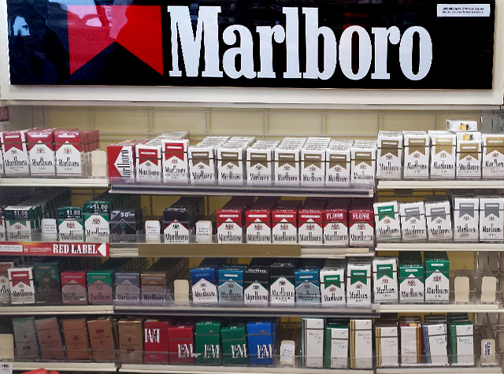

Modified

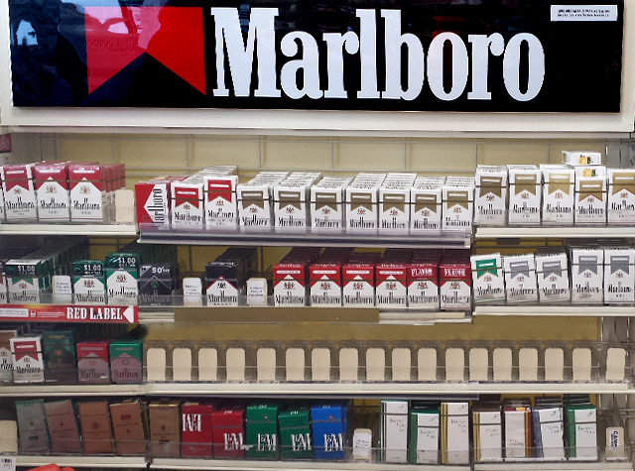

[*Page 1*]

Please describe what changed in the textbox below. Be as specific as you can.

If you didn’t notice any chance, type ‘No change.’

[*Text Box*]

W3AL2Q_textboxresponse1 W3FlickerChange1

[*Page 2*]

How difficult was it to detect the change? W3AI2Q2 W3FlickerDifficulty2

Very Easy 1 Somewhat Easy 2 Somewhat Difficult 3 Very Difficult 4

[*Page 3*]



How often do you visit stores that have displays that look like the one above? W3AI2Q3 W3FlickerStoreVisit3

Never 0

Once a month or less 1

2-3 times a month 2

Once a week 3

2-3 times a week 4

Almost every day or every day 5

[*Page 4*]

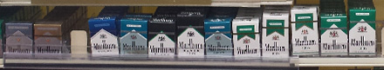

How often have you seen this sign at a store? W3AI2Q4 W3FlickerAdvertisementSeen4

Never 0

Once a month or less 1

2-3 times a month 2

Once a week 3

2-3 times a week 4

Almost every day or every day 5

**Additional Information:**

* There will be no practice images.
* There will be one manipulated image.
* There will be no clues or suggested fixation points.
* Each image will be displayed for 240 milliseconds followed by a black screen for 80 milliseconds. This will continue for 60 seconds.
* The original image will be displayed twice followed by the manipulated image



**Data Provided:**

* Date
* Time
* Count_cycles - counts the number of cycles started until a response occurs
* Responsepoint - determines the stimulus in the response cycle (the cycle that participant made a positive response) that was presented when participant made response: "StimA1", "flicker_AA", "StimA2", "flicker_AB", "StimB1", "flicker_BB", "StimB2", "flicker_BA" or "N/A" (if no response was given)
* Alternations - Determines the number of alternations between original and altered pictures until response occurs. Each switch between originals and altered pictures as well as each switch between altered pictures and original pictures is counted as an alternation. For each completed cycle, participants go through 2 alternations. If the response occurs AFTER the change from original to altered pic in the last cycle, one more alternation is added to the count.
* Cycle_rt - stores the combined trial latencies across the entire cycle until response occurs
* Textboxresponse - stores the open-ended response
* Textboxresponse_rt - stores the time it took participant to work on the openended response until pressing the button

**Symmetry Span Task**

**Source:** Kane, M.J., Hambrick, D.Z., Tuholski, S.W., Wilhelm, O., Payne, T.W., & Engle, R.W. (2004). The generality of working memory capacity: A latent variable approach to verbal and visuospatial memory span and reasoning. *Journal of Experimental Psychology: General, 133*, 189-217.

Heitz, R.P. & Engle, R.W. (2007). Focusing the spotlight: Individual differences in visual attention control. *Journal of Experimental Psychology: General, 136*, 217 - 240.

Redick, T.S., Broadway, J.M., Meier, M.E., Kuriakose, P.S., Unsworth, N., Kane, M.J., Engle, R.W. (2012). Measuring working memory capacity with automated complex span tasks. *European Journal of Psychological Assessment, 28*(3), 164-171.

**Designed For:** Adolescents

**Psychometrics:** Cronbach’s alpha = .76 and test-retest reliability r = .77

**Items:**

W3BFQ

**Scoring:** The program reports five values at the conclusion of the experiment.

The first, SSPAN score, uses the traditional "absolute sspan" scoring method. It is the sum of all perfectly recalled sets. So, for example, if an individual recalled correctly 2 squares in a set size of 2, 3 squares in a set size of 3, and 3 squares in a set size of 4, their SSPAN score would be 5 (2 + 3 + 0).

Total number correct is the total number of squares recalled in the correct position (2 + 3 + 3 = 8 in the above example).

Symmetry errors are reported as total number of errors, accuracy errors where the subject solved the operation incorrectly, and speed errors in which the subject ran out of time in attempting to solve a given operation.

**Instructions:**

#### *Screen One*

In this task, squares will appear on the screen one at a time. Try to remember where each square is on the screen.

FIRST SCREEN SECOND SCREEN

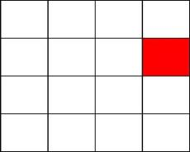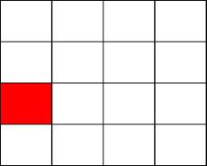

Your job is to select each square in the order it appears.

Click NEXT at the bottom right of the screen when you finish selecting the squares.

If you forget one, click BLANK to mark that position.

Click CLEAR if you need to start over.

It is very important to select the squares in the same order you saw them.

Click the mouse button to try some practice problems.

#### *Screen Two*

Now you will have to decide if different pictures are symmetrical. A picture is symmetrical if you can fold it in half and the picture on the left lines up with the picture on the right. Below are two examples.

SYMMETRICAL NOT SYMMETRICAL

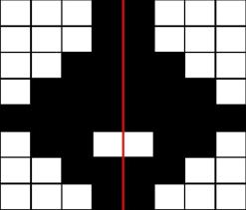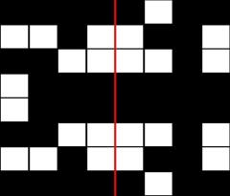

If the picture is symmetrical click YES.

If the picture is NOT symmetrical click NO.

The computer will tell you if you made the right choice.

Click the mouse button to try some practice problems.

#### *Screen Three*

Now you will practice doing both parts of the task at the same time.

The computer will automatically move to the next screen if you take too long.

It is VERY important to solve the problems as quickly and as accurately as possible.

A red number will appear in the top right of the screen. This indicates your percent correct on the symmetry part of the task. Keep this percentage as high as possible while doing your best to get the squares in the correct order.

Click the mouse to try some practice problems.

#### *Screen Four*

That is the end of the practice.

The real task will be just like the practice, but it will be longer and may be harder.

It is important that you do your best.

Click the mouse to begin the task.

#### *Final Screen*

This concludes this task.

Click the mouse to continue.

#### Example:

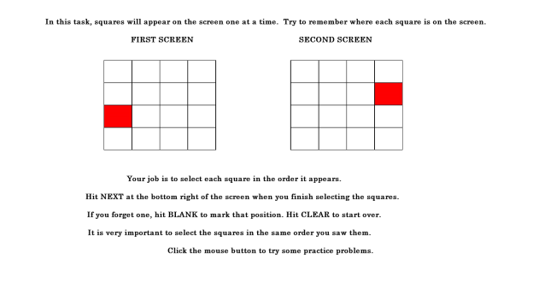

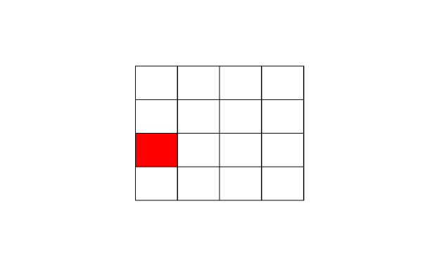

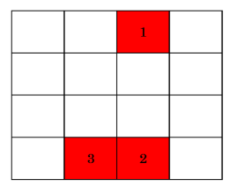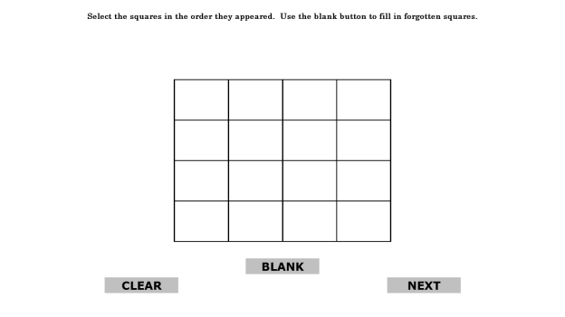

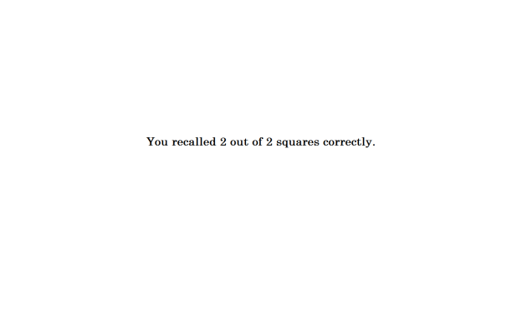

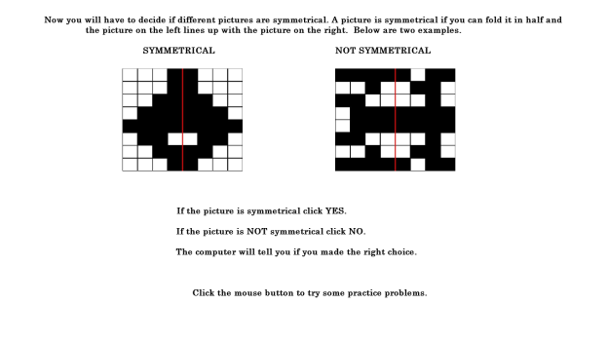

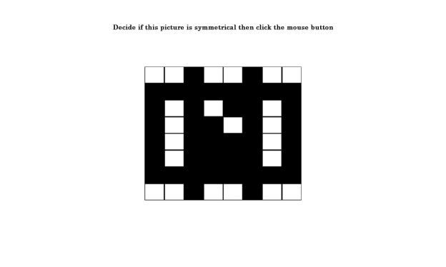

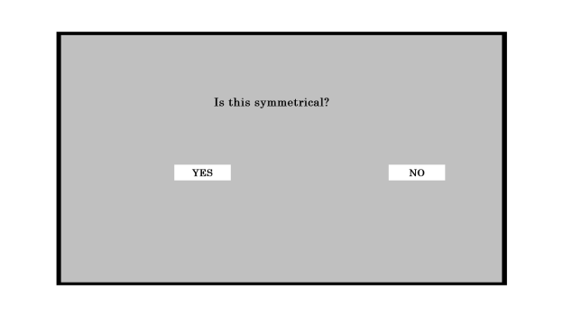

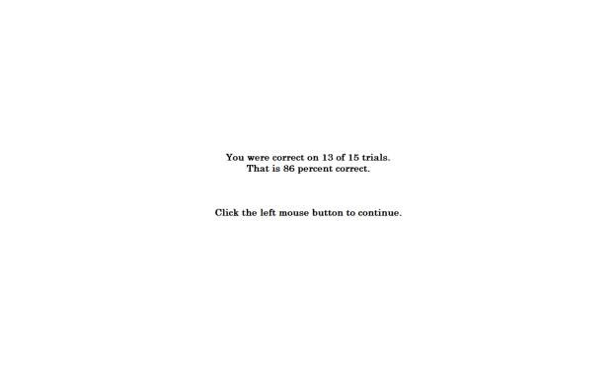

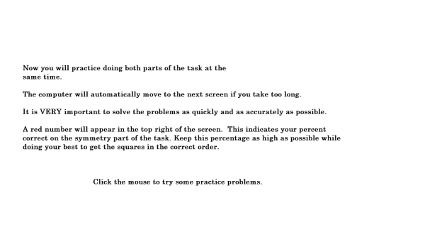

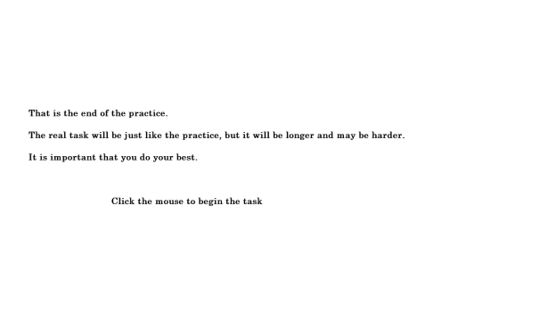

**Go/No-Go Task**

**Source:** Fillmore, M.T., Ostling, E.W., Martin, C.A., Kelly, T.H. (2009). Acute effects of alcohol on inhibitory control and information processing in high and low sensation-seekers. *Drug and Alcohol Dependence, 100*(1-2), 91-99.

Fillmore, M.T., Rush, C.R., and Hays, L. (2006). Acute effects of cocaine in two models of inhibitory control: Implications of non-linear dose effects. Addiction, 101, 1323-1332.

Finn, P.R., Justus, A., Mazas, C., Steinmetz, J.E. (1999). Working memory, executive processes and the effects of alcohol on Go/No-go learning: Testing a model of behavioral regulation and impulsivity. *Psychopharmacology, 146*(4), 465-472.

Mostofsky, S.H., Simmonds, D.J. (2008). Response inhibition and response selection: Two sides of the same coin. *Journal of Cognitive Neuroscience, 20*(5), 751-761.

Simmonds, D.J., Pekar, J.J., Mostofsky, S.H. (2008).Meta-analysis of go/no-go tasks demonstrating that fMRI activation associated with response inhibition is task-dependent. *Neuropsychologia, 46*(1), 224-232.

Weafer, J., Fillmore, M.T., & Milich, R. (2009). Increased sensitivity to the disinhibiting effects of alcohol in adults with ADHD. *Experimental And Clinical Psychopharmacology*, *17*(2), 113-121.

Little, T.D., Cunningham, W.A., Shahar, G., & Widaman, K.F. (2002). To parcel or not to parcel: Exploring the question, weighing the merits. *Structural Equation Modeling*, *9*(2), 151-173.

**Designed For:** Adults and Adolescents

**Items:**

W3BGQ

**Instructions:**

The next task will ask you to respond as quickly as possible while making as few errors as possible.

Please do the best that you can.

Please place your finger on the spacebar.

First, you will see a plus sign in the middle of the screen.

Then you will see an empty rectangle.

Next the rectangle will fill with a color.

When you see the color GREEN, press the spacebar.

When you see the color BLUE, DO NOT press the spacebar.

Respond as quickly as possible and make as few errors as possible.

If you make a mistake the screen will say ‘Incorrect’.

The task takes about 10 minutes to complete.

**Additional Information:**

* There will be 0 practice trials.
* There will be 160 trials for the main task.
* The fixation point, i.e. the plus sign, will be displayed for 500 milliseconds.
* The cue, a blank rectangle, will be displayed for 100 milliseconds, 200 milliseconds, 300 milliseconds, 400 milliseconds, or 500 milliseconds.
* A Go cue, i.e. a green rectangle, will be displayed for 1000 milliseconds 70% of the time.
* A No-Go cue, i.e. a blue rectangle, will be displayed for 1000 milliseconds 30% of the time.
* The orientation of the rectangle, i.e. horizontal or vertical, will signal the probability that a go or no-go cue will be displayed.
  + Vertical rectangles precede a Go cue 70% of the time.
  + Horizontal rectangles precede a No-Go cue 70% of the time.
  + Vertical rectangles were presented 50% of the time.
  + Horizontal rectangles were presented 50% of the time.
* After the trial is complete, a blank screen will be displayed for 300 milliseconds.
* There will be no breaks.
* If a participant presses a key in response to a Go cue, the reaction time in milliseconds will be displayed for 500 milliseconds.
* If a study participant presses a key in response to a No Go cue, the word ‘Incorrect’ will appear for 500 milliseconds.
* If a study participant does not respond after 1000 milliseconds, the word ‘Incorrect’ will appear for 500 milliseconds.

**65% Update**

[*A 65% Progress Bar Will Be Shown Here*]

Your Progress

Nice work! You have completed all of the tasks in the survey. From here, all you have to do is answer a series of questions.

Remember that your opinion matters. Be as honest as possible. Your answers will be kept confidential.

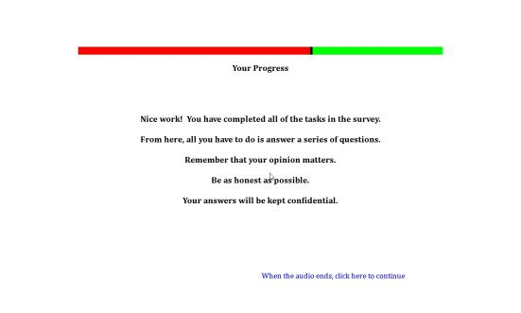

**Short Form Smoking Consequences Questionnaire (S-SCQ)**

**Source:** Myers, M.G., MacPherson, L., McCarthy, D.M., & Brown, S.A. (2003). Constructing a short form of the Smoking Consequences Questionnaire with adolescents and young adults. *Psychological* *Assessment*, *15*(2), 163-172.

Penzes, M., Czégledi, E., Balázs, P., & Foley, K.L. (2012). Factors associated with tobacco smoking and the belief about weight control effect of smoking among hungarian adolescents. *Cent Eur J Public Health, 20*, 11-17.

Urbán, R., & Demetrovics, Z. (2010). Smoking outcome expectancies: A multiple indicator and multiple cause (MIMIC) model. *Addictive Behaviors*, *35*(6), 632-635.

Urbán, R. (2010). Smoking outcome expectancies mediate the association between sensation seeking, peer smoking, and smoking among young adolescents. *Nicotine & Tobacco Research*, *12*(1), 59-68.

Response options are based on Ajzen, I. & Fishbein, M. (1980). *Understanding Attitudes and Predicting Social Behavior.* Englewood Cliffs, NJ: Prentice-Hall, Inc.

**Designed For:** Use with adolescents and young adults, derived from Smoking Consequences Questionnaire (Brandon & Baker, 1991)

**Psychometrics:** Internal consistencies for four-factor model solution: Negative Consequences (.84), Negative Reinforcement (.92), Positive Reinforcement (.95), and Appetite-Weight Control (.93)

**Codebook:**For each statement, please indicate how LIKELY or UNLIKELY you believe each statement is for you when you smoke. If you have never smoked, answer according to your personal beliefs, regardless of what other people might think.

1. Cigarettes taste good. W3BHQ1 W3OutExpecPosRe1

Extremely Likely 5 Somewhat Likely 4 Neutral 3 Somewhat Unlikely 2 Extremely Unlikely1

2. Smoking controls my appetite. W3BHQ2 W3OutExpecAppWeight2

Extremely Likely 5 Somewhat Likely 4 Neutral 3 Somewhat Unlikely 2 Extremely Unlikely1

3. Cigarettes help me deal with anxiety or worry. W3BHQ3 W3OutExpecNegRe3

Extremely Likely 5 Somewhat Likely 4 Neutral 3 Somewhat Unlikely 2 Extremely Unlikely1

4. I enjoy the taste sensations while smoking. W3BHQ4 W3OutExpecPosRe4

Extremely Likely 5 Somewhat Likely 4 Neutral 3 Somewhat Unlikely 2 Extremely Unlikely1

5. Smoking helps me deal with depression. W3BHQ5 W3OutExpecNegRe5

Extremely Likely 5 Somewhat Likely 4 Neutral 3 Somewhat Unlikely 2 Extremely Unlikely1

6. Cigarettes keep me from overeating. W3BHQ6 W3OutExpecAppWeight6

Extremely Likely 5 Somewhat Likely 4 Neutral 3 Somewhat Unlikely 2 Extremely Unlikely1

7. Cigarettes help me deal with anger. W3BHQ7 W3OutExpecNegRe7

Extremely Likely 5 Somewhat Likely 4 Neutral 3 Somewhat Unlikely 2 Extremely Unlikely1

8. When I smoke the taste is pleasant. W3BHQ8 W3OutExpecPosRe8

Extremely Likely 5 Somewhat Likely 4 Neutral 3 Somewhat Unlikely 2 Extremely Unlikely1

9. I will enjoy the flavor of a cigarette. W3BHQ9 W3OutExpecPosRe9

Extremely Likely 5 Somewhat Likely 4 Neutral 3 Somewhat Unlikely 2 Extremely Unlikely1

10. I will enjoy feeling a cigarette on my tongue and lips. W3BHQ10 W3OutExpecPosRe10

Extremely Likely 5 Somewhat Likely 4 Neutral 3 Somewhat Unlikely 2 Extremely Unlikely1

11. By smoking I risk heart disease and lung cancer. W3BHQ11 W3OutExpecNegCon11

Extremely Likely 5 Somewhat Likely 4 Neutral 3 Somewhat Unlikely 2 Extremely Unlikely1

12. Cigarettes help me reduce or handle tension. W3BHQ12 W3OutExpecNegRe12

Extremely Likely 5 Somewhat Likely 4 Neutral 3 Somewhat Unlikely 2 Extremely Unlikely1

13. Smoking helps me control my weight. W3BHQ13 W3OutExpecAppWeight13

Extremely Likely 5 Somewhat Likely 4 Neutral 3 Somewhat Unlikely 2 Extremely Unlikely1

14. When I'm upset with someone, a cigarette helps me cope. W3BHQ14 W3OutExpecNegRe14

Extremely Likely 5 Somewhat Likely 4 Neutral 3 Somewhat Unlikely 2 Extremely Unlikely1

15. The more I smoke, the more I risk my health. W3BHQ15 W3OutExpecNegCon15

Extremely Likely 5 Somewhat Likely 4 Neutral 3 Somewhat Unlikely 2 Extremely Unlikely1

16. Cigarettes keep me from eating more than I should. W3BHQ16 W3OutExpecAppWeight16

Extremely Likely 5 Somewhat Likely 4 Neutral 3 Somewhat Unlikely 2 Extremely Unlikely1

17. Smoking keeps my weight down. W3BHQ17 W3OutExpecAppWeight17

Extremely Likely 5 Somewhat Likely 4 Neutral 3 Somewhat Unlikely 2 Extremely Unlikely1

18. Smoking is hazardous to my health. W3BHQ18 W3OutExpecNegCon18

Extremely Likely 5 Somewhat Likely 4 Neutral 3 Somewhat Unlikely 2 Extremely Unlikely1

19. Smoking calms me down when I feel nervous. W3BHQ19 W3OutExpecNegRe19

Extremely Likely 5 Somewhat Likely 4 Neutral 3 Somewhat Unlikely 2 Extremely Unlikely1

20. When I'm angry a cigarette can calm me down. W3BHQ20 W3OutExpecNegRe20

Extremely Likely 5 Somewhat Likely 4 Neutral 3 Somewhat Unlikely 2 Extremely Unlikely1

21. Smoking is taking years off my life. W3BHQ21 W3OutExpecNegCon21

Extremely Likely 5 Somewhat Likely 4 Neutral 3 Somewhat Unlikely 2 Extremely Unlikely1

**Family and Peer Smoking**

**Source:** Items 1-4 are optional questions from:

Centers for Disease Control and Prevention (CDC). (2014a). 2012 National youth tobacco survey (NYTS). Retrieved from: <http://www.cdc.gov/TOBACCO/data_statistics/surveys/NYTS/index.htm>

Centers for Disease Control and Prevention (CDC). (2014b). 2011 Youth tobacco survey (YTS). Retrieved from: <http://www.cdc.gov/tobacco/data_statistics/surveys/yts/index.htm>

Item 1 was expanded to assess tobacco use by older brothers, older sisters, younger brothers, and younger sisters. Item 3 was added to assess the use electronic cigarettes. Item 3 was added to assess the use of smokeless tobacco. Item 4 was expanded to include smokeless tobacco, electronic cigarettes, hookah/shisha, pipe tobacco, and cigarettes combined with marijuana.

Items 5-8 are from the California Department of Public Health (CDPH). (2014). 2011-2012 California Student Tobacco Survey (CSTS). Retrieved from: <http://www.cdph.ca.gov/programs/tobacco/Pages/default.aspx>.

Item 6 was added to assess the use of smokeless tobacco. Item 7 was added to assess the use of electronic cigarettes. Item 8 was expanded to include hookah/shisha, pipe tobacco, and cigarettes combined with marijuana.

**Designed For:** Adolescents

**Psychometrics**: Not reported

**Codebook:**

[*Family*]

Please answer the following questions about your family.

1. Who in your family smokes? (check all that apply) W3BIQ8, W3FamCig1, 0 When Not Selected, 1 When Selected

No one smokes in my family W3BIQ8option1 W3FamCigNoOne1

I am the only one who smokes in my family W3BIQ8option2 W3FamCigOnlyMe1

Father (Male Guardian) W3BIQ8option3 W3FamCigDad1

Mother (Female Guardian) W3BIQ8option4 W3FamCigMom1

Older Brother W3BIQ8option5 W3FamCigOldBro1

Older Sister W3BIQ8option6 W3FamCigOldSis1

Younger Brother W3BIQ8option7 W3FamCigYoungBro1

Younger Sister W3BIQ8option8 W3FamCigYoungSis1

Grandmother / Grandfather W3BIQ8option9 W3FamCigGrandparent1

Other (please specify) W3BIQ8option10 W3FamCigOther1 ____________ W3BIQ8other W3FamCigOtherSpecify1

1. Who in your family uses chewing tobacco, snuff, or dip? (check all that apply) W3BIQ9, W3FamChew1, 0 When Not Selected, 1 When Selected

No one uses chewing tobacco, snuff, or dip in my family W3BIQ9option1 W3FamChewNoOne2

I am the only one who uses chewing tobacco, snuff, or dip in my family W3BIQ9option2 W3FamChewOnlyMe2

Father (Male Guardian) W3BIQ9option3 W3FamChewDad2

Mother (Female Guardian) W3BIQ9option4 W3FamChewMom2

Older Brother W3BIQ9option5 W3FamChewOldBro2

Older Sister W3BIQ9option6 W3FamChewOldSis2

Younger Brother W3BIQ9option7 W3FamChewYoungBro2

Younger Sister W3BIQ9option8 W3FamChewYoungSis2

Grandmother / Grandfather W3BIQ9option9 W3FamChewGrandparent2

Other (please specify) W3BIQ9option10 W3FamChewOther2 ____________ W3BIQ9other W3FamChewOtherSpecify2

[*Experience At Home*]

1. Does anyone who lives with you now…? (check all that apply) W3BIQ10, W3FamOtherTob3, 0 When Not Selected, 1 When Selected

Smoke cigarettes W3BIQ10option1 W3FamOtherTobCig3

Use electronic cigarettes, vaporizers, or vape pens W3BIQ10option2 W3FamOtherTobEcig3

Use chewing tobacco, snuff, or dip W3BIQ10option3 W3FamOtherTobChew3

Smoke cigars, cigarillos, or little cigars W3BIQ10option4 W3FamOtherTobCigar3

Smoke tobacco in a pipe W3BIQ10option5 W3FamOtherTobPipe3

Smoke cigarettes with tobacco and marijuana W3BIQ10option6 W3FamOtherTobPot3

Smoke hookah or shisha W3BIQ10option7 W3FamOtherTobHookah3

Use any other form of tobacco W3BIQ10option8 W3FamOtherNew3

No one who lives with me now uses any form of tobacco W3BIQ10option9 W3FamOtherTobNoOne3

[*Peer*]

Please answer the following questions about your friends.

1. How many of your four closest friends smoke cigarettes? W3BIQ4, W3FriendCig5

None 0

One 1

Two 2

Three 3

Four 4

Not sure -7

1. How many of your four closest friends use chewing tobacco, snuff, or dip? W3BIQ5, W3FriendChew6

None 0

One 1

Two 2

Three 3

Four 4

Not sure -7

1. How many of your four closest friends use electronic cigarettes, vaporizers, or vape pens? W3BIQ6, W3FriendECig7

None 0

One 1

Two 2

Three 3

Four 4

Not sure -7

1. Do any of your four closest friends…? (check all that apply) W3BIQ7, W3FriendOtherTob8, 0 When Not Selected, 1 When Selected

Smoke cigars, cigarillos, or little cigars W3BIQ7option1 W3FriendOtherTobCigar8

Smoke tobacco in a pipe W3BIQ7option2 W3FriendOtherTobPipe8

Smoke cigarettes with tobacco and marijuana W3BIQ7option3 W3FriendOtherTobPot8

Smoke hookah or shisha W3BIQ7option4 W3FriendOtherTobHookah8

Use any other form of tobacco W3BIQ7option5 W3FriendOtherTobNew8

My four closest friends do not use any form of tobacco W3BIQ7option6 W3FriendOtherNoOne8

**Injunctive Norms**

**Source:** Questions are based on Wilkinson, D., & Abraham, C. (2004). Constructing an integrated model of the antecedents of adolescent smoking. *British Journal Of Health Psychology, 9*(3), 315-333.

Response options are based on Ajzen, I. & Fishbein, M. (1980). *Understanding Attitudes and Predicting Social Behavior.* Englewood Cliffs, NJ: Prentice-Hall, Inc.

**Designed For:** Adolescents (Ages 13-14)

**Psychometrics:** Cronbach’s alpha = .81.

**Codebook:**

Please answer the following questions about your friends and family.

1. How likely is it that your MOTHER would NOT want you to smoke? W3BJQ1 W3InjNormMom1

Extremely Likely 1 Somewhat Likely 2 Neutral 3 Somewhat Unlikely 4 Extremely Unlikely 5

1. How likely is it that your FATHER would NOT want you to smoke? W3BJQ2 W3InjNormDad2

Extremely Likely 1 Somewhat Likely 2 Neutral 3 Somewhat Unlikely 4 Extremely Unlikely 5

1. How likely is it that your SISTER(S) would NOT want you to smoke? W3BJQ3 W3InjNormSis3

Extremely Likely 1 Somewhat Likely 2 Neutral 3 Somewhat Unlikely 4 Extremely Unlikely 5

1. How likely is it that your BROTHER(S) would NOT want you to smoke? W3BJQ4 W3InjNormBro4

Extremely Likely 1 Somewhat Likely 2 Neutral 3 Somewhat Unlikely 4 Extremely Unlikely 5

1. How likely is it that your RELATIVES would NOT want you to smoke? W3BJQ5 W3InjNormRelatives5

Extremely Likely 1 Somewhat Likely 2 Neutral 3 Somewhat Unlikely 4 Extremely Unlikely 5

1. How likely is it that your FRIENDS would NOT want you to smoke? W3BJQ6 W3InjNormFriends6

Extremely Likely 1 Somewhat Likely 2 Neutral 3 Somewhat Unlikely 4 Extremely Unlikely 5

1. How likely is it that your PEERS would NOT want you to smoke? W3BJQ7 W3InjNormPeers7

Extremely Likely 1 Somewhat Likely 2 Neutral 3 Somewhat Unlikely 4 Extremely Unlikely 5

**Media Exposure**

**Source:** Item 9 was adapted from Eynon, R., & Malmberg, L-E. (2011). A typology of young people's Internet use: Implications for education. *Computers & Education*, 585-595.

Items 15 and 16 was adapted from Unger, J.B., Cruz, T., Schuster, D., Flora, J.A., & Johnson, C. (2001). Measuring exposure to pro- and anti-tobacco marketing among adolescents: Intercorrelations among measures and associations with smoking status. *Journal Of Health Communication, 6*(1), 11-29.

All other items were adapted from:

Centers for Disease Control and Prevention (CDC). (2014a). 2012 National youth tobacco survey (NYTS). Retrieved from: <http://www.cdc.gov/TOBACCO/data_statistics/surveys/NYTS/index.htm>

Centers for Disease Control and Prevention (CDC). (2014b). 2011 Youth tobacco survey (YTS). Retrieved from: <http://www.cdc.gov/tobacco/data_statistics/surveys/yts/index.htm>

**Designed For:** Adolescents

**Psychometrics**: No psychometrics were reported

**Codebook:**

Please answer the following questions.

1. During the past 30 days, about how often have you seen ADS OR PROMOTIONS FOR tobacco products at convenience stores, supermarkets, or gas stations? W3BKQ1 W3MediaPOSAds1

None 0

1-3 times in the past 30 days 1

1-3 times per week 2

Daily or almost daily 3

More than once a day 4

1. During the past 30 days, about how often have you seen WARNING SIGNS ABOUT UNDERAGE PURCHASES of tobacco products at convenience stores, supermarkets, or gas stations? W3BKQ2 W3MediaPOSPurchaseWarning2

None 0

1-3 times in the past 30 days 1

1-3 times per week 2

Daily or almost daily 3

More than once a day 4

1. During the past 30 days, about how often have you seen ADS, COMMERCIALS, OR SIGNS ABOUT NOT using tobacco products? W3BKQ3 W3MediaAnti3

None 0

1-3 times in the past 30 days 1

1-3 times per week 2

Daily or almost daily 3

More than once a day 4

1. During the past 30 days, about how often have you seen POSTERS OR SIGNS FOR tobacco products (cigarettes, electronic cigarettes, vape pens, cigars, chewing tobacco, etc.)? W3BKQ4 W3MediaProPoster4

None 0

1-3 times in the past 30 days 1

1-3 times per week 2

Daily or almost daily 3

More than once a day 4

1. During the past 30 days, about how often have you seen ads in NEWSPAPERS OR MAGAZINES FOR tobacco products? W3BKQ5 W3MediaProMag5

None 0

1-3 times in the past 30 days 1

1-3 times per week 2

Daily or almost daily 3

More than once a day 4

1. During the past 30 days, about how often have you seen TELEVISION ADS FOR tobacco products? W3BKQ6 W3MediaProTV6

None 0

1-3 times in the past 30 days 1

1-3 times per week 2

Daily or almost daily 3

More than once a day 4

1. During the past 30 days, about how often have you heard RADIO ADS FOR tobacco products? W3BKQ7 W3MediaProRadio7

None 0

1-3 times in the past 30 days 1

1-3 times per week 2

Daily or almost daily 3

More than once a day 4

1. During the past 30 days, about how often have you seen ADS ONLINE FOR tobacco products? W3BKQ8 W3MediaProWeb8

None 0

1-3 times in the past 30 days 1

1-3 times per week 2

Daily or almost daily 3

More than once a day 4

1. During the past 30 days, where did you see ADS ONLINE FOR tobacco products? (Check all that apply) W3BKQ9 W3MediaProWeb9, 0 When Not Selected, 1 When Selected

Social Networks (Facebook, myspace, Instagram, etc.) W3BKQ9option1 W3MediaProWebSocialNet9

Email (Gmail, Yahoo mail, Hotmail, etc.) W3BKQ9option2 W3MediaProWebEmail9

Forums (Xual, Ultimate Teen Forums, All About Goldfish, etc.) W3BKQ9option3 W3MediaProWebForums9

Search Engine (Google, Yahoo, Ask, etc.) W3BKQ9option4 W3MediaProWebSearch9

Online Shopping (Amazon, Ebay, Overstock, etc.) W3BKQ9option5 W3MediaProWebShopping9

Video Streaming (YouTube, Vimeo, DailyMotion, etc.) W3BKQ9option6 W3MediaProWebVideo9

Music Streaming (Pandora, Spotify, Grooveshark, etc.) W3BKQ9option7 W3MediaProWebMusic9

Download sites (Vertor, Take.FM, ThePirateBay, etc.) W3BKQ9option8 W3MediaProWebDownload9

Blogs (Blog.com, Wordpress, Blogger, etc.) W3BKQ9option9 W3MediaProWebBlog9

Wikis (Wikipedia, Wiktionary, ZineWiki, etc.) W3BKQ9option10 W3MediaProWebWiki9

Podcasts (Teen Talk, TBTL, NLCast, etc.) W3BKQ9option11 W3MediaProWebPodcast9

None of the above W3BKQ9option12 W3MediaProWebNone9

1. During the past 30 days, did you receive coupons from a tobacco company through… (Check all that apply) W3BKQ10 W3MediaCoupons10, 0 When Not Selected, 1 When Selected

The mail W3BKQ10option1 W3MediaCouponsMail10

E-mail W3BKQ10option2 W3MediaCouponsEmail10

The Internet W3BKQ10option3 W3MediaCouponsInternet10

A text message W3BKQ10option4 W3MediaCouponsText10

A cigarette pack or other tobacco product W3BKQ10option5 W3MediaCouponsCigPack10

I did not receive coupons from a tobacco company W3BKQ10option6 W3MediaCouponsNever10

1. How often do you see celebrities (movie stars, musicians, athletes, etc.) using tobacco products in the media or face-to-face? W3BKQ11 W3MediaCeleb11

Never 0

Less than half the time 1

About half the time 2

More than half the time 3

All the time 4

1. What are the brand names of your favorite cigarette ads? (Check all that apply) W3BKQ12 W3MediaCigBrand12, 0 When Not Selected, 1 When Selected

American Spirit W3BKQ12option1 W3MediaCigBrandSpirit12

Camel W3BKQ12option2 W3MediaCigBrandCamel12

GPC, Basic, or Doral W3BKQ12option3 W3MediaCigBrandGPC12

Kool W3BKQ12option4 W3MediaCigBrandKool12

Lucky Strike W3BKQ12option5 W3MediaCigBrandLucky12

Marlboro W3BKQ12option6 W3MediaCigBrandMarlboro12

Newport W3BKQ12option7 W3MediaCigBrandNewport12

Parliament W3BKQ12option8 W3MediaCigBrandParliament12

Summit W3BKQ12option9 W3MediaCigBrandFake12

Virginia Slims W3BKQ12option10 W3MediaCigBrandVirginia12

I don’t have any favorite cigarette ads W3BKQ12option11 W3MediaCigBrandNone12

Another brand (please specify): W3BKQ12option12 W3MediaCigBrandOther12__________ W3BKQ12other W3MediaCigBrandOtherSpecify12

1. What are the brand names of your favorite electronic cigarette ads? (Check all that apply) W3BKQ13 W3MediaECigBrand13, 0 When Not Selected, 1 When Selected

Blu W3BKQ13option1 W3MediaECigBrandBlu13

Green Smart Living W3BKQ13option2 W3MediaECigBrandGreen13

MarkTen W3BKQ13option3 W3MediaECigBrandMarkTen13

NJOY W3BKQ13option4 W3MediaECigBrandNJOY13

Xcite W3BKQ13option5 W3MediaECigBrandFake13

Square W3BKQ13option6 W3MediaECigBrandSquare13

Vuse W3BKQ13option7 W3MediaECigBrandVuse13

V2 W3BKQ13option8 W3MediaECigBrandVTwo13

I don’t have any favorite electronic cigarette ads W3BKQ13option9 W3MediaECigBrandNone13

Another brand (please specify): W3BKQ13option10 W3MediaECigBrandOther13 _______ W3BKQ13other W3MediaECigBrandOtherSpecify13

1. What are the brand names of your favorite chewing tobacco, snuff, or dip ads? (Check all that apply) W3BKQ14 W3MediaChewBrand14, 0 When Not Selected, 1 When Selected

Beechnut W3BKQ14option1 W3MediaChewBrandBeechnut14

Back Country W3BKQ14option2 W3MediaChewBrandFake14

Copenhagen W3BKQ14option3 W3MediaChewBrandCopen14

Grizzly W3BKQ14option4 W3MediaChewBrandGrizzly14

Kodiak W3BKQ14option5 W3MediaChewBrandKodiak14

Levi Garrett W3BKQ14option6 W3MediaChewBrandLevi14

Longhorn W3BKQ14option7 W3MediaChewBrandLonghorn14

Red Man W3BKQ14option8 W3MediaChewBrandRedman14

Skoal W3BKQ14option9 W3MediaChewBrandSkoal14

I don’t have any favorite chewing tobacco, snuff, or dip ads W3BKQ14option10 W3MediaChewBrandNone14

Another brand (please specify): W3BKQ14option11 W3MediaChewBrandOther14

_______ W3BKQ14other W3MediaChewBrandOtherSpecify14

1. How often do you see other young people wearing clothing or carrying gear, like t-shirts, lighters, gym bags, hats, or sunglasses that have a tobacco company name or picture on it? W3BKQ15 W3MediaWearBrand15

Never 0

Less than half the time 1

About half the time 2

More than half the time 3

All the time 4

1. How many items do you own that have a tobacco company name or picture on it? W3BKQ16 W3MediaOwnBrand16

___________

**Prevention Program Exposure**

**Source:** Item 1 is adapted from the California Healthy Kids Resource Center (2014). Research Validated Programs: R-V Tobacco. Retrieved From: <http://www.californiahealthykids.org/rvtobacco>.

Item 2 is from Centers for Disease Control and Prevention (CDC). (2014). 2012 National youth tobacco survey (NYTS). Retrieved from: <http://www.cdc.gov/TOBACCO/data_statistics/surveys/NYTS/index.htm>.

**Designed For:** Adolescents

**Psychometrics:** No psychometrics were reported

**Codebook:**

1. Have you received any of the following health programs in the past year? (check all that apply) W3BLQ1 W3PrevProg1

Butt Out Now W3BLQ1option1 W3PrevProgTobIndusButtOut1

DARE W3BLQ1option2 W3PrevProgNotValidDare1

Empowering Discipline W3BLQ1option3 W3PrevProgNotValidEmpower1

HERE'S LOOKING AT YOU W3BLQ1option4 W3PrevProgNotValidLookYou1

In It to Win It W3BLQ1option5 W3PrevProgFake1

Keepin’ it REAL W3BLQ1option6 W3PrevProgResValidREAL1

LifeSkills Training W3BLQ1option7 W3PrevProgResValidLifeSkills1

McGruff W3BLQ1option8 W3PrevProgNotValidMcGruff1

Minnesota Smoking Prevention Program W3BLQ1option9 W3PrevProgResValidMinn1

Project ALERT W3BLQ1option10 W3PrevProgResValidALERT1

Project Northland W3BLQ1option11 W3PrevProgResValidNorthland1

Project SUCCESS W3BLQ1option12 W3PrevProgResValidSUCCESS1

Project Towards No Drug Abuse W3BLQ1option13 W3PrevProgResValidTND1

Project Towards No Tobacco Use W3BLQ1option14 W3PrevProgResValidTNT1

QUEST W3BLQ1option15 W3PrevProgNotValidQUEST1

Reconnecting Youth W3BLQ1option16 W3PrevProgResValidReconnect1

Red Ribbon Week W3BLQ1option17 W3PrevProgNotValidRedRibbon1

Residential Student Assistance Program W3BLQ1option18 W3PrevProgResValidResStudent1

Right Decisions, Right Now W3BLQ1option19 W3PrevProgTobIndusRightNow1

State-Wide Indian Drug Prevention Program W3BLQ1option20 W3PrevProgResValidIndian1

Think. Don’t Smoke W3BLQ1option21 W3PrevProgTobIndusThink1

Tobacco is Whacko If You’re A Teen W3BLQ1option22 W3PrevProgTobIndusWhacko1

Wake Up, Live Big, Be Smoke Free W3BLQ1option23 W3PrevProgTobIndusWakeUp1

None of the above W3BLQ1option24 W3PrevProgNone1

Other (please specify) W3BLQ1option25 W3PrevProgOther1 ____________ W3BLQ1other W3PrevProgOtherSpecify1

1. In the past 12 months, did you do any of the following to help you quit using tobacco? (Check all that apply) W3BLQ2 W3PrevQuitType2

I did not use tobacco of any kind during the past 12 months W3BLQ2option1 W3PrevQuitTypeDidNotUse2

I did not try to quit during the past 12 months W3BLQ2option2 W3PrevQuitTypeDidNotTry2

Attended a program at my school W3BLQ2option3 W3PrevQuitTypeSchool2

Attended a program in the community W3BLQ2option4 W3PrevQuitTypeCommunity2

Called a telephone help line or telephone quit line W3BLQ2option5 W3PrevQuitTypePhone2

Used nicotine gum W3BLQ2option6 W3PrevQuitTypeGum2

Used nicotine patch W3BLQ2option7 W3PrevQuitTypePatch2

Used medicine to help quit W3BLQ2option8 W3PrevQuitTypeMed2

Used electronic cigarettes, vaporizers, or vape pens W3BLQ2option9 W3PrevQuitTypeEcig2

Visited an Internet quit site W3BLQ2option10 W3PrevQuitTypeInternet2

Got help from family or friends W3BLQ2option11 W3PrevQuitTypeFamily2

Used another method such as hypnosis or acupuncture W3BLQ2option12 W3PrevQuitTypeAltMed2

Tried to quit on my own or quit “cold turkey” W3BLQ2option13 W3PrevQuitTypeTurkey2

**75% Update**

[*A 75% Progress Bar Will Be Shown Here*]

Your Progress

Great job! You are getting close to the end of the survey. At that time, you will receive a code that will allow you to claim your gift card.

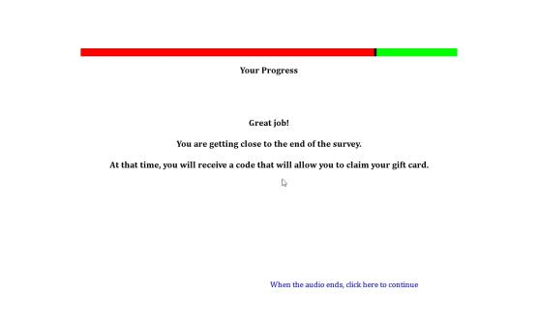

**Drug Use Frequency Scale**

**Source:** Items 17 and 18 developed based on D. Paul Moberg, Center for Health Policy and Program Evaluation, University of Wisconsin Medical School. Adapted with permission from Mayer, J., Filstead, W.J. (1979). The Adolescent Alcohol Involvement Scale. An instrument for measuring adolescents' use and misuse of alcohol. *Journal of Studies on Alcohol, 40*(3), 291-300.

The definition of drinks was provided by Johnston, L.D., O’Malley, P.M., Bachman, J.G., & Schulenberg, J.E. (2014) 2011 Monitoring the future survey (MTF). Retrieved from <http://www.monitoringthefuture.org/>. Ann Arbor: Institute for Social Research, The University of Michigan.

Items 18-20 were developed for the first time for this study.

All other items adapted from Graham, J.W., Flay B.R., Johnson, C.A., Hansen, W.B., Grossman, L., Sobel, J.L. (1984) Reliability of self-report measures of drug use in prevention research: Evaluation of the Project SMART questionnaire via the test-retest reliability matrix. *Journal of Drug Education, 14*, 75–193.

It should also be noted that this measure can be used to identify polysubstance users. Polysubstance use is typically defined as the consumption of multiple drugs in the past 30 days according to Moss, H.B., Chen, C.M., Yi, H.Y. (2014). Early adolescent patterns of alcohol, cigarettes, and marijuana polysubstance use and young adult substance use outcomes in a nationally representative sample. *Drug and Alcohol Dependence, 136*(1), 51-62.

**Designed For:** Adolescents

**Psychometrics:** Coefficient Alphas range from .60 to .86. Across Time Coefficient Alphas range from .52 to .80

**Codebook:**

Please answer each of the following questions about tobacco, alcohol, and other drug use.

About how many times have you used each of the drugs below in the PAST YEAR? Select your answer for each drug.

|  |  |  |  |  |  |  |  |  |  |  |  |
| --- | --- | --- | --- | --- | --- | --- | --- | --- | --- | --- | --- |
|  | 0 | 1-10 times | 11-20 times | 21-30 times | 31-40 times | 41-50 times | 51-60 times | 61-70 times | 71-80 times | 81-90 times | 91+ times |
| *1. Cigarettes*  W3BMQ1 W3DrugYearCig1 | ❑0 | ❑1 | ❑2 | ❑3 | ❑4 | ❑5 | ❑6 | ❑7 | ❑8 | ❑9 | ❑10 |
| *2. Electronic Cigarettes, Vaporizers, or Vape Pens*  W3BMQ2 W3DrugYearEcig2 | ❑0 | ❑1 | ❑2 | ❑3 | ❑4 | ❑5 | ❑6 | ❑7 | ❑8 | ❑9 | ❑10 |
| *3. Cigars, Cigarillos, or Little Cigars*  W3BMQ3W3DrugYearCigar3 | ❑0 | ❑1 | ❑2 | ❑3 | ❑4 | ❑5 | ❑6 | ❑7 | ❑8 | ❑9 | ❑10 |
| *4. Chewing Tobacco, Snuff, or Dip*  W3BMQ4 W3DrugYearChew4 | ❑0 | ❑1 | ❑2 | ❑3 | ❑4 | ❑5 | ❑6 | ❑7 | ❑8 | ❑9 | ❑10 |
| *5. Alcohol (beer, wine, wine coolers, liquor)*  W3BMQ5 W3DrugYearAlco5 | ❑0 | ❑1 | ❑2 | ❑3 | ❑4 | ❑5 | ❑6 | ❑7 | ❑8 | ❑9 | ❑10 |

About how many times have you used each of the drugs below in the PAST YEAR?

|  |  |  |  |  |  |  |  |  |  |  |  |
| --- | --- | --- | --- | --- | --- | --- | --- | --- | --- | --- | --- |
|  | 0 | 1-10 times | 11-20 times | 21-30 times | 31-40 times | 41-50 times | 51-60 times | 61-70 times | 71-80 times | 81-90 times | 91+ times |
| *6. Marijuana (weed, grass, pot, chronic)*  W3BMQ6 W3DrugYearPot6 | ❑0 | ❑1 | ❑2 | ❑3 | ❑4 | ❑5 | ❑6 | ❑7 | ❑8 | ❑9 | ❑10 |
| *7. Cocaine or crack*  W3BMQ7 W3DrugYearCoke7 | ❑0 | ❑1 | ❑2 | ❑3 | ❑4 | ❑5 | ❑6 | ❑7 | ❑8 | ❑9 | ❑10 |
| *8. Caffeine (coffee, energy drinks, soda, NoDoz pills)*  W3BMQ8 W3DrugYearCaff8 | ❑0 | ❑1 | ❑2 | ❑3 | ❑4 | ❑5 | ❑6 | ❑7 | ❑8 | ❑9 | ❑10 |
| *9. Ecstasy (“E”)*  W3BMQ9 W3DrugYearE9 | ❑0 | ❑1 | ❑2 | ❑3 | ❑4 | ❑5 | ❑6 | ❑7 | ❑8 | ❑9 | ❑10 |
| *10. Hallucinogens (LSD, PCP, peyote, mushrooms)*  W3BMQ10 W3DrugYearLSD10 | ❑0 | ❑1 | ❑2 | ❑3 | ❑4 | ❑5 | ❑6 | ❑7 | ❑8 | ❑9 | ❑10 |
| *11. Methamphetamine (speed, crank, ice, crystal meth)*  W3BMQ11 W3DrugYearMeth11 | ❑0 | ❑1 | ❑2 | ❑3 | ❑4 | ❑5 | ❑6 | ❑7 | ❑8 | ❑9 | ❑10 |

About how many times have you used each of the drugs below in the PAST YEAR?

|  |  |  |  |  |  |  |  |  |  |  |  |
| --- | --- | --- | --- | --- | --- | --- | --- | --- | --- | --- | --- |
|  | 0 | 1-10 times | 11-20 times | 21-30 times | 31-40 times | 41-50 times | 51-60 times | 61-70 times | 71-80 times | 81-90 times | 91+ times |
| *12. Inhalants or vapors (poppers, rush, nitrous, gas, paint, glues)*  W3BMQ14 W3DrugYearInhal14 | ❑0 | ❑1 | ❑2 | ❑3 | ❑4 | ❑5 | ❑6 | ❑7 | ❑8 | ❑9 | ❑10 |
| *13. Other club/party drugs (special K, ketamine, Rohypnol, GHB)*  W3BMQ15 W3DrugYearClub15 | ❑0 | ❑1 | ❑2 | ❑3 | ❑4 | ❑5 | ❑6 | ❑7 | ❑8 | ❑9 | ❑10 |

About how many times have you used each of the drugs below in the PAST YEAR? (without a doctor telling you to take them, or taking more than a doctor told you to take).

|  |  |  |  |  |  |  |  |  |  |  |  |
| --- | --- | --- | --- | --- | --- | --- | --- | --- | --- | --- | --- |
|  | 0 | 1-10 times | 11-20 times | 21-30 times | 31-40 times | 41-50 times | 51-60 times | 61-70 times | 71-80 times | 81-90 times | 91+ times |
| *14. Tranquilizers (valium, Xanax)*  W3BMQ12 W3DrugYearTranq12 | ❑0 | ❑1 | ❑2 | ❑3 | ❑4 | ❑5 | ❑6 | ❑7 | ❑8 | ❑9 | ❑10 |
| *15. Opiates (heroin, opium, morphine, Vicodin, OxyContin)*  W3BMQ13 W3DrugYearOpiate13 | ❑0 | ❑1 | ❑2 | ❑3 | ❑4 | ❑5 | ❑6 | ❑7 | ❑8 | ❑9 | ❑10 |
| *16. Ritalin/ Adderall (addy, bennies, uppers)*  W3BMQ16 W3DrugYearRita16 | ❑0 | ❑1 | ❑2 | ❑3 | ❑4 | ❑5 | ❑6 | ❑7 | ❑8 | ❑9 | ❑10 |

17. When you drink alcohol, how much do you usually drink?

(A “drink” is a bottle of beer, a glass of wine, a wine cooler, a shot glass of liquor, a mixed drink, etc.)

W3BMQ17 W3DrugQuantAlco17

1 drink 1

2 drinks 2

3-4 drinks 3

5-9 drinks 4

10 or more drinks 5

I do not drink alcohol 0

18. When you smoke pot, how many hits do you usually take?

W3BMQ18 W3DrugQuantPot18

1 hit 1

2 hits 2

3-4 hits 3

5-9 hits 4

10 or more hits 5

I do not smoke pot 0

About how many times have you used the drugs below AT THE SAME TIME in the PAST YEAR?

|  |  |  |  |  |  |  |  |  |  |  |  |
| --- | --- | --- | --- | --- | --- | --- | --- | --- | --- | --- | --- |
|  | 0 | 1-10 times | 11-20 times | 21-30 times | 31-40 times | 41-50 times | 51-60 times | 61-70 times | 71-80 times | 81-90 times | 91+ times |
| *19. Tobacco and Alcohol*  W3BMQ19 W3DrugYearSimulTobAlco19 | ❑0 | ❑1 | ❑2 | ❑3 | ❑4 | ❑5 | ❑6 | ❑7 | ❑8 | ❑9 | ❑10 |
| *20. Tobacco and Marijuana*  W3BMQ20 W3DrugYearSimulTobPot20 | ❑0 | ❑1 | ❑2 | ❑3 | ❑4 | ❑5 | ❑6 | ❑7 | ❑8 | ❑9 | ❑10 |
| *21. Tobacco and Methamphetamine (speed, crank, ice, crystal meth)*  W3BMQ21 W3DrugYearSimulTobMeth21 | ❑0 | ❑1 | ❑2 | ❑3 | ❑4 | ❑5 | ❑6 | ❑7 | ❑8 | ❑9 | ❑10 |
| *22. Tobacco, Alcohol, and Energy Drinks (Red Bull, RockStar, Monster, etc.)*  W3BMQ25 W3DrugYearSimulTobEnergy25 | ❑0 | ❑1 | ❑2 | ❑3 | ❑4 | ❑5 | ❑6 | ❑7 | ❑8 | ❑9 | ❑10 |

In the PAST YEAR, how often did you…

|  |  |  |  |  |  |
| --- | --- | --- | --- | --- | --- |
|  | **Never** | **Less than half the time** | **About half the time** | **More than half the time** | **All the time** |
| **23. Smoke cigarettes while high or drunk on alcohol**  W3BMQ22 W3DrugYearHighAlco22 | ❑0 | ❑1 | ❑2 | ❑3 | ❑4 |
| **24. Smoke cigarettes while high on marijuana**  W3BMQ23 W3DrugYearHighPot23 | ❑0 | ❑1 | ❑2 | ❑3 | ❑4 |
| **25. Smoke cigarettes while high on methamphetamine (speed, crank, meth)**  W3BMQ24 W3DrugYearHighMeth24 | ❑0 | ❑1 | ❑2 | ❑3 | ❑4 |

Please answer each of the following questions about tobacco, alcohol, and other drug use.

About how many times have you used each of the drugs below in the PAST 30 DAYS? Select your answer for each drug.

|  |  |  |  |  |  |  |  |  |  |  |  |
| --- | --- | --- | --- | --- | --- | --- | --- | --- | --- | --- | --- |
|  | 0 | 1-10 times | 11-20 times | 21-30 times | 31-40 times | 41-50 times | 51-60 times | 61-70 times | 71-80 times | 81-90 times | 91+ times |
| *1. Cigarettes*  W3BNQ1 W3Drug30DayCig1 | ❑0 | ❑1 | ❑2 | ❑3 | ❑4 | ❑5 | ❑6 | ❑7 | ❑8 | ❑9 | ❑10 |
| *2. Electronic Cigarettes, Vaporizers, or Vape Pens*  W3BNQ2 W3Drug30DayEcig2 | ❑0 | ❑1 | ❑2 | ❑3 | ❑4 | ❑5 | ❑6 | ❑7 | ❑8 | ❑9 | ❑10 |
| *3. Cigars, Cigarillos, or Little Cigars*  W3BNQ3W3Drug30DayCigar3 | ❑0 | ❑1 | ❑2 | ❑3 | ❑4 | ❑5 | ❑6 | ❑7 | ❑8 | ❑9 | ❑10 |
| *4. Chewing Tobacco, Snuff, or Dip*  W3BNQ4 W3Drug30DayChew4 | ❑0 | ❑1 | ❑2 | ❑3 | ❑4 | ❑5 | ❑6 | ❑7 | ❑8 | ❑9 | ❑10 |
| *5. Alcohol (beer, wine, wine coolers, liquor)*  W3BNQ5 W3Drug30DayAlco5 | ❑0 | ❑1 | ❑2 | ❑3 | ❑4 | ❑5 | ❑6 | ❑7 | ❑8 | ❑9 | ❑10 |

About how many times have you used each of the drugs below in the PAST 30 DAYS?

|  |  |  |  |  |  |  |  |  |  |  |  |
| --- | --- | --- | --- | --- | --- | --- | --- | --- | --- | --- | --- |
|  | 0 | 1-10 times | 11-20 times | 21-30 times | 31-40 times | 41-50 times | 51-60 times | 61-70 times | 71-80 times | 81-90 times | 91+ times |
| *6. Marijuana (weed, grass, pot, chronic)*  W3BNQ6 W3Drug30DayPot6 | ❑0 | ❑1 | ❑2 | ❑3 | ❑4 | ❑5 | ❑6 | ❑7 | ❑8 | ❑9 | ❑10 |
| *7. Methamphetamine (speed, crank, ice, crystal meth)*  W3BNQ7 W3Drug30DayMeth7 | ❑0 | ❑1 | ❑2 | ❑3 | ❑4 | ❑5 | ❑6 | ❑7 | ❑8 | ❑9 | ❑10 |

About how many times have you used the drug below in the PAST 30 DAYS? (without a doctor telling you to take them, or taking more than a doctor told you to take).

|  |  |  |  |  |  |  |  |  |  |  |  |
| --- | --- | --- | --- | --- | --- | --- | --- | --- | --- | --- | --- |
|  | 0 | 1-10 times | 11-20 times | 21-30 times | 31-40 times | 41-50 times | 51-60 times | 61-70 times | 71-80 times | 81-90 times | 91+ times |
| *8. Ritalin/Adderall (addy, bennies, uppers)*  W3BNQ8 W3Drug30DayRita8 | ❑0 | ❑1 | ❑2 | ❑3 | ❑4 | ❑5 | ❑6 | ❑7 | ❑8 | ❑9 | ❑10 |

About how many times have you used the drugs below AT THE SAME TIME in the PAST 30 DAYS?

|  |  |  |  |  |  |  |  |  |  |  |  |
| --- | --- | --- | --- | --- | --- | --- | --- | --- | --- | --- | --- |
|  | 0 | 1-10 times | 11-20 times | 21-30 times | 31-40 times | 41-50 times | 51-60 times | 61-70 times | 71-80 times | 81-90 times | 91+ times |
| *9. Tobacco and Alcohol*  W3BNQ9 W3Drug30DaySimulTobAlco9 | ❑0 | ❑1 | ❑2 | ❑3 | ❑4 | ❑5 | ❑6 | ❑7 | ❑8 | ❑9 | ❑10 |
| *10. Tobacco and Marijuana*  W3BNQ10 W3Drug30DaySimulTobPot10 | ❑0 | ❑1 | ❑2 | ❑3 | ❑4 | ❑5 | ❑6 | ❑7 | ❑8 | ❑9 | ❑10 |
| *11. Tobacco and Methamphetamine (speed, crank, ice, crystal meth)*  W3BNQ11 W3Drug30DaySimulTobMeth11 | ❑0 | ❑1 | ❑2 | ❑3 | ❑4 | ❑5 | ❑6 | ❑7 | ❑8 | ❑9 | ❑10 |
| *12. Tobacco, Alcohol, and Energy Drinks (Red Bull, RockStar, Monster, etc.)*  W3BNQ12 W3Drug30DaySimulTobEnergy12 | ❑0 | ❑1 | ❑2 | ❑3 | ❑4 | ❑5 | ❑6 | ❑7 | ❑8 | ❑9 | ❑10 |

**Depression Anxiety Stress Scale (DASS-21)**

**Source:** Henry, J.D., & Crawford, J.R. (2005). The short-form version of the Depression Anxiety Stress Scales (DASS-21): construct validity and normative data in a large non-clinical sample. *The* *British Journal of Clinical Psychology / the British Psychological Society*, *44(2)*, 227–239.

Szabo, M. (2010). The short version of the Depression Anxiety Stress Scales (DASS-21): Factor structure in a young adolescent sample. *Journal of Adolescence, 33*(1), 1–8.

**Designed For:** Adults, Adolescents

**Psychometrics:**

Depression = .88

Anxiety = .82

Stress = .90

Total Scale = .93

**Codebook:**

Please read each statement and select an answer to indicate how much the statement applied to you *over the past week*. There are no right or wrong answers. Do not spend too much time on any statement.

1. I found it hard to wind down. W3BPQ1 W3DASSStress1

Did not apply Applied to me to some Applied to me to a considerable Applied to me very much

to me at all degree or some of the time degree, or a good part of the time or most of the time

0 1 2 3

1. I was aware of dryness of my mouth. W3BPQ2 W3DASSAnx2

Did not apply Applied to me to some Applied to me to a considerable Applied to me very much

to me at all degree or some of the time degree, or a good part of the time or most of the time

0 1 2 3

1. I couldn't seem to experience any positive feeling at all. W3BPQ3 W3DASSDep3

Did not apply Applied to me to some Applied to me to a considerable Applied to me very much

to me at all degree or some of the time degree, or a good part of the time or most of the time

0 1 2 3

1. I experienced breathing difficulty (e.g., excessively rapid breathing, breathlessness in the absence of physical exertion). W3BPQ4 W3DASSAnx4

Did not apply Applied to me to some Applied to me to a considerable Applied to me very much

to me at all degree or some of the time degree, or a good part of the time or most of the time

0 1 2 3

1. I found it difficult to work up the initiative to do things. W3BPQ5 W3DASSDep5

Did not apply Applied to me to some Applied to me to a considerable Applied to me very much

to me at all degree or some of the time degree, or a good part of the time or most of the time

0 1 2 3

1. I tended to over-react to situations. W3BPQ6 W3DASSStress6

Did not apply Applied to me to some Applied to me to a considerable Applied to me very much

to me at all degree or some of the time degree, or a good part of the time or most of the time

0 1 2 3

1. I experienced trembling (e.g., in the hands). W3BPQ7 W3DASSAnx7

Did not apply Applied to me to some Applied to me to a considerable Applied to me very much

to me at all degree or some of the time degree, or a good part of the time or most of the time

0 1 2 3

1. I felt that I was using a lot of nervous energy. W3BPQ8 W3DASSStress8

Did not apply Applied to me to some Applied to me to a considerable Applied to me very much

to me at all degree or some of the time degree, or a good part of the time or most of the time

0 1 2 3

1. I was worried about situations in which I might panic and make a fool of myself. W3BPQ9 W3DASSAnx9

Did not apply Applied to me to some Applied to me to a considerable Applied to me very much

to me at all degree or some of the time degree, or a good part of the time or most of the time

0 1 2 3

1. I felt that I had nothing to look forward to. W3BPQ10 W3DASSDep10

Did not apply Applied to me to some Applied to me to a considerable Applied to me very much

to me at all degree or some of the time degree, or a good part of the time or most of the time

0 1 2 3

1. I found myself getting agitated. W3BPQ11 W3DASSStress11

Did not apply Applied to me to some Applied to me to a considerable Applied to me very much

to me at all degree or some of the time degree, or a good part of the time or most of the time

0 1 2 3

1. I found it difficult to relax. W3BPQ12 W3DASSStress12

Did not apply Applied to me to some Applied to me to a considerable Applied to me very much

to me at all degree or some of the time degree, or a good part of the time or most of the time

0 1 2 3

1. I felt down-hearted and blue. W3BPQ13 W3DASSDep13

Did not apply Applied to me to some Applied to me to a considerable Applied to me very much

to me at all degree or some of the time degree, or a good part of the time or most of the time

0 1 2 3

1. I was intolerant of anything that kept me from getting on with what I was doing. W3BPQ14 W3DASSStress14

Did not apply Applied to me to some Applied to me to a considerable Applied to me very much

to me at all degree or some of the time degree, or a good part of the time or most of the time

0 1 2 3

1. I felt I was close to panic. W3BPQ15 W3DASSAnx15

Did not apply Applied to me to some Applied to me to a considerable Applied to me very much

to me at all degree or some of the time degree, or a good part of the time or most of the time

0 1 2 3

1. I was unable to become enthusiastic about anything. W3BPQ16 W3DASSDep16

Did not apply Applied to me to some Applied to me to a considerable Applied to me very much

to me at all degree or some of the time degree, or a good part of the time or most of the time

0 1 2 3

1. I felt I wasn't worth much as a person. W3BPQ17 W3DASSDep17

Did not apply Applied to me to some Applied to me to a considerable Applied to me very much

to me at all degree or some of the time degree, or a good part of the time or most of the time

0 1 2 3

1. I felt that I was rather touchy. W3BPQ18 W3DASSStress18

Did not apply Applied to me to some Applied to me to a considerable Applied to me very much

to me at all degree or some of the time degree, or a good part of the time or most of the time

0 1 2 3

1. I was aware of the action of my heart in the absence of physical exertion (e.g., sense of heart rate increase, heart missing a beat). W3BPQ19 W3DASSAnx19

Did not apply Applied to me to some Applied to me to a considerable Applied to me very much

to me at all degree or some of the time degree, or a good part of the time or most of the time

0 1 2 3

1. I felt scared without any good reason. W3BPQ20 W3DASSAnx20

Did not apply Applied to me to some Applied to me to a considerable Applied to me very much

to me at all degree or some of the time degree, or a good part of the time or most of the time

0 1 2 3

1. I felt that life was meaningless. W3BPQ21 W3DASSDep21

Did not apply Applied to me to some Applied to me to a considerable Applied to me very much

to me at all degree or some of the time degree, or a good part of the time or most of the time

0 1 2 3

**Head Injury**

**Source** Suhr, J.A., & Gunstad, J. (2002). ‘Diagnosis threat’: The effect of negative expectations on cognitive performance in head injury. *Journal of Clinical and Experimental Neuropsychology, 24*, 448-457.

**Designed For:** Adolescents

**Psychometrics:** Not provided

**Codebook:**

Have you experienced a concussion or a head injury in the past year where you were knocked unconscious?

W3BRQ1 W3HeadInjury1

Yes 1

No 0

**Electronic Cigarette Commercials**

**Source:** Items 1-7 are adapted from Grube, J.W., & Wallack, L. (1994). Television beer advertising and drinking knowledge, beliefs, and intentions among schoolchildren. *American Journal of Public Health, 84*(2), 254-259.

Items 13-20 were adapted from measures used to analyze the content of individual tobacco advertisements and warning signs photographed at stores near participating schools.

Items 21-25 and 27-28 are adapted from Unger, J.B., Schuster, D., Zogg, J.B., Dent, C.W., & Stacy, A.W. (2003). Alcohol advertising exposure and adolescent alcohol use: A comparison of exposure measures. *Addiction Research & Theory, 11(3)*, 177-193.

Items 29-30 are adapted from:

* Schooler, C., Feighery, E., Flora, J.A. (1996). Seventh graders’ self-reported exposure to cigarette marketing and its relationship to their smoking behavior. *American Journal of Public Health, 86(9)*, 1216–1221.
* Stacy, A.W., Zogg, J.B., Unger, J.B., & Dent, C.W. (2004). Exposure to televised alcohol ads and subsequent adolescent alcohol use. *American Journal of Health Behavior, 28(6)*, 498-509.

**Designed For:** Adolescents

**Psychometrics**:

General Television Viewing: Cronbach’s alpha = 0.82.

Liking of Electronic Cigarette Advertisements: Cronbach’s alpha = 0.80

Pro-Electronic Cigarette Receptivity: Cronbach’s alpha = 0.77

Self-Reported Frequency of Exposure to Electronic Cigarette Commercials: Cronbach’s alpha = 0.67.

**Codebook:**

[*General Television Viewing*]

In the last month on a typical weekday (Monday through Friday), how many hours a day did you watch TV or watch videos online (YouTube, Hulu, Netflix, etc.)?

|  |  |  |  |  |  |
| --- | --- | --- | --- | --- | --- |
|  | Did not watch TV or Online Videos | Less than 1 hour | 1-2 hours | 3-4 hours | 5 hours or more |
| 1. Before school? W3BSQ1 W3ECigComTVWeekdayBeforeSchool1 | ❑0 | ❑1 | ❑2 | ❑3 | ❑4 |
| 2. After school before dinner? W3BSQ2 W3ECigComTVWeekdayAfterSchool2 | ❑0 | ❑1 | ❑2 | ❑3 | ❑4 |
| 3. From dinner until bedtime? W3BSQ3 W3ECigComTVWeekdayAfterDinner3 | ❑0 | ❑1 | ❑2 | ❑3 | ❑4 |

In the last month on a typical weekend (Saturday and Sunday), how many hours a day did you watch TV or watch videos online (YouTube, Hulu, Netflix, etc.)?

|  |  |  |  |  |  |
| --- | --- | --- | --- | --- | --- |
|  | Did not watch TV or Online Videos | Less than 1 hour | 1-2 hours | 3-4 hours | 5 hours or more |
| 4. Saturday morning until noon? W3BSQ4 W3ECigComTVSatBeforeNoon4 | ❑0 | ❑1 | ❑2 | ❑3 | ❑4 |
| 5. Saturday noon until bedtime? W3BSQ5 W3ECigComTVSatAfterNoon5 | ❑0 | ❑1 | ❑2 | ❑3 | ❑4 |
| 6. Sunday morning until noon? W3BSQ6 W3ECigComTVSunBeforeNoon6 | ❑0 | ❑1 | ❑2 | ❑3 | ❑4 |
| 7. Sunday noon until bedtime? W3BSQ7 W3ECigComTVSunAfterNoon7 | ❑0 | ❑1 | ❑2 | ❑3 | ❑4 |

[*Electronic Cigarette Commercial Viewing*]

1. Have you ever seen a commercial for electronic cigarettes on television? W3BSQ8 W3ECigComSeenOnTV8

Yes 1

No 0

1. Have you ever seen a commercial for electronic cigarettes online (YouTube, Hulu, Netflix etc.)? W3BSQ9 W3ECigComSeenOnline9

Yes 1

No 0

**Think of the last time you saw a commercial for electronic cigarettes either on TV or online. Try to form a picture of this commercial in your mind.**

1. What were you doing when you saw the electronic cigarette commercial? W3BSQ10 W3ECigComWhatDoing10

Watching television 1

Watching a video online at a website like YouTube, Hulu, Netflix, etc. 2

Using a social network like Facebook, Instagram, etc. 3

Other (please specify): _____________ 4 W3BSQ10Other W3ECigComWhatDoingOther10

1. When did you last see this electronic cigarette commercial? W3BSQ11 W3ECigComWhenSaW31

1-2 days ago 7

3-6 days ago 6

1-2 weeks ago 5

3-4 weeks ago 4

1-2 months ago 3

3-6 months ago 2

More than 6 months ago 1

1. What brand was being advertised in the electronic cigarette commercial? W3BSQ12 W3ECigComBrandSeen12

Blu 1

Green Smart Living 2

MarkTen 3

NJOY 4

Xcite* -5

Square 5

Vuse 6

V2 7

I don’t know -7

Another brand (please specify): 8 ___________ W3BSQ12Other W3ECigComBrandSeenOther12

For each numbered item below answer the following question.

How did the electronic cigarette commercial make you feel?

W3BSQ13 W3ECigComFeelHappy13

1. Very Unhappy 1 Unhappy 2 Neutral 3 Happy 4 Very Happy 5

W3BSQ14 W3ECigComFeelPleasant14

1. Very Unpleasant 1 Unpleasant 2 Neutral 3 Pleasant 4 Very Pleasant 5

W3BSQ15 W3ECigComFeelGood15

1. Very Bad 1 Bad 2 Neutral 3 Good 4 Very Good 5

W3BSQ16 W3ECigComFeelCool16

1. Very Uncool 1 Uncool 2 Neutral 3 Cool 4 Very Cool 5
2. Were there people in the electronic cigarette commercial? W3BSQ17 W3ECigComPeoplePresent17

Yes 1

No 0

1. How old were the people in the electronic cigarette commercial? (Check all that apply) W3BSQ18 W3ECigComPeopleAge18, 0 When Not Selected, 1 When Selected

Under 18 W3BSQ18option1 W3ECigComPeopleAgeUnder18_18

18 to 25 W3BSQ18option2 W3ECigComPeopleAge18_25_18

26 to 30 W3BSQ18option3 W3ECigComPeopleAge26_30_18

31 or older W3BSQ18option4 W3ECigComPeopleAge31Over18

There were no people in the advertisement W3BSQ18option5 W3ECigComPeopleAgeNone18

1. What was the gender of the people in the electronic cigarette commercial? W3BSQ19 W3ECigComPeopleGender19

One male only 1

Two or more males (no females) 2

One female only 3

Two or more females (no males) 4

A mix of males and females 5

There were no people in the advertisement 0

1. What was the race/ethnicity of the people in the electronic cigarette commercial? (Check all that apply) W3BSQ20 W3ECigComPeopleRace20, 0 When Not Selected, 1 When Selected

White W3BSQ20option1 W3ECigComPeopleRaceWhite20

Hispanic W3BSQ20option2 W3ECigComPeopleRaceHispanic20

Black or African American W3BSQ20option3 W3ECigComPeopleRaceBlack20

Asian W3BSQ20option4 W3ECigComPeopleRaceAsian20

Native Hawaiian or Other Pacific Islander W3BSQ20option5 W3ECigComPeopleRacePacIs20

American Indian or Alaska Native W3BSQ20option6 W3ECigComPeopleRaceNative20

There were no people in the advertisement W3BSQ20option7 W3ECigComPeopleNone20

Other (please specify): W3BSQ20option8 W3ECigComPeopleOther20__________________ W3BSQ20other W3ECigComPeopleOtherSpecify20

[*Liking of Electronic Cigarette Advertisements*]

**When you see electronic cigarettes commercials on TV or online…**

1. Do you think they are funny? W3BSQ21 W3ECigComLikeFunny21

Yes, always 3

Yes, usually 2

No, usually not 1

No, never 0

1. Do you think they are sexy? W3BSQ22 W3ECigComLikeSexy22

Yes, always 3

Yes, usually 2

No, usually not 1

No, never 0

1. Do you wish you were like the people in the commercials? W3BSQ23 W3ECigComLikeWishPeople23

Yes, always 3

Yes, usually 2

No, usually not 1

No, never 0

[*New Screen*]

1. When you see electronic cigarette commercials, how often do you pay attention to them? W3BSQ24 W3ECigComLikeAttention24

Always 3

Most of the time 2

Some of the time 1

Never 0

1. Of all the commercials you see, how much do you like electronic cigarette commercials? W3BSQ25 W3ECigComLikeMost25

I like electronic cigarette commercials the most 3

I like electronic cigarette commercials a little more than the other commercials 2

I like electronic cigarette commercials a little less than the other commercials 1

I like electronic cigarette commercials the least 0

[*Talking About Electronic Cigarette Advertisements*]

1. How often do you talk to other people about electronic cigarette commercials you saw on TV or online? W3BSQ26 W3ECigComTalkAbout26

Very Often 3

Often 2

Sometimes 1

Never 0

[*Pro-Electronic Cigarette Receptivity*]

1. Think back to the electronic cigarette commercials you have seen in the past month. What brand of electronic cigarette was advertised the most? W3BSQ27 W3ECigComBrandMostSeen27

Blu 1

Green Smart Living 2

MarkTen 3

NJOY 4

Xcite* -5

Square 5

Vuse 6

V2 7

I don’t know -7

Another brand (please specify): 8 ___________ W3BSQ27other W3ECigComBrandMostSeenOther27

1. What is the name of the brand of your favorite electronic cigarette commercial? W3BSQ28 W3ECigComBrandFav28

Blu 1

Green Smart Living 2

MarkTen 3

NJOY 4

Xcite* -5

Square 5

Vuse 6

V2 7

I don’t know -7

Another brand (please specify): 8 ___________ W3BSQ28other W3ECigComBrandFavOther28

[*Self-Reported Frequency of Exposure to Electronic Cigarette Commercials*]

1. About how often did you see an electronic cigarette commercial in the last six months? W3BSQ29 W3ECigComSeen6MonthFreq29

Every day 6

2-6 times a week 5

Once a week 4

2-3 times a month 3

Once a month 2

Less than once a month 1

Never 0

1. In the past week, how many commercials have you seen for electronic cigarettes? W3BSQ30 W3ECigComSeenWeekQuant30

0 0

1 1

2 2

3 3

4 4

5 5

6 or more 6

**Affective Response To Point-Of-Sale Ads and Warning Signs**

**Source:** New measure

**Designed For:** Adolescents

**Psychometrics:** Not provided

**Items**:

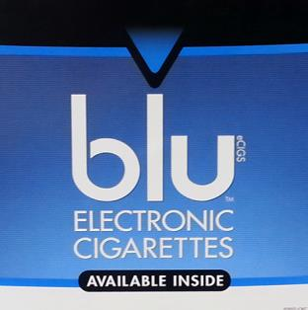

How does this poster make you feel?

W3DBQ1 W3POSECigFeelHappy1

1. Very Unhappy 1 Unhappy 2 Neutral 3 Happy 4 Very Happy 5

W3DBQ2 W3POSECigFeelPleasant2

1. Very Unpleasant 1 Unpleasant 2 Neutral 3 Pleasant 4 Very Pleasant 5

W3DBQ3 W3POSECigFeelGood3

1. Very Bad 1 Bad 2 Neutral 3 Good 4 Very Good 5

W3DBQ4 W3POSECigFeelCool4

1. Very Uncool 1 Uncool 2 Neutral 3 Cool 4 Very Cool 5

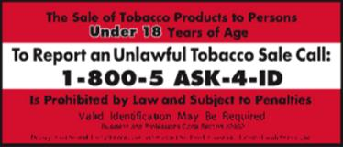

How does this poster make you feel?

W3DBQ5 W3POSWarn1FeelHappy5

1. Very Unhappy 1 Unhappy 2 Neutral 3 Happy 4 Very Happy 5

W3DBQ6 W3POSWarn1FeelPleasant6

1. Very Unpleasant 1 Unpleasant 2 Neutral 3 Pleasant 4 Very Pleasant 5

W3DBQ7 W3POSWarn1FeelGood7

1. Very Bad 1 Bad 2 Neutral 3 Good 4 Very Good 5

W3DBQ8 W3POSWarn1FeelCool8

1. Very Uncool 1 Uncool 2 Neutral 3 Cool 4 Very Cool 5

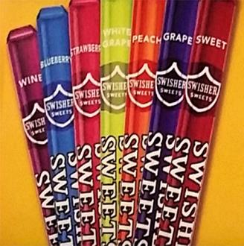

How does this poster make you feel?

W3DBQ9 W3POSCigarFeelHappy9

1. Very Unhappy 1 Unhappy 2 Neutral 3 Happy 4 Very Happy 5

W3DBQ10 W3POSCigarFeelPleasant10

1. Very Unpleasant 1 Unpleasant 2 Neutral 3 Pleasant 4 Very Pleasant 5

W3DBQ11 W3POSCigarFeelGood11

1. Very Bad 1 Bad 2 Neutral 3 Good 4 Very Good 5

W3DBQ12 W3POSCigarFeelCool12

1. Very Uncool 1 Uncool 2 Neutral 3 Cool 4 Very Cool 5



How does this poster make you feel?

W3DBQ13 W3POSCigFeelHappy13

1. Very Unhappy 1 Unhappy 2 Neutral 3 Happy 4 Very Happy 5

W3DBQ14 W3POSCigFeelPleasant14

1. Very Unpleasant 1 Unpleasant 2 Neutral 3 Pleasant 4 Very Pleasant 5

W3DBQ15 W3POSCigFeelGood15

1. Very Bad 1 Bad 2 Neutral 3 Good 4 Very Good 5

W3DBQ16 W3POSCigFeelCool16

1. Very Uncool 1 Uncool 2 Neutral 3 Cool 4 Very Cool 5

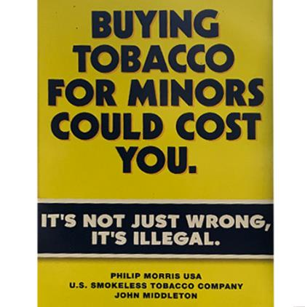

How does this poster make you feel?

W3DBQ17 W3POSWarn2FeelHappy17

1. Very Unhappy 1 Unhappy 2 Neutral 3 Happy 4 Very Happy 5

W3DBQ18 W3POSWarn2FeelPleasant18

1. Very Unpleasant 1 Unpleasant 2 Neutral 3 Pleasant 4 Very Pleasant 5

W3DBQ19 W3POSWarn2FeelGood19

1. Very Bad 1 Bad 2 Neutral 3 Good 4 Very Good 5

W3DBQ20 W3POSWarn2FeelCool20

1. Very Uncool 1 Uncool 2 Neutral 3 Cool 4 Very Cool 5

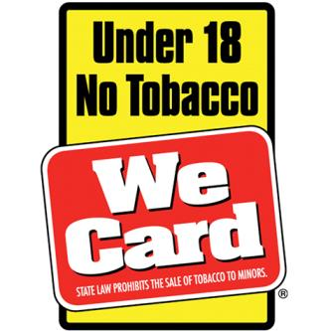

How does this poster make you feel?

W3DBQ21 W3POSWarn3FeelHappy21

1. Very Unhappy 1 Unhappy 2 Neutral 3 Happy 4 Very Happy 5

W3DBQ22 W3POSWarn3FeelPleasant22

1. Very Unpleasant 1 Unpleasant 2 Neutral 3 Pleasant 4 Very Pleasant 5

W3DBQ23 W3POSWarn3FeelGood23

1. Very Bad 1 Bad 2 Neutral 3 Good 4 Very Good 5

W3DBQ24 W3POSWarn3FeelCool24

1. Very Uncool 1 Uncool 2 Neutral 3 Cool 4 Very Cool 5

**Point-of-Sale Sensitivity**

**Source:** Germain, D., McCarthy, M., & Wakefield, M. (2009). Smoker sensitivity to retail tobacco displays and quitting: a cohort study. *Addiction. 105*, 159-163.

**Designed For:** Adult smokers in Australia

**Psychometrics**: Smokers who had a medium or high level of sensitivity to POS displays were significantly less likely to have quit at follow-up [odds ratio (OR) = 0.32, 95% confidence interval

(CI) = 0.14–0.74; OR = 0.27, 95% CI = 0.08–0.91, respectively].

**Codebook:**

1. When you are in a supermarket, convenience store, gas station, or tobacco store, how often do you notice the cigarette pack display near the cash register? W3BTQ1 W3POSSNoteCig1

Never 0 Less than half the time 1 About half the time 2 More than half the time 3 All the time 4

1. When shopping for something other than cigarettes, how often do you decide to buy cigarettes as a result of seeing the cigarette pack display in the store? W3BTQ2 W3POSSBuyCig2

Never 0 Less than half the time 1 About half the time 2 More than half the time 3 All the time 4

1. When buying cigarettes, how often do you decide what brand or type of cigarettes to buy based on the cigarette pack display in the store? W3BTQ3 W3POSSBrandChoice3

Never 0 Less than half the time 1 About half the time 2 More than half the time 3 All the time 4

**90% Update**

[*A 90% Progress Bar Will Be Shown Here*]

Your Progress

Almost done! There are only a few more questions to answer.

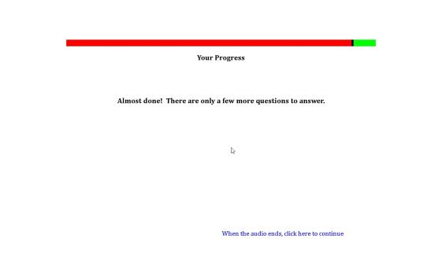

**Perceived Stress PSS-10**

**Source:** Cohen, S., Kamarck, T., Mermelstein, R. (1983). A global measure of perceived stress. *Journal of Health and Social Behavior, 24*, 385-396.

Cohen, S. (1988). Perceived stress in a probability sample of the United States. In S. Spacapan, S. Oskamp (Eds.), *The social psychology of health* (pp. 31-67). Thousand Oaks, CA, US: Sage Publications, Inc.

**Designed For:** Adults

**Psychometrics:** Cronbach’s alpha = .78

**Codebook:**

The following questions will ask about your stress.

1. In the last month, how often have you been upset because of something that happened unexpectedly? W3BWQ1 W3PerStress1

Never 0 Almost Never 1 Sometimes 2 Fairly Often 3 Very Often 4

1. In the last month, how often have you felt that you were unable to control the important things in life? W3BWQ2 W3PerStress2

Never 0 Almost Never 1 Sometimes 2 Fairly Often 3 Very Often 4

1. In the last month, how often have you felt nervous and “stressed”? W3BWQ3 W3PerStress3

Never 0 Almost Never 1 Sometimes 2 Fairly Often 3 Very Often 4

1. In the last month, how often have you felt confident about your ability to handle your personal problems? W3BWQ4 W3PerStress4

Never 0 Almost Never 1 Sometimes 2 Fairly Often 3 Very Often 4

1. In the last month, how often have you felt that things were going your way? W3BWQ5 W3PerStress5

Never 0 Almost Never 1 Sometimes 2 Fairly Often 3 Very Often 4

1. In the last month, how often have you found that you could not cope with all the things that you had to do? W3BWQ6 W3PerStress6

Never 0 Almost Never 1 Sometimes 2 Fairly Often 3 Very Often 4

1. In the last month, how often have you been able to control irritations in your life? W3BWQ7 W3PerStress7

Never 0 Almost Never 1 Sometimes 2 Fairly Often 3 Very Often 4

1. In the last month, how often have you felt that you were on top of things? W3BWQ8 W3PerStress8

Never 0 Almost Never 1 Sometimes 2 Fairly Often 3 Very Often 4

1. In the last month, how often have you been angered because of things that happened that were outside of your control? W3BWQ9 W3PerStress9

Never 0 Almost Never 1 Sometimes 2 Fairly Often 3 Very Often 4

1. In the last month, how often have you felt difficulties were piling up so high that you could not overcome them? W3BWQ10 W3PerStress10

Never 0 Almost Never 1 Sometimes 2 Fairly Often 3 Very Often 4

**Shopper Type**

**Source:** Modeled on research from Sorensen, H. (2009). Inside the mind of the shopper: The science of retailing. Upper Saddle River, N.J.: Prentice Hall.

**Designed For:** Adults

**Psychometrics**: Not reported

1. When you go to LARGE SUPERMARKETS, what types of products do you typically buy? (Check all that apply) W3DCQ1 W3SuperMarkShopType1, 0 When Not Selected, 1 When Selected

Cigarettes W3DCQ1option1 W3SuperMarkShopTypeCig1

Electronic Cigarettes, Vaporizers, or Vape Pens W3DCQ1option2 W3SuperMarkShopTypeECig1

Cigars, Cigarillos, or Little Cigars W3DCQ1option3 W3SuperMarkShopTypeCigar1

Chewing Tobacco, Snuff, or Dip W3DCQ1option4 W3SuperMarkShopTypeChew1

Candy (M & M’s, Snickers, Skittles) W3DCQ1option5 W3SuperMarkShopTypeCandy1

Snacks (chips, cookies, ice cream) W3DCQ1option6 W3SuperMarkShopTypeSnack1

Fruits or Vegetables (bananas, apples, celery NOT fruit rollups, fruit candy, onion rings) W3DCQ1option7 W3SuperMarkShopTypeFruitVeg1

Soda (Coke, Pepsi, Mountain Dew) W3DCQ1option8 W3SuperMarkShopTypeSoda1

Diet Soda (Diet Coke, Coke Zero, Diet Pepsi) W3DCQ1option9 W3SuperMarkShopTypeDietSoda1

Energy Drinks (Red Bull, Rock Star, Gatorade, PowerAde) W3DCQ1option10 W3SuperMarkShopTypeEnergyDrink1

Coffee or Coffee Drinks (latte, cappuccino, frappuccino) W3DCQ1option11 W3SuperMarkShopTypeCoffee1

Alcohol (beer, wine, wine coolers, liquor) W3DCQ1option12 W3SuperMarkShopTypeAlco1

Juice (orange juice, apple juice, tomato juice) W3DCQ1option13 W3SuperMarkShopTypeJuice1

Water W3DCQ1option14 W3SuperMarkShopTypeWater1

Lottery Tickets W3DCQ1option15 W3SuperMarkShopTypeLotto1

Magazines or Newspapers W3DCQ1option16 W3SuperMarkShopTypeMag1

None of the above W3DCQ1option17 W3SuperMarkShopTypeNone1

1. When you go to SMALL GROCERY STORES, what types of products do you typically buy? (Check all that apply) W3DCQ2 W3SmallMarkShopType2, 0 When Not Selected, 1 When Selected

Cigarettes W3DCQ2option1 W3SmallMarkShopTypeCig2

Electronic Cigarettes, Vaporizers, or Vape Pens W3DCQ2option2 W3SmallMarkShopTypeECig2

Cigars, Cigarillos, or Little Cigars W3DCQ2option3 W3SmallMarkShopTypeCigar2

Chewing Tobacco, Snuff, or Dip W3DCQ2option4 W3SmallMarkShopTypeChew2

Candy (M & M’s, Snickers, Skittles) W3DCQ2option5 W3SmallMarkShopTypeCandy2

Snacks (chips, cookies, ice cream) W3DCQ2option6 W3SmallMarkShopTypeSnack2

Fruits or Vegetables (bananas, apples, celery NOT fruit rollups, fruit candy, onion rings) W3DCQ2option7 W3SmallMarkShopTypeFruitVeg2

Soda (Coke, Pepsi, Mountain Dew) W3DCQ2option8 W3SmallMarkShopTypeSoda2

Diet Soda (Diet Coke, Coke Zero, Diet Pepsi) W3DCQ2option9 W3SmallMarkShopTypeDietSoda2

Energy Drinks (Red Bull, Rock Star, Gatorade, PowerAde) W3DCQ2option10 W3SmallMarkShopTypeEnergyDrink2

Coffee or Coffee Drinks (latte, cappuccino, frappuccino) W3DCQ2option11 W3SmallMarkShopTypeCoffee2

Alcohol (beer, wine, wine coolers, liquor) W3DCQ2option12 W3SmallMarkShopTypeAlco2

Juice (orange juice, apple juice, tomato juice) W3DCQ2option13 W3SmallMarkShopTypeJuice2

Water W3DCQ2option14 W3SmallMarkShopTypeWater2

Lottery Tickets W3DCQ2option15 W3SmallMarkShopTypeLotto2

Magazines or Newspapers W3DCQ2option16 W3SmallMarkShopTypeMag2

None of the above W3DCQ2option17 W3SmallMarkShopTypeNone2

1. When you go to CONVENIENCE STORES, what types of products do you typically buy? (Check all that apply) W3DCQ3 W3ConvenienceShopType3, 0 When Not Selected, 1 When Selected

Cigarettes W3DCQ3option1 W3ConvenienceShopTypeCig3

Electronic Cigarettes, Vaporizers, or Vape Pens W3DCQ3option2 W3ConvenienceShopTypeECig3

Cigars, Cigarillos, or Little Cigars W3DCQ3option3 W3ConvenienceShopTypeCigar3

Chewing Tobacco, Snuff, or Dip W3DCQ3option4 W3ConvenienceShopTypeChew3

Candy (M & M’s, Snickers, Skittles) W3DCQ3option5 W3ConvenienceShopTypeCandy3

Snacks (chips, cookies, ice cream) W3DCQ3option6 W3ConvenienceShopTypeSnack3

Fruits or Vegetables (bananas, apples, celery NOT fruit rollups, fruit candy, onion rings) W3DCQ3option7 W3ConvenienceShopTypeFruitVeg3

Soda (Coke, Pepsi, Mountain Dew) W3DCQ3option8 W3ConvenienceShopTypeSoda3

Diet Soda (Diet Coke, Coke Zero, Diet Pepsi) W3DCQ3option9 W3ConvenienceShopTypeDietSoda3

Energy Drinks (Red Bull, Rock Star, Gatorade, PowerAde) W3DCQ3option10 W3ConvenienceShopTypeEnergyDrink3

Coffee or Coffee Drinks (latte, cappuccino, frappuccino) W3DCQ3option11 W3ConvenienceShopTypeCoffee3

Alcohol (beer, wine, wine coolers, liquor) W3DCQ3option12 W3ConvenienceShopTypeAlco3

Juice (orange juice, apple juice, tomato juice) W3DCQ3option13 W3ConvenienceShopTypeJuice3

Water W3DCQ3option14 W3ConvenienceShopTypeWater3

Lottery Tickets W3DCQ3option15 W3ConvenienceShopTypeLotto3

Magazines or Newspapers W3DCQ3option16 W3ConvenienceShopTypeMag3

None of the above W3DCQ3option17 W3ConvenienceShopTypeNone3

1. When you go to GAS STATIONS, what types of products do you typically buy? (Check all that apply) W3DCQ4 W3GasShopType4, 0 When Not Selected, 1 When Selected

Cigarettes W3DCQ4option1 W3GasShopTypeCig4

Electronic Cigarettes, Vaporizers, or Vape Pens W3DCQ4option2 W3GasShopTypeECig4

Cigars, Cigarillos, or Little Cigars W3DCQ4option3 W3GasShopTypeCigar4

Chewing Tobacco, Snuff, or Dip W3DCQ4option4 W3GasShopTypeChew4

Candy (M & M’s, Snickers, Skittles) W3DCQ4option5 W3GasShopTypeCandy4

Snacks (chips, cookies, ice cream) W3DCQ4option6 W3GasShopTypeSnack4

Fruits or Vegetables (bananas, apples, celery NOT fruit rollups, fruit candy, onion rings) W3DCQ4option7 W3GasShopTypeFruitVeg4

Soda (Coke, Pepsi, Mountain Dew) W3DCQ4option8 W3GasShopTypeSoda4

Diet Soda (Diet Coke, Coke Zero, Diet Pepsi) W3DCQ4option9 W3GasShopTypeDietSoda4

Energy Drinks (Red Bull, Rock Star, Gatorade, PowerAde) W3DCQ4option10 W3GasShopTypeEnergyDrink4

Coffee or Coffee Drinks (latte, cappuccino, frappuccino) W3DCQ4option11 W3GasShopTypeCoffee4

Alcohol (beer, wine, wine coolers, liquor) W3DCQ4option12 W3GasShopTypeAlco4

Juice (orange juice, apple juice, tomato juice) W3DCQ4option13 W3GasShopTypeJuice4

Water W3DCQ4option14 W3GasShopTypeWater4

Lottery Tickets W3DCQ4option15 W3GasShopTypeLotto4

Magazines or Newspapers W3DCQ4option16 W3GasShopTypeMag4

None of the above W3DCQ4option17 W3GasShopTypeNone4

1. When you go to DRUG STORES, what types of products do you typically buy? (Check all that apply) W3DCQ5 W3DrugShopType5, 0 When Not Selected, 1 When Selected

Cigarettes W3DCQ5option1 W3DrugShopTypeCig5

Electronic Cigarettes, Vaporizers, or Vape Pens W3DCQ5option2 W3DrugShopTypeECig5

Cigars, Cigarillos, or Little Cigars W3DCQ5option3 W3DrugShopTypeCigar5

Chewing Tobacco, Snuff, or Dip W3DCQ5option4 W3DrugShopTypeChew5

Candy (M & M’s, Snickers, Skittles) W3DCQ5option5 W3DrugShopTypeCandy5

Snacks (chips, cookies, ice cream) W3DCQ5option6 W3DrugShopTypeSnack5

Fruits or Vegetables (bananas, apples, celery NOT fruit rollups, fruit candy, onion rings) W3DCQ5option7 W3DrugShopTypeFruitVeg5

Soda (Coke, Pepsi, Mountain Dew) W3DCQ5option8 W3DrugShopTypeSoda5

Diet Soda (Diet Coke, Coke Zero, Diet Pepsi) W3DCQ5option9 W3DrugShopTypeDietSoda5

Energy Drinks (Red Bull, Rock Star, Gatorade, PowerAde) W3DCQ5option10 W3DrugShopTypeEnergyDrink5

Coffee or Coffee Drinks (latte, cappuccino, frappuccino) W3DCQ5option11 W3DrugShopTypeCoffee5

Alcohol (beer, wine, wine coolers, liquor) W3DCQ5option12 W3DrugShopTypeAlco5

Juice (orange juice, apple juice, tomato juice) W3DCQ5option13 W3DrugShopTypeJuice5

Water W3DCQ5option14 W3DrugShopTypeWater5

Lottery Tickets W3DCQ5option15 W3DrugShopTypeLotto5

Magazines or Newspapers W3DCQ5option16 W3DrugShopTypeMag5

None of the above W3DCQ5option17 W3DrugShopTypeNone5

1. When you go to LIQUOR STORES, what types of products do you typically buy? (Check all that apply) W3DCQ6 W3LiquorShopType6, 0 When Not Selected, 1 When Selected

Cigarettes W3DCQ6option1 W3LiquorShopTypeCig6

Electronic Cigarettes, Vaporizers, or Vape Pens W3DCQ6option2 W3LiquorShopTypeECig6

Cigars, Cigarillos, or Little Cigars W3DCQ6option3 W3LiquorShopTypeCigar6

Chewing Tobacco, Snuff, or Dip W3DCQ6option4 W3LiquorShopTypeChew6

Candy (M & M’s, Snickers, Skittles) W3DCQ6option5 W3LiquorShopTypeCandy6

Snacks (chips, cookies, ice cream) W3DCQ6option6 W3LiquorShopTypeSnack6

Fruits or Vegetables (bananas, apples, celery NOT fruit rollups, fruit candy, onion rings) W3DCQ6option7 W3LiquorShopTypeFruitVeg6

Soda (Coke, Pepsi, Mountain Dew) W3DCQ6option8 W3LiquorShopTypeSoda6

Diet Soda (Diet Coke, Coke Zero, Diet Pepsi) W3DCQ6option9 W3LiquorShopTypeDietSoda6

Energy Drinks (Red Bull, Rock Star, Gatorade, PowerAde) W3DCQ6option10 W3LiquorShopTypeEnergyDrink6

Coffee or Coffee Drinks (latte, cappuccino, frappuccino) W3DCQ6option11 W3LiquorShopTypeCoffee6

Alcohol (beer, wine, wine coolers, liquor) W3DCQ6option12 W3LiquorShopTypeAlco6

Juice (orange juice, apple juice, tomato juice) W3DCQ6option13 W3LiquorShopTypeJuice6

Water W3DCQ6option14 W3LiquorShopTypeWater6

Lottery Tickets W3DCQ6option15 W3LiquorShopTypeLotto6

Magazines or Newspapers W3DCQ6option16 W3LiquorShopTypeMag6

None of the above W3DCQ6option17 W3LiquorShopTypeNone6

**Extracurricular Activities**

**Source:** Adapted from Hornik, D., Hornik, S., Hornik, R., & Maklan, D. (2011). National survey of parents and youth (NSPY), 1998-2004 -- Restricted Use Files. ICPSR27868-v2. Ann Arbor, MI: Inter-university Consortium for Political and Social Research [distributor], 2011-03-03. <http://doi.org/10.3886/ICPSR27868.v2>

**Designed for:** Adolescents

**Psychometrics:** Not provided

**Items:**

1. In the last 12 months, which of the following organized activities or groups have you participated in? (Check all that apply) W3CDQ1 W3ExCurPast1, 0 When Not Selected, 1 When Selected

Music, dance, theater or other performing arts (in or outside of school) W3CDQ1option1 W3ExCurPastArts1

Athletic teams or organized sports (in or outside of school) W3CDQ1option2 W3ExCurPastSports1

Boys or girls clubs (Boy Scouts, Girl Scouts, etc.) W3CDQ1option3 W3ExCurPastScouts1

Youth groups sponsored by a church, synagogue, mosque, or other religious institution W3CDQ1option4 W3ExCurPastChurch1

Another club or activity, in or outside of school, or volunteer work W3CDQ1option5 W3ExCurPastOther1

None of these clubs or activities W3CDQ1option6 W3ExCurPastNone1

(If an option other than ‘None of these clubs or activities’ is selected…) [*Page 2*]

1. How many hours a week did you participate in these activities? ___________ W3CDQ2 W3ExCurPastHours1

[*Page 3*]

1. Which of the following organized activities or groups are you currently participating in? (Check all that apply) W3CDQ3 W3ExCurNow1, 0 When Not Selected, 1 When Selected

Music, dance, theater or other performing arts (in or outside of school) W3CDQ3option1 W3ExCurNowArts1

Athletic teams or organized sports (in or outside of school) W3CDQ3option2 W3ExCurNowSports1

Boys or girls clubs (Boy Scouts, Girl Scouts, etc.) W3CDQ3option3 W3ExCurNowScouts1

Youth groups sponsored by a church, synagogue, mosque, or other religious institution W3CDQ3option4 W3ExCurNowChurch1

Another club or activity, in or outside of school, or volunteer work W3CDQ3option5 W3ExCurNowOther1

None of these clubs or activities W3CDQ3option6 W3ExCurNowNone1

(If an option other than ‘None of these clubs or activities’ is selected…) [*Page 4*]

1. How many hours a week do you participate in these activities? ___________ W3CDQ4 W3ExCurNowHours1
2. How many close friends participate in these activities with you? W3CDQ5 W3ExCurNowFriends1

None of them 0

A few of them 1

About half of them 2

Most of them 3

All of them 4

**Final Screen**

Congratulations! You are done with the survey.

All you have to do now is email or text the following keyword to your Study Coordinator.

[*4 Digit Code*]

In the next couple days, they will send you a Target eGiftCard.

Thank you for all the time you have given to CHAMP. If you have any questions or need any assistance, don’t hesitate to contact us or visit our website at [www.champsurvey.com](http://www.champsurvey.com).